|  |
| --- |
| BOCHU, Inc. |
| BOCHU TubePro Tube Cutting Control Software |
| **User Manual Multi-Chuck** |
| For FSCUT5000A  Version 7.27.200.3 |

5000A supports the full range of BOCHU functions:

|  |  |
| --- | --- |
|  | 5000A |
| Function |
| Follow-up Holder | √ |
| Chuck Size (> 120) | √ |
| Plate and Tube in One | √ |
| Focusing | √ |
| Pull-Feed Cutting | √ |
| Dodge | √ |
| Probe Centering | √ |
| FlyCut | √ |
| Bevel Cutting | √ |
| Hardware | Master Card |
| 3-Chuck | √ |
| 4-Chuck | √ |
| 7-axis Pulling | √ |

# Welcome

Thank you for choosing BOCHU TubePro Tube Cutting Software!

"TubePro tube cutting software" (hereinafter referred to as TubePro) is used for laser cutting of metal pipe, with high precision and high efficiency. Its main functions include calibration of the B-axis center, automatic tube centering, parameter setting, custom PLC, simulation and cutting control.

TubePro has to work with the control card for processing control. When TubePro is running on a computer that does not have a control card connected, it enters Demo(Offline) mode.

Please note that this user manual is only intended as a operating instruction for the main program of TubePro. For tools that is installed with TubePro, including the Machine Config Tool(CypConfig), please contact us.

**This manual is based on TubePro version 7.27.200.3**. Your TubePro may differ in some respects from the content in this manual due to the continuous updating of TubePro.

If you have any questions or suggestions, feel free to contact us!



The machine tool operation and laser cutting quality have something to do with the material being cut, the laser used, the gas used, the pressure and the parameters you set. Please set the parameters according to your cutting process requirements!

Improper parameter setting and operation can lead to low cutting results, damage to laser heads or machine parts or even human injury, TubePro has provided various protective measures to its best. Laser equipment manufacturers and end users should comply with operating procedures to avoid the occurrence of accidents.

BOCHU shall not be liable for any direct, indirect, incidental, or consequential losses and liabilities resulting from the improper use of this manual or TubePro!

Table of Contents

Welcome 3

Table of Contents 4

1. Initial Debug 7

1.1 Debugging 7

1.2 Steps 7

1.2.1 System Return Origin 8

1.2.2 Holder Debugging 8

1.2.3 Chuck Debugging 9

1.2.4 Capacitance Calibration 9

1.2.5 Calibrate B-axis Center 9

2. Quick Start 11

2.1 Processing Flow 11

2.1.1 Import File 11

2.1.2 Set Layer Parameters 11

2.1.3 Start Processing 11

2.1.4 Display Alarm 12

2.2 Install and Uninstall TubePro 12

2.2.1 Installation 12

2.2.2 Uninstallation 13

3. Function Description 15

3.1 Quick Access 15

3.2 Processing Bar 17

3.2.1 Burst Action Bar 17

3.2.2 Jog Action Bar 18

3.2.3 Debug Action Bar 19

3.2.4 Processing Bar 20

3.3 File 21

3.3.1 About 21

3.3.2 Parameter Backup 22

3.4 Machine Calibration and Return Origin 22

3.4.1 Return Origin 22

3.4.2 Follower 25

3.4.3 Calibrate B-axis Center 25

3.5 Function Debug 27

3.5.1 Manual Debug 27

3.5.1.1 Chuck Debug 27

3.5.1.2 Holder Debug 28

3.5.1.3 Single Axis Tuning 29

3.5.2 Follow-up Holder 29

3.6 Monitoring Tools 34

3.6.1 Follower Monitoring 34

3.6.2 Motion Control Monitoring 36

3.6.3 Extend Board Monitoring 39

3.6.4 Real-time Curve Monitoring 39

3.6.5 WKB Function Hint 40

3.7 Assist Functions 41

3.7.1 Quick CutOff 41

3.7.2 Quick Align Pipe 41

3.7.3 Display Multi-file Cutting 42

3.7.4 Time Estimates 43

3.7.5 Tube Profile Offset 43

3.7.6 Gas DA Calibration 44

3.7.7 Quick Save Fault Info 45

3.7.8 Loop Machining Settings 45

3.7.9 Set Current Position as Machine Origin 48

3.8 Centering/FindEdge/Leveling 48

3.8.1 Single-face Leveling 49

3.8.2 4-point Centering 51

3.8.3 5-point Centering+Leveling 52

3.8.4 Multi-face Centering 53

3.8.5 Ellipse Centering 54

3.8.6 Angle Steel Centering 55

3.8.7 FindEdge Centering 56

3.8.8 Symmetric Arc Centering 57

3.8.9 I-beam Centering 58

3.8.10 Advanced Centering 59

3.8.11 Calibrate B-axis and Square Centering 59

3.8.12 Manual Centering 60

3.8.13 Centering During Machining 61

3.8.14 Single-face Centering 62

3.9 Cutter 63

3.9.1 BLT Cutter Debug 63

3.9.2 Focus Autotest 66

3.10 Debugging Tool 67

3.10.1 Auto Gas Correction 67

3.10.2 Photo Paper Test 67

3.10.3 Z-phase Signal Initialization 68

3.11 Installation Tools 69

3.11.1 Burn-in Test 69

3.11.2 Interferometer Program 69

3.12 Advanced Tools 70

3.12.1 New Motor Tuning 70

3.12.2 FindEdge Repeatability Analysis 71

3.12.3 Square Profile Precision Analysis 72

3.12.4 Coordinates Viewer 73

3.12.5 Create CAD Test File 73

3.12.6 Advanced Debugging Tools 74

3.13 Global Parameter 74

3.13.1 Machining Settings 74

3.13.2 Motion Parameters 76

3.13.3 Algorithm Parameter 77

3.13.4 Speed Unit 78

3.14 Layer Parameters 78

3.14.1 Cut Technique 78

3.14.2 Pierce Technique 80

3.14.3 Corner Technique 81

3.14.4 File Parameter 81

3.15 Custom PLC 82

3.15.1 Function Layout 82

3.15.2 Logical Conditions 84

3.15.3 Single-step Execution 85

3.15.4 JavaScript 85

4. Machine Function 87

4.1 Auto Dodge 87

4.1.1 Cutter Dodge 87

4.1.2 Chuck Dodge 89

4.2 Bevel Cutting 92

4.2.1 Preparation Before Debugging 92

4.2.2 Adjust Servo Rigidity 92

4.2.3 Swing Axis Calibration Parameter 93

4.2.4 Verticality Correction/Test 93

4.2.5 Vaz Calibration 94

4.2.6 Swing(A) Axis Calibration 95

4.3 7-axis Pulling 95

4.4 3-Chuck 98

4.4.1 3-chuck Position Parameters 100

4.4.2 3-chuck Position 102

4.4.3 3-chuck Unloading Action 105

4.4.4 3-chuck Parameter Configuration 106

1. Initial Debug

The preliminary debugging is performed for the first-time power-on testing after mechanical assembly, aiming to ensure that all motion axes, chucks, holders, and other functions can be used properly.

For more detailed configuration, refer to the user manual of the control system.

* 1. **Debugging**

图片1

* 1. Steps

Before opening TubePro, the basic parameters for the height controller and the X/Y/Z/A/B axis of the machine should be configured in the Machine Config Tool(CypConfig).

The parameters such as travel range can be initially set to approximate values. The pulse equivalent, limit switch logic, return origin switch logic, servo alarm logic, return origin direction, and return origin sampling signal should be filled in according to the actual situation.

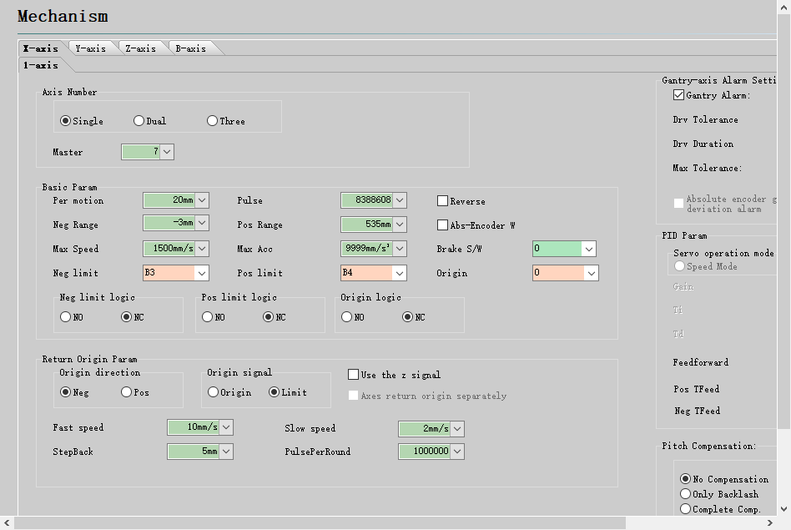

* + 1. System Return Origin

Open the TubePro softwareand enter Administrator mode for debugging.

Jog each axis slowly. If there is a soft limit alarm, the soft limit protection can be temporarily switched off in the console - jog speed setting. If there is a return origin alarm, use the < force to ignore return origin alarm > in the drop-down button of <return origin>.

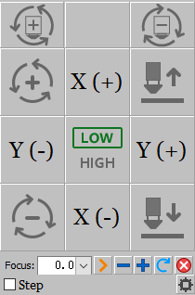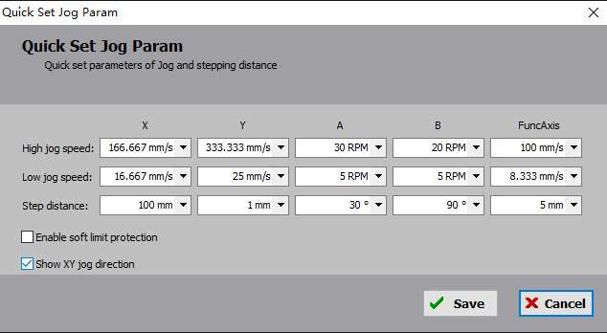

If the jog is correct, switch on <Motion Control Monitor> in <Tools> to trigger the origin of each axis and the limit switch in turn (Do not jog the axis. If the limit switch is a photoelectric switch, just cover the door with a spacer) and observe the monitor screen for a corresponding signal.

After checking that the origin and limit switches are correct, return origin can be performed.

For the first time debugging, perform a single axis return origin test. Click the drop-down button for <Return Origin> and perform the Z/X/Y/B single axis return origin.

After the single axis return origin is all correct, set a specific return origin action in the <return origin setting> according to the model needs, then click <return origin> to complete all axis return origin. Please refer to Chapter 2 for details of return origin.

* + 1. Holder Debugging

Before closing the software to configure the holder, you can estimate the Y-down position parameters of each holder. After the system returns to the origin, jog the Y-axis to the position where the main chuck holds a safe distance from each holder. Taking into account the parameters such as the duration of the holder up and down and the travel speed, ensure that the holder up does not hit the main chuck, record the current Y-axis value as the reference basis for the holder down position parameters.

After all holders have been recorded, close the software and open CypConfig and go to Holder interface to fill in the parameters. After configuring the holder function in the Machine Config Tool(CypConfig), click the menu bar <Manual Debug> - <Chuck Holder and Single Axis Debug> menu.

If the gas general valve of the holder is configured in the Platform Configuration Tool, the <Forbid Holder Function> is ON by default and needs to be manually turned off for holder debugging. Holders with Y down position parameter is greater than the current actual Y coordinate value are considered safety holders and can be manually raised and lowered on the manual debug interface.

This allows you to use a stopwatch to measure the time the holder is going up and down, and further adjust the up/down in-place default time and down position parameters.

* + 1. Chuck Debugging

The specific configuration and parameters of the chucks in the Machine Config Tool(CypConfig) are explained in the Appendix.

Once configured, the clamping/unclamping of the chuck can be controlled in <Manual Debug>. Measure the time it takes to open and close the chuck using a stopwatch, and set this time as the default time for chuck clamping and releasing.

After successful debugging, clamp/unclamp the pipe by clicking on the chuck. If a holder is configured, it can be used in conjunction.

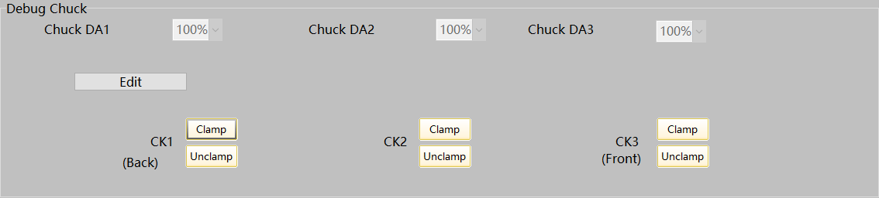

* + 1. Capacitance Calibration

Move the rectangular tube under the cutting head by jog the X/Y/B axis and adjust the top surface of the rectangular tube to be basically horizontal, then jog the Z axis to move the cutting head nozzle close to the tube surface. For FSCUT5000A and FSCUT5000B systems, click <Capacitance Calibration>, a confirmation dialog box will pop up. Click OK and the height controller begins to calibrate.

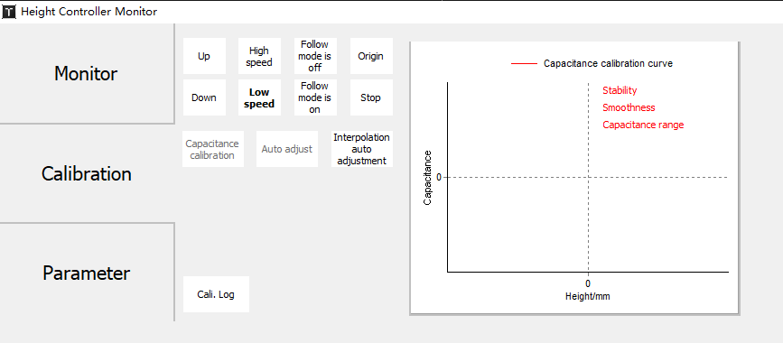

* + 1. Calibrate B-axis Center

Jog the X/Y/B axis and move the standard rectangular tube without fillet (fillets will affect the accuracy of the B-axis calibration!) under the cutting head nozzle and adjust the top surface of the rectangular tube to be basically horizontal. Open <Calibrate B axis center>, and enter the size of the rectangular tube, then click <Start Calibration>, and then click <Save> to exit when calibration is complete.

Note: Before calibrating the center of the B-axis, it is necessary to have accurate and reliable coordinates for the X, Z, and B axes. This means that before calibrating the center of the B-axis, all axes should be homed once. The rectangular pipe shown in the diagram below is preferred for calibrating the center of the B-axis. It is only necessary to calibrate the center of the B-axis once during the initial debugging, and it is not required to be repeated unless the machine is moved.

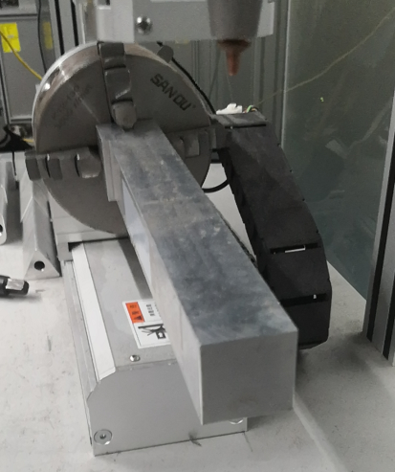

Once the basic parameters such as laser settings, gas settings, and alarms are configured, the machine will have the basic processing capabilities. Refer to the system manual for additional configurations.

1. Quick Start

Quick start for machining with debugged machines. Before processing, it should be confirmed that the system has returned to the origin, capacitance is calibrated, and it has a more accurate B-axis center. Otherwise, perform a return origin, capacitance calibration, and calibrate the B-axis center with a standard rectangular tube without chamfers.

2.1 Processing Flow

图片2

2.1.1 Import File

Click <Open> and select the *.zx or *.zzx file to be processed. The right side of the <Open> menu allows you to preview the processing graphics and the graphic dimensions of the file. The dimensions of the graphic to be processed will be displayed on the upper left corner of the interface.

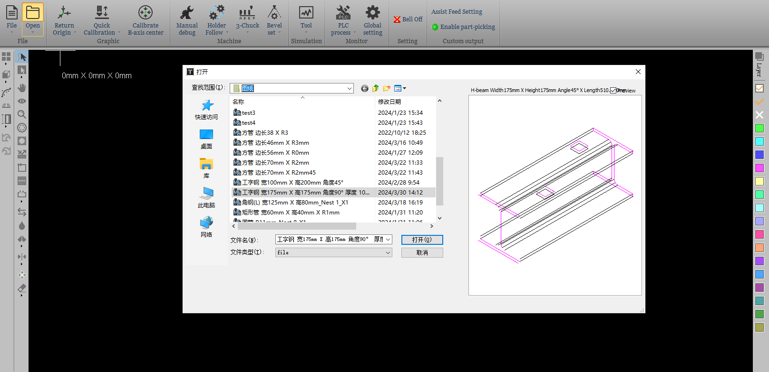

You can use the CAD tools on the left side to set the start point, guide line, and center point of the graphic, and the tools on the right side can be used to set the layer and layer process of the graphic.

2.1.2 Set Layer Parameters

Click the <Layer> tool button to set the process parameters for the layer, which allows you to set the cut, pierce, pipe corner, parameters for the bevel process

2.1.3 Start Processing

Before starting the processing, the tube should be centered (see Appendix for details of the centering method) and then the graphic can be processed by clicking the <Start> button in the action bar.

During processing, you can see the progress of the part in the status bar.

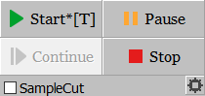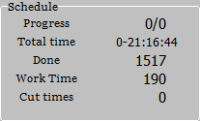

2.1.4 Display Alarm

During operation, when an alarm or warning occurs, the information is displayed in the top alarm status bar and the alarm time and information is displayed in the alarm description at the bottom.

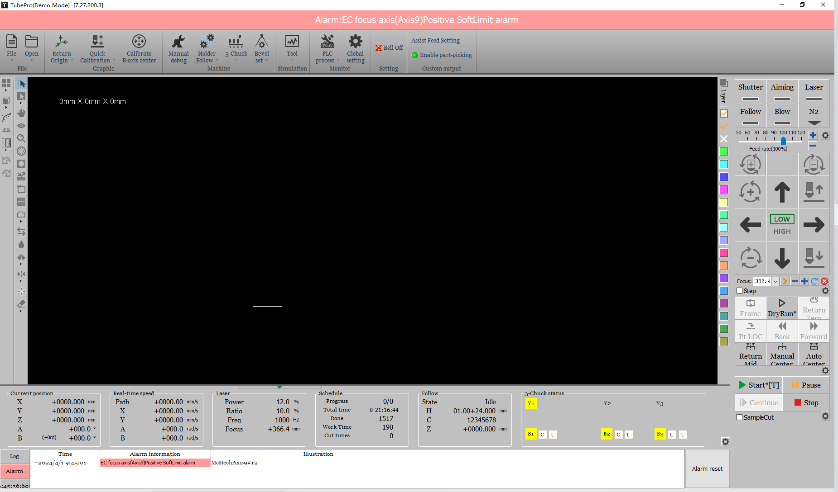

For example, the two alarms above can be viewed by opening the <Tools> Menu → <Motion Control Monitor> to view the status of the X axis, and the <Tools> Menu →<Extension Board Monitor> or <Terminal Board Monitor>to view the status of the input ports for troubleshooting purposes.

2.2 Install and Uninstall TubePro

2.2.1 Installation

Close Antivirus, TubePro, CypConfig, and install software.

For a first-time installation or upgrade, simply install it. The override installation does not change the previous configuration. To clear all data, uninstall the installed program first.

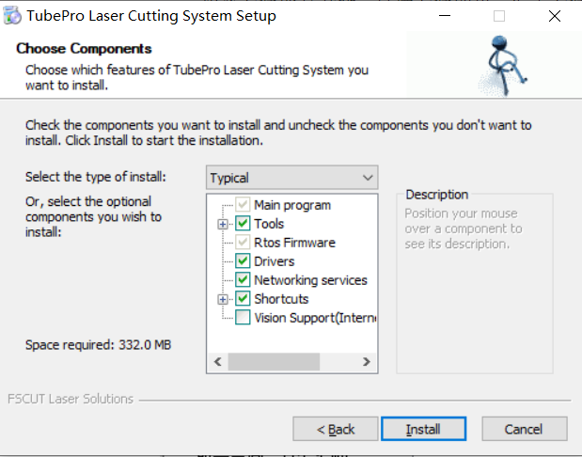

Download it at www.fscut.com

2.2.2 Uninstallation

When the TubePro software is uninstalled, you can set whether or not to delete user data. If Delete User Data is ticked, the mechanical configuration, PLC configuration and process parameters will be deleted after the software is uninstalled.

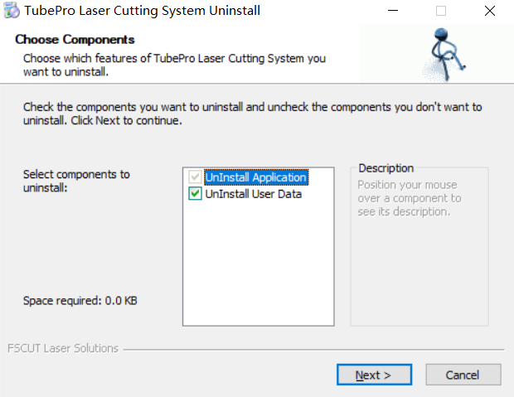

Note: Delete User Data is ticked by default when the software is uninstalled. The uninstallation operation is generally used in cases of missing user data or file corruption to avoid overwriting installation and directly calling that data, which may result in software errors. For regular software upgrades, please proceed with a direct installation over the existing installation.

1. Function Description

3.1 Quick Access

Leadline, StartPoint, MicroJoint, Reverse, Cooling Point, Weld Compensation, centering, Nudge,Clear, Display Mode, View Selection, Smooth Curve, and so on.

H:\Stable\test\Cyptube2017 SVN\trunk\bin\Icons\sfrmCAD\btnSel.png - Select a line. Select the specified graphic. If you click on the part area, you can select all paths of the part at once (the front face of the co-edge part is not selected).

H:\Stable\test\Cyptube2017 SVN\trunk\bin\Icons\sfrmCAD\btnDrag.png - Drag, drag the graphic to view. Alternatively, you can drag the graphic to view it by pressing and holding the Ctrl key + scroll.

H:\Stable\test\Cyptube2017 SVN\trunk\bin\Icons\sfrmCAD\btn3DView.png - 3D view, rotate the view for 3D graphics. You can also enter 3D view mode by holding and dragging the mouse. Press and hold the Shift key + scroll, then drag the mouse to rotate the graphics around the central axis of the pipe.

H:\Stable\test\Cyptube2017 SVN\trunk\bin\Icons\sfrmCAD\btnViewZoom.png - Zoom, zoom in and out to view the graphic. Alternatively, you can scroll to zoom in and out.

H:\Stable\test\Cyptube2017 SVN\trunk\bin\Icons\sfrmCAD\btnOffset.png - Compensation, for the selected graphic or forall graphics, set kerf compensation. When compensation is added, the original graphic changes to white, the compensated graphic changes to the original layer color. The actual cut will follow the compensated trajectory.

H:\Stable\test\Cyptube2017 SVN\trunk\bin\Icons\sfrmCAD\btnInOut.png - Inner/outer,set the graphic to cut inner or outer, which decides the leadline and compensation are inside or outside the graphic.

H:\Stable\test\Cyptube2017 SVN\trunk\bin\Icons\sfrmCAD\btnLeadIn.png - Leadline, for the selected graphic or all graphics, set leadlines. You can set the type, length, and position of the leadline, or add a cooling point at the leadin point.

H:\Stable\test\Cyptube2017 SVN\trunk\bin\Icons\sfrmCAD\btnStartPoint.png - Start point, set the start position of each path in the graphic.

H:\Stable\test\Cyptube2017 SVN\trunk\bin\Icons\sfrmCAD\btnMicroJoint.png - MicroJoint,insert an uncut MicroJoint to the path. You can insert multiple MicroJoints by clicking in succession on the graphic. Press Shift and click a MicroJoint to clear it in the MicroJoint mode.

btnLeadSealGap - Gap, leave a section uncut at the end of the cutting path (applied in C-type co-edge);

Seal, clear gaps and overcuts and return to a gap-free/overcut state.

H:\Stable\test\Cyptube2017 SVN\trunk\bin\Icons\sfrmCAD\btnReverse.png - Reverse, reverse the motion direction of the machining graphic paths.

H:\Stable\test\Cyptube2017 SVN\trunk\bin\Icons\sfrmCAD\btnCool.png - Cooling point, the laser is off and the gas is blowing at the cooling point. After the cooling point delay, the processing continues. The cooling point delay is configured in the global parameters.

H:\Stable\test\Cyptube2017 SVN\trunk\bin\Icons\sfrmCAD\btnWeldComp.png - Weld compensation, set whether weld compensation is applied at the position of the graphic section.

btnSeekCenter - Find Center,set the starting point of the graphic to be the centering point. Select a single graphic and click Find Center, the starting point of the graphic will be set as the centering point; select multiple graphics and click Find Center to automatically set the centering point. By setting the minimum distance between the centering points, TubePro can automatically add the centering point on the appropriate graphic. When processing at the centering point, auto centering will be started automatically and then processing is continued.

Simplex, setting the Simplex midpoint of the trace in the graph, square tube and L/C steel supports adding Simplex midpoint, cut lines and cross-faces cannot add Simplex midpoint.

btnMicroMove - Nudge, move the selected graphics slightly along the X or Y-axis direction for easy debugging.

H:\Stable\test\Cyptube2017 SVN\trunk\bin\Icons\sfrmCAD\btnClear.png - Clear, you can select Clear Compensation/Leadline/MicroJoint/Cooling Point/FindCenter/All.

btnShowMode - Display Mode, display open graphics/processing sequence/path start/path direction/travel path/section/surface rendering/normal vector, or not.

H:\Stable\test\Cyptube2017 SVN\trunk\bin\Icons\sfrmCAD\btnViewSel.png - View selection, select the view mode. You can select Default/Top/Main/Bottom/Back/Right/Left/Southwest Isometric/Northeast Isometric/Southeast Isometric/East-West Isometric/Northwest Isometric view;View refresh can be switched on/off; you can refresh the view will be jagging during large image processing, so you can choose not to refresh it; you can set the view to reverse (rotate the drawing 180° along the Z-axis) in cases where the clamping method of non-symmetric pipe materials such as angle steel and profiled steel is inconsistent with the drawing on the YOZ plane. In this situation, there is no need to remove and re-clamp the pipe. You can just reverse the view to ensure the actual pipe orientation is consistent with that is in the drawing.

btnCurveSmoothSmooth Curve, which smooths the curve of the selected graphic. Only applies to graphics on the surface, not applied to the section graphic.

btnSwingLength - Fast swinging cuts, swinging is involved in interpolated cutting.

btnMeasure- Measure, click on the measurement and left-click on the graphic of the two points to be measured, then the distance between the two points and the absolute distance in the X/Y/Z direction are displayed in the log.

 - Undo, click Undo to undo the previous action.

- Restore, click Restore to resume the previous action.

3.2 Processing Bar

As shown in the diagram, the processing bar is located on the right side of the interface and contains the Burst action bar, the Jog action bar, and the Debug action bar, processing action bar.

The actions of each of these four action bars are described in detail below.

3.2.1 Burst Action Bar

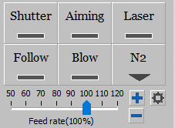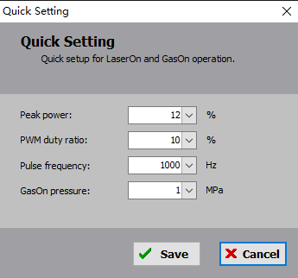

|  |  |
| --- | --- |
| **Parameter Name** | **Description** |
| Shutter | Laser shutter |
| Aiming | Laser aiming |
| Laser | Laser burst Left-click to do Laser Burst; right-click to turn on the laser |
| Follow | Height controller starts to follow |
| Blow | Press it to turn the gas on |
| Select Gas | Select Blowing Gas Type |
| btnGlobalParams | Burst quick setting, which is as shown below. |

Burst Quick Setting

|  |  |
| --- | --- |
| **Parameter Name** | **Description** |
| Burst peak power | Burst peak power |
| Burst PWM duty cycle | Laser signal duty cycle |
| Burst pulse frequency | Laser signal frequency |
| GasOn Pressure | Blowing air pressure settings |

3.2.2 Jog Action Bar



|  |  |
| --- | --- |
| **Parameter Name** | **Description** |
| Jog Panel | X/Y/Z/A/B axis jog or step. When the common axis is configured, you can also set the common axis jog or step. |
| LOW/HIGH | Set the low/high speed for jog or step |
| Step | Check the "Step" option to move the axis in a step-by-step manner using the directional keys. If unchecked, the axis will move in jog mode. |
| Focus/Beam | If equipped with an electrically focused cutting head, the focus and beam can be jog. The five buttons are Locate to a specified point, negative jog, positive jog, return origin, and stop. |
| btnGlobalParams | Jog quick setting is as shown below. |

Jog Quick Setting

|  |  |
| --- | --- |
| **Param Name** | **Description** |
| Jog high speed | Set the X/Y/A/B/Common axis, high speed jog/step speed |
| Jog low speed | Set the X/Y/A/B/Common axis, low speed jog/step speed |
| Step distance | Set the X/Y/A/B/Comm axis, step speed |
| Enable Soft Limit | Set whether to enable soft limit protection, and the soft limit stroke is set in the machine config tool |
| Display XY jog direction | When ticked, the jog icon of the XY changes from an arrow to ± XY direction, showing the jog direction |

3.2.3 Debug Action Bar

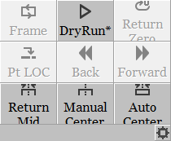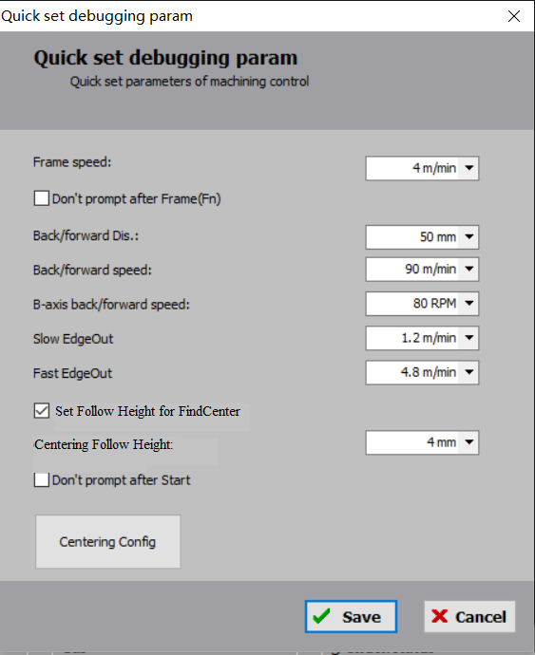

|  |  |
| --- | --- |
| **Parameter Name** | **Description** |
| Frame | Depending on the graphic range, walk along the maximum bounding rectangle of the graphic on the machine tool's working area. |
| DryRun | The machine tool moves according to the graphic, but there is no laser emission, no follow, and no gas blowing. |
| Return Zero | The machine tool moves to the zero point of the graphic, and during this movement, the X, Y, Z, B, and A axes will all be in motion. |
| ReturnMid | The machine tool's X, B, Z, and A axes move to the program zero point. |
| Pt LOC | During the machining process, if an abnormality occurs and triggers an alarm resulting in a stop, you can use breakpoint positioning(Pt LOC) to locate the position at the moment of the interruption. Afterward, you can resume the machining process. |
| Forward/Stepback | After performing a Pt LOC or Pause, click <Forward> or <Stepback> to adjust the position of the processing point. If 7-axis switching is involved, the Stepback action cannot be performed. |
| Manual Centering | For shape pipes of which the center cannot be found using regular center-finding methods, you can manually set the offset value between the center of the shape pipe in the drawing and the rotation center. Please refer to the Appendix for a summary of how to find the center. |
| Auto Centering | The automatic centering can be used to determine the deviation of the tube, to ensure the accuracy of the processing path. The auto centering function will automatically select the appropriate centering method according to the type of drawing imported. Refer to the Appendix for the summary of centering method. |
| btnGlobalParams | Debug quick setting, which is as shown below. |

Debug Quick Setting

|  |  |
| --- | --- |
| **Parameter Name** | **Description** |
| Frame Speed | Set the frame speed |
| Forward/Stepback distance | Set the Forward/Stepback distance In a Paused state, the forward and stepback position can be used to locate to the desired position. |
| Back/forward speed | Set the back/forward speed |
| B axis back/forward speed | Set the B axis back/forward speed |
| Fine EdgeOut speed | Set slow EdgeOut speed for the B axis centering and the centering |
| Coarse EdgeOut speed | Set fast EdgeOut speed for the B axis centering and the centering |
| Do not prompt again | When processing is stopped and you click Start with the hand-held box, there is no longer a pop-up window for "Resume machining" |
| Centering Method | The software will provide available automatic centering methods based on the current pipe type in the drawing. Please choose the appropriate automatic center-finding method based on the actual condition of the clamped pipe. For C-shaped steel/Channel steel/Angle steel, you can choose Find Edge/Center or Angle Steel Centering. Find Edge/Center is faster and achieved by finding the edge. Angle Steel Centering involves following while also providing Leveling functionality. Please refer to the Appendix for a summary of how to find the center. |

3.2.4 Processing Bar

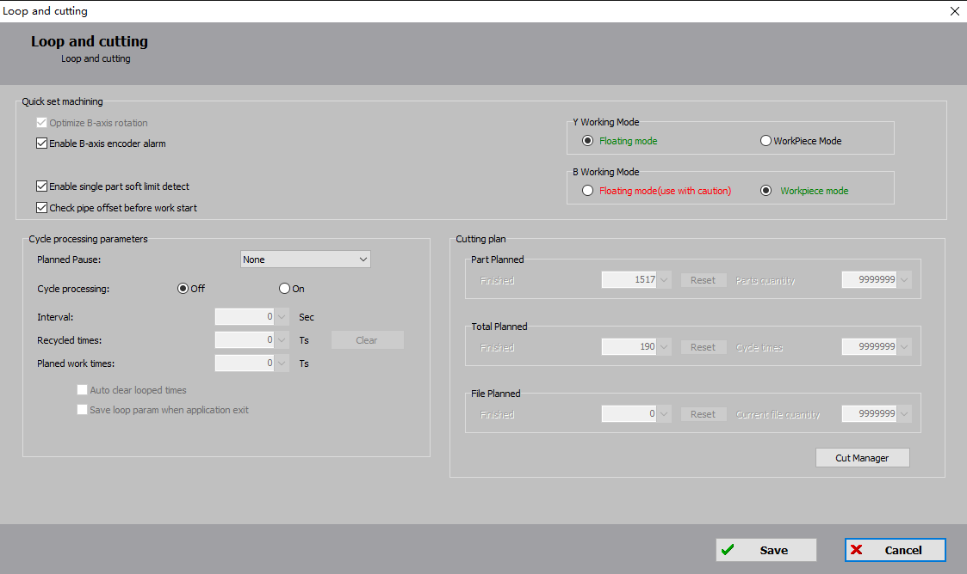

|  |  |
| --- | --- |
| **Parameter Name** | **Description** |
| Start | Start machining * - The graphic parameters have been modified; A - Automatic loading/unloading is on;  F - Auto feeding is on; L - Loop machining is on; S - 7-axis pulling is on. |
| Pause | The system command is suspended; <Pause> button will be changed to <Fast Resume> and the piercing action is not performed when processing is continued. |
| Resume | Continue executing system commands. If the graphic parameters have been set for piercing, the piercing action will be performed. |
| Stop | Stop the current system command |
| Proofing Mode | It is for non-continuous pipe machining. After completing the machining, the machine will stop at the end point without returning to the zero point or executing the File End PLC. |
| btnGlobalParams | For loop machining and machining settings, refer to 3.7.8. |

3.3 File

3.3.1 About

Click <File> → <About> in the upper left corner of the interface to open the About window. You can view the program's version number, release date, control card type, follower type, laser model and license expiration, etc.

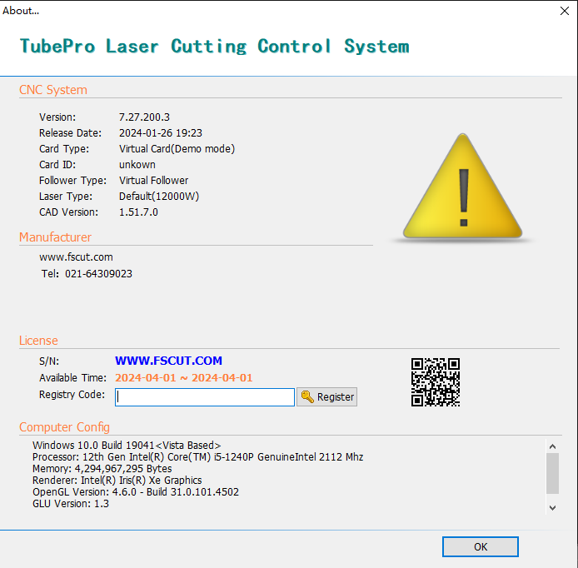

3.3.2 Parameter Backup

TubePro provides parametric backup and restore functions. Go to <File> → <Parameter Backup> to generates backup files *.cfgpkg files with file icons.

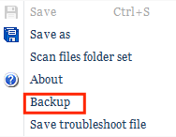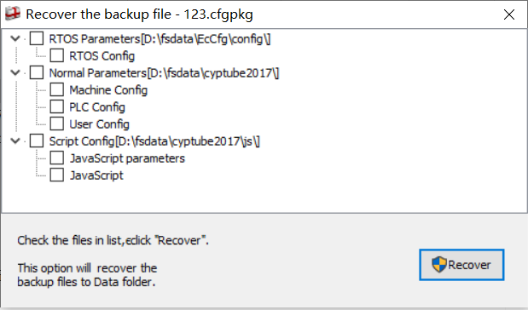

Double-click on the backup file, the Restore Parameters Backup Files dialog box will pop up, then select the list of files that need to be restored. Click Restore, then the recovery is complete.

3.4 Machine Calibration and Return Origin

3.4.1 Return Origin

The Return Origin drop-down menu contains All ReturnOrigin, Z-axis (follower) Return Origin, X-axis Return Origin, Y-axis Return Origin, B-axis Return Origin, All Holders Return Origin, Return Origin Setting, and Force Ignore Return Origin warning button.

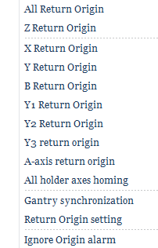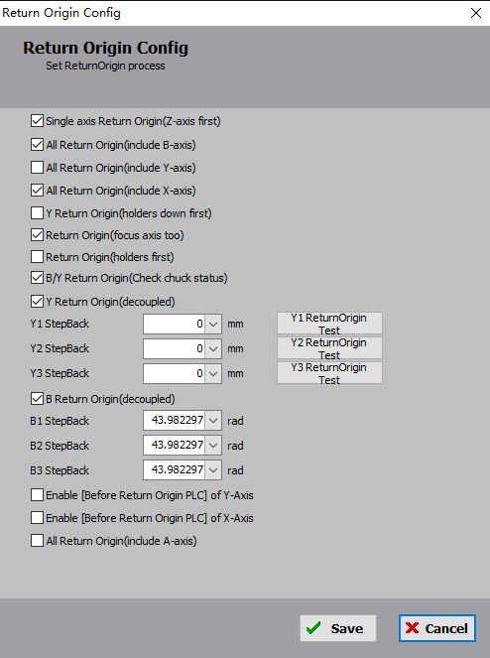

The Return Origin setting can be set for different models.

You can specify the Y1/Y2/B1/B2/B3 independent return to the origin in the Return Origin drop-down. After one of the B axes is returned to the origin, you need to go to <Manual Debug> and select the Y2-B3 mode and perform a ReturnMid before machining.

If <Forced Return Origin Alarm> is checked in the Advanced Config in the Machine Config Tool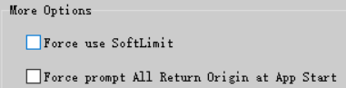, there is a Return Origin alarm when the software starts and you must return to the origin. Then the alarm can be dismissed. In the administrator mode, you can shield this alarm by clicking <Force Ignore Return Origin Alarm> and continue debugging even if the origin is not returned. Personal safety and equipment safety should be prioritized.

|  |  |
| --- | --- |
| **Parameter Name** | **Description** |
| Z axis first before single axis return origin | For safe cutting heads, tick this to let the Z axis (follower) return to the origin before the X/Y/A/B axis is returned to the origin |
| All Return Origin(include B axis) | Not ticked by default. This cannot be ticked for models without B-axis origin switch. It is not recommended to select this option for machine models with dual-driven B-axis that have independent return origin. This is to prevent accidentally selecting both the B-axis release synchronization and independent return origin options, which could result in twisting the pipe if the pipe is not removed before returning to the origin. |
| All Return Origin(include Y axis) | Not ticked by default. Tick this option if you want the Y-axis to return to the origin simultaneously when you perform All Return Origin. It is recommended not to tick it. It is to avoid All Return Origin after the tube is clamped, which might cause the tube to come out of the middle chuck to drop or fall by gravity. |
| Y Return Origin(holders down first) | Ticked by default. For safety reasons, it is recommended to have the holder in the down position during the Y-axis Return Origin process to prevent any collision with the holder. |
| After the software is launched, the focus axis should return to its origin before the first homing operation. | When this option is selected, the software will ensure that the focus axis returns to its origin before the first homing operation, thus ensuring the correct focus. |
| When the software is started, all support axes return to the origin before the first time they return to the origin. | To prevent coordinate errors, selecting this option ensures that all holder axes return to their origins before the first complete homing operation, thus preventing collisions between the chuck and the holder. |
| B/Y Return Origin(Check chuck state) | When checked, B/Y independent return origin is not allowed if both the main chuck and the middle chuck are clamped, this is to prevent the independent return origin of the chuck from pulling or twisting the clamped pipe during the main operation. |
| Y Return Origin(separately) | Tick this option for FSCUT5000A systems where the Y1 and Y2 axes require independent return origin. Y1 and Y2 axes need to have their respective origin switches or origin limit switches set. |
| Y2 Stepback | The FSCUT5000A system uses an independent return origin of the Y-axis after it is unsynchronized, which sets the respective stepback distance of the two Y-axes. |
| B Unsync and Return Origin(separately) | For a 2-chuck pipe cutting machine with origin switches set for both B1 and B2 axes, if the two chucks on the B-axis are not synchronized, you can resolve the issue by having B1 and B2 independently release synchronization and return to their origins. Each chuck should then move back by the preset distance, ensuring that both chucks are aligned at the same angle.  If this option is ticked, please ensure that the chucks do not clamp any pipes before returning to the origin. This is because the B-axis will perform independent homing and move back by their respective preset distances. Throughout this process, the angles of the chucks on the B-axis will be inconsistent. Clamping pipes during this process may result in pipe twisting or other serious consequences. |
| B1/B2/B3 Stepback | By utilizing the independent homing of the B-axis and setting appropriate stepback distances for B1, B2, and B3, it is possible to ensure that after homing, all chucks are precisely aligned horizontally or at the same angle. |
| Enable [Before Return Origin PLC] of Y-Axis | If the default option is ticked, the Y-axis will execute the "Before return origin PLC" and "After return origin PLC" during the homing process in the automation. |
| Enable [Before Return Origin PLC] of X-Axis | If the default option is ticked, the X-axis will execute the "Before return origin PLC" and "After return origin PLC" during the homing process in the automation. |
| All Return Origin(include A axis) | Not ticked by default. Tick this option if you want the A-axis to return to the origin simultaneously when you perform All Return Origin. |

3.4.2 Follower

The FSCUT5000A uses the BCS100E bus follower which requires the nozzle to be jog about 2mm above the tube surface before calibration. Then click <Capacitance Calibration> and wait for calibration to be done.

The calibration results indicate excellent smoothness and stability, confirming a successful calibration.

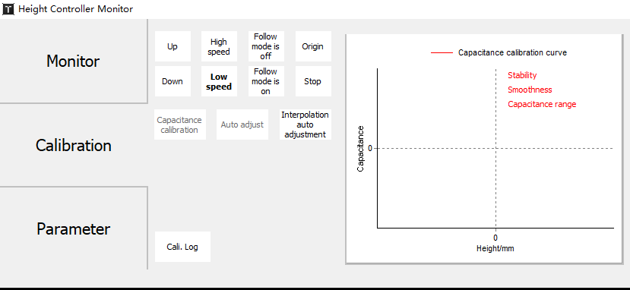

3.4.3 Calibrate B-axis Center

When the mechanical structure is fixed, the B-axis rotation has a fixed center of rotation, which is determined in the XZ plane (X, Z). To measure the center of the B-axis, you will need to use a standard rectangular pipe without any fillets. Before calibration, ensure that the system's X, Z, A, and B axes have already returned to their origins. Then, move the cutting head nozzle above the standard pipe and input the width and height of the standard pipe. Finally, click on "Start Calibration" to initiate the calibration process. Once the calibration is complete, click on "Save" to exit.

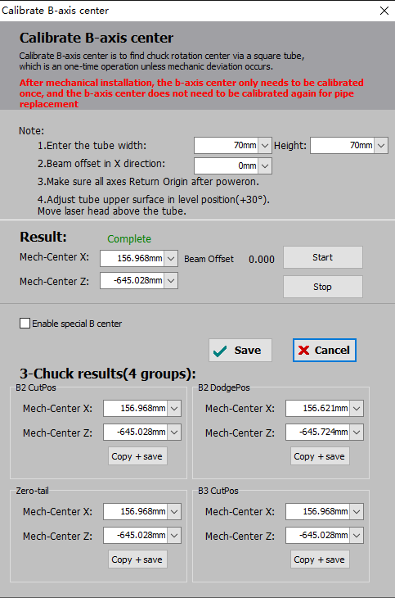

|  |  |
| --- | --- |
| **Parameter Name** | **Description** |
| Rect-Pipe size | Set the width and height of the standard rectangular tube. It is recommended to use a standard rectangular tube without fillets. |
| Beam offset | Set the spot offset error for the cutting head of the machine.  Scenario: TubePro measures the center of the B axis based on the nozzle center. If there is a certain deviation in the piercing because the laser spot is not in the nozzle center, divide the deviation by 2 and fill it in the spot offset. |
| Calibration result | Display the coordinates of the mechanical rotation center |
| Enable special B-axis center | If the machine tool has a unique structure where there are variations in the mechanical rotation center during cutting (such as in a 7-axis feeding structure or a middle-chuck avoidance structure), it is possible to pre-calibrate a specific center for the B-axis. In normal cutting operations, the B-axis center mentioned earlier is still used. However, when there are variations in the mechanical rotation center, you can enable the special B-axis center through the PLC to enhance cutting precision.  The <Copy+Save> button copies the values from the center of the B axis |
| Save/Cancel | Clicking "Save" will record the measurement result as the center of the B-axis, while clicking "Cancel" will not save the result. |
| 7-axis mode test results | The center of the B-axis is determined based on four different positions in the 7 axes, and automatically switches the center of the B-axis after switching positions. |

3.5 Function Debug

3.5.1 Manual Debug

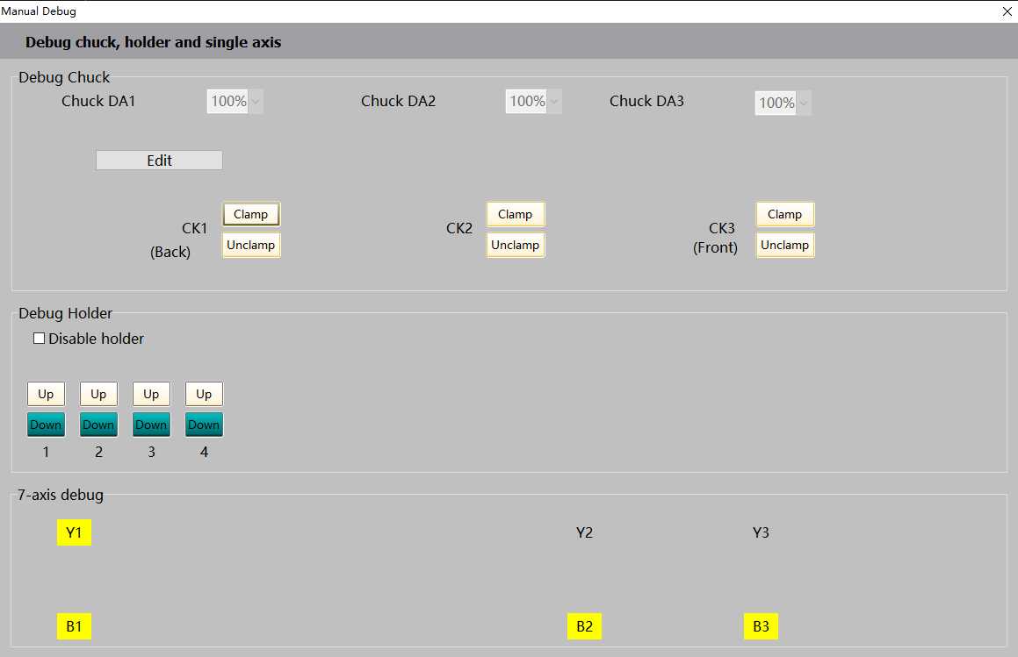

The manual debugging interface is shown in the diagram.

3.5.1.1 Chuck Debug

Manually test the chuck clamping/release action and before that, it is advisable to measure the time required for the chuck to open and close using a stopwatch. Then, you can configure this time as the"Default In-Place Time” for clamp and unclamp in the Machine Config Tool(CypConfig). Test that the in-place time is set properly after the configuration is complete.

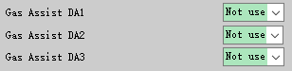There are several chucks configured in the Machine Config Tool, and the manual debug interface will display the corresponding chucks, and those that are not configured will not.

The chuck pressure ratio corresponds to the chuck pressure assist DA in the Machine Config Tool and can be configured to adjust the clamping air pressure.

Click <Unclamp> and <Clamp> on the chuck to release or clamp the corresponding chuck, wait until it is in place for a default time and the button turns green which represents the current chuck status.

The button of the chuck logic is reversed. For the main chuck and the tail card, single IO - [main/tail chuck clamp], [main/tail chuck inside clamp]. Dual IO - [main/tail chuck up-down clamp, left-right inside clamp], [main/tail card chuck up-down inside clamp, left-right clamp], which is easy to adjust the chuck logic.

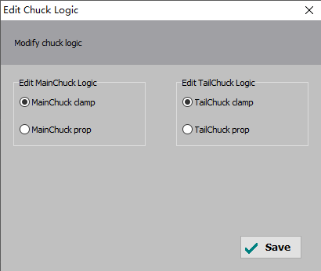

3.5.1.2 Holder Debug

Before debugging the holder, the down position parameter for each holder needs to be configured in the Machine Configuration Tool(CypConfig). Only the holder with the Y-axis down position parameter greater than the current actual Y-coordinate value is considered a Safety Holder. You can manually ascend and descend it on the manual debugging page.

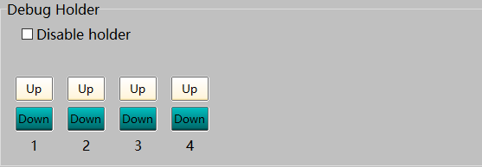

If the gas general valve of the holder is configured in the Machine Config Tool, the <Disable holder> is ON by default and needs to be manually turned off for holder debugging.

3.5.1.3 Single Axis Tuning

This function can be used tomeasure the B1chuckand B2chuck’sstepback distance when they return to their respective origin. During initial installation, B1 and B2 stepback distances in TubePro are equal, while that of the actual chuck is not synchronized. At this point, check <B Return Origin(separately)> in <Return Origin Setting>and set the stepback distance for B1/B2 to 0 to perform B-axis return origin. Then unlock B1 and B2 in <single axis debug>, adjust B1 and B2 to horizontal by jog or step, then lock it. Open <Tools> → <Monitoring Tools> → <Motion Control Monitoring> → <B-axis> to view the mechanical coordinates of B1 and B2, and save the coordinate values as the stepback distance of the origin of B1/B2, respectively. The B-axis is then unsynchronized and independently returned to the origin, which ensures that both B1 and B2 are horizontal after the return to the origin.

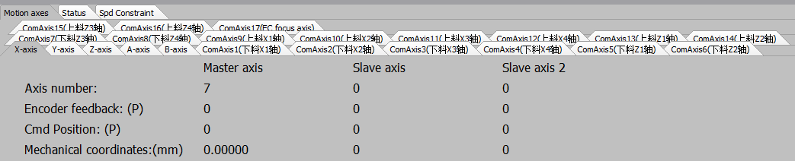

3.5.2 Follow-up Holder

The 5000A system, if the follow-up holder is configured, the holder icon appears in the function debug area.

For the follow-up holder between the main chuck and the middle chuck, click <follow-up holder> to access the debug page; for the follow-up holder that is after the middle chuck, click <assist unload holder> in the drop-down menu to debug.

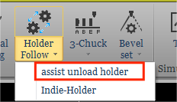

First, go to the Machine Configuration Tool(CypConfig) and configure the follow-up holder there. You can increase or decrease the number of holders by using the Add, Delete buttons. The number of holders is up to 20 and no less than 7. The holder types are single IO, follow-up, and cylinder follow-up. Users can set the parameters according to the actual needs.

**Required Parameters**

1. Based on the actual mechanical structure of the follow-up holder, whether it has a cylinder or not, choose the holder type.

2. Select the common axis used by the follow-up motor of the holder. Configure the basic parameters and return origin parameters of the motor on the common axis page.The basic parameters of the motor, the return origin parameters are configured on the CommAxis page.

3. For a cylinder-driven holder, you need to configure the parameters for the up and down movements. If the same output port is used for both the up and down actions (i.e., opening and closing), you only need to configure the output port for the up action, and set the output port for the down action to 0. The default time for the holder to go up or down should be filled in according to the actual situation. After opening the output port, the system will consider the holder to be in the correct position after the default waiting time.

4. Configure the parameters for the Y-axis down parameter. When the main chuck reaches the Y-axis down position, the corresponding holder will begin to descend. If the main chuck moves to the Y limit and the holder has not yet been lowered into position, a holder alarm is generated and the chuck movement is stopped.

Note: Each holder that is used must be configured separately with the above parameters.

**Optional Parameters**

1. If the <Gas General Valve Outport> is configured, an outport <General Valve> appears in the custom output area of the software, and the outport is open for manual debugging without checking <Disable holder>. You can manually enable and disable it.

2. If the "Allow auto up" option is ticked, the safety holder will automatically ascend when the Y1 coordinate is smaller than the up position (if the up input port is configured, it must also be valid). For the follow-up holder the up output port is open when it reaches the docking position.

3. If <Allow speed limit for down zone> is checked, the main chuck moves at a speed of between the Y down position and the Y limit position图片3. This speed limit is only valid for the travel process, not for jog or machining. It is used to reduce the travel time between the Y descent position and the Y limit position, thereby improving the utilization of the holder.

4. If the mechanical structure has a limit switch configured with the holder to go up and down, you can configure the in-place input port instead of the default in-place time.

5. If the mechanical structure has a limit switch before configuring the holder, the alarm input can be configured. When the alarm input is active and the holder is not descended into the right position, a holder alarm is generated and the chuck stops moving. Both the alarm input and the limit position are intended to prevent the chuck from colliding with the holder. The former serves like the hard limit protection and the later the soft limit protection.

6. If the holder is a dual-IO control, i.e. Up and down actions are controlled by different outports, you can tick <Close outport upon in-place>, so the output port will be closed after the holder ascends or descends to the right position.

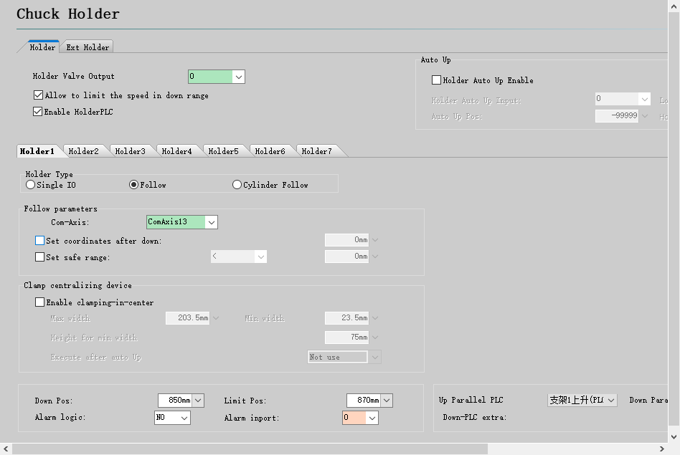

When the configuration is complete, open the software. Click <Holder Follow>to perform a teach-in of the follow-up holder (calibrate with the rectangular tube once and then the holder can follow according to the drawing).

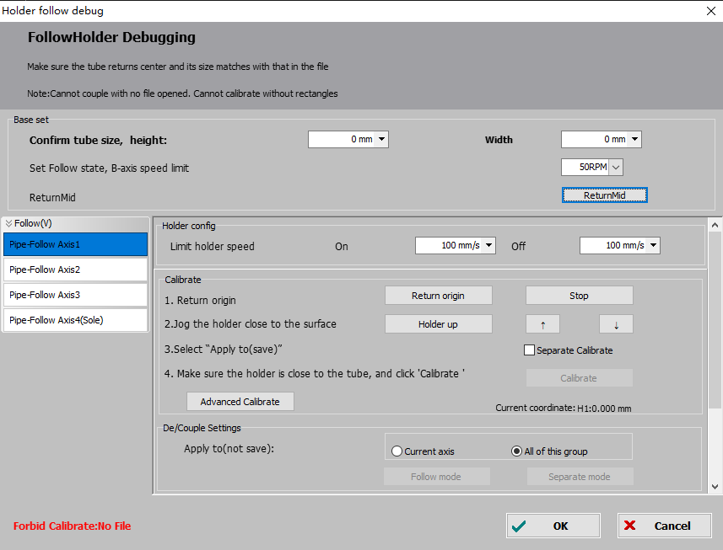

Before stepping back the main chuck down to the down distance of the holder 1, clamp the rectangular tube, click the ReturnMid button and do a single-sided leveling again. Then click the Holder Up, and Jog to make the holder align with the tube surface. Click the "Calibrate" button to complete the calibration.

|  |  |
| --- | --- |
| **Parameter Name** | **Description** |
| The dimensions of the pipe to be cut | Please use a rectangular tube to calibrate. After the drawing is imported, TubePro can automatically acquires the dimensions of the tube. |
| B max speed | When the follow-up mode is enabled, limit the maximum speed of B-axis to prevent the holder from failing to keep up with the up/down speed during B-axis rotation, which could result in the pipe colliding with the holder. |
| Coupled Motion | In the corresponding follow-up mode, the holder will adjust its height according to the rotation of the pipe. |
| Decouple Holder | Disable the follow-up mode for the holder. The holder will return to its docking position and will not adjust its height based on the rotation of the pipe. |

1. Loading Holder Debug

Click the Holder Follow button to open the Loading Holder Debug window. Before debugging, confirm the tube size, then ReturnMid. TubePro allows configuring different types of follow-up holders, both vertical and horizontal, with options for pure follow-up holders and cylinder follow-up holders. These configurations will be grouped on the left side of the interface.

Within the same group, you can set individual calibration heights for each follow-up axis. By selecting the "Independent Calibration" option and clicking on "Calibrate," the corresponding axis will be marked with "(Ind)" to indicate its distinct calibration. Click on "Advanced Calibration Settings" to set different follow-up mode for each follow-up axis in the same group. The follow-up modes are linear, nonlinear, Round tube V-slot fitting, which can coexist in the same group. Check "Dodge downwards when follow holder travels" to set a different down avoidance distance for each follow-up axis in the same category.

You can set de/coupling for a single follow-up axis, and the simultaneous de/coupling of all the follow-up axes in the same group, with "All of this group" selected by default.

1. Unloading Holder Debug

In the unloading holder debugging interface, different types of unloading holders are grouped into vertical and horizontal. To enable the collision avoidance feature for the unloading holder, it is necessary to configure the "Common Unloader" so that the unloading follow-up axis corresponds to the general unloading device.

You can set de/coupling for a single follow-up axis, and the simultaneous de/coupling of all the follow-up axes in the same group, with "current axis" selected by default.

The unloading follow-up holder does not support independent calibration, the corresponding option is grayed out.

1. Advanced Calibration Settings

|  |  |
| --- | --- |
| **Param Name** | **Description** |
| Dodge downwards when follow-up holder travels | If the tube is rectangular/L/C/H steel, and the B-axis rotation angle is more than 45 degrees, the holder will dodge for a longer distance downwards, which can also be set by itself. |
| B-axis wait for dodge | The user can set "B-axis wait for dodge" according to the actual situation. This helps to prevent situations where the B-axis starts moving prematurely before the holder has completed its dodge movement, resulting in the B-axis waiting for dodge shorter than the actual dodge time. |
| Wait time after reset | After the follow-up holder returns to its follow-up state from the dodge position, it is necessary to ensure that it must "Wait after reset" before the height controller can follow. This is to avoid the shaking of the pipe head caused by returning to the follow-up state. |

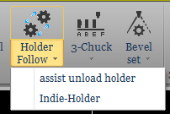If the follow-up holder (i.e. the picking holder) is also configured, the picking method is configured on the Part-Pick setting page in the Platform Configuration Tool and the 7-axis Y2 pick security setting is also required.

Once configured, a calibration is also required, as mentioned above. In the drop-down menu of <Holder Follow>, click <assist unload holder> to open the Calibration page.

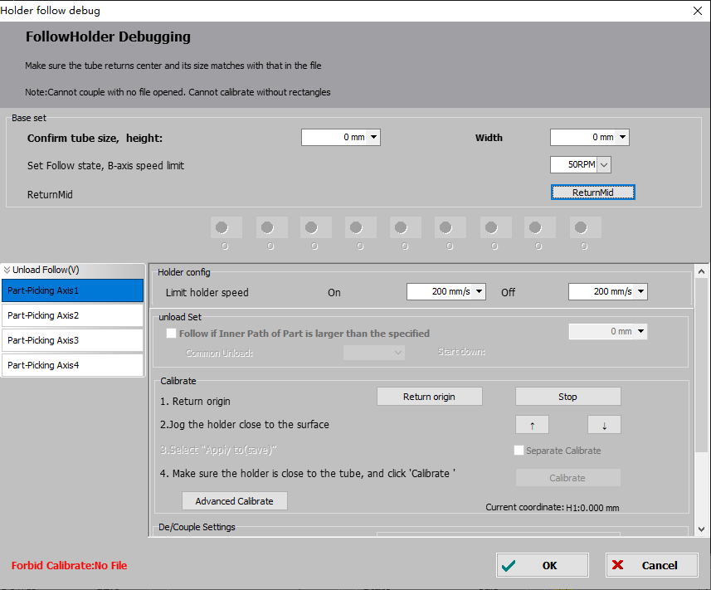

3.6 Monitoring Tools

3.6.1 Follower Monitoring

The monitoring page displays real-time capacitance, capacitance curves, and capacitance temperature drift of the height controller.

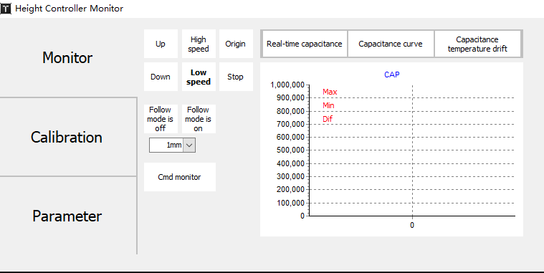

In the calibration page, you can perform capacitance calibration, adjust rigidity level, and check the historical records of capacitance calibration.

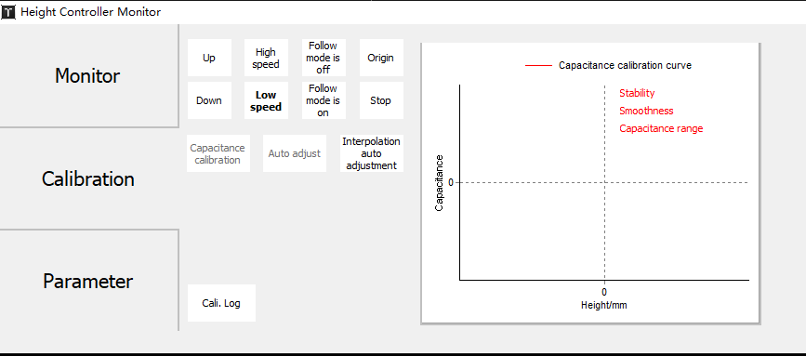

The parameter page is used to adjust the parameters of the height controller. After clicking on "Unlock Parameter", you can modify the parameters. After modification, you must click on "Write Parameters" to save and apply the modified parameters.

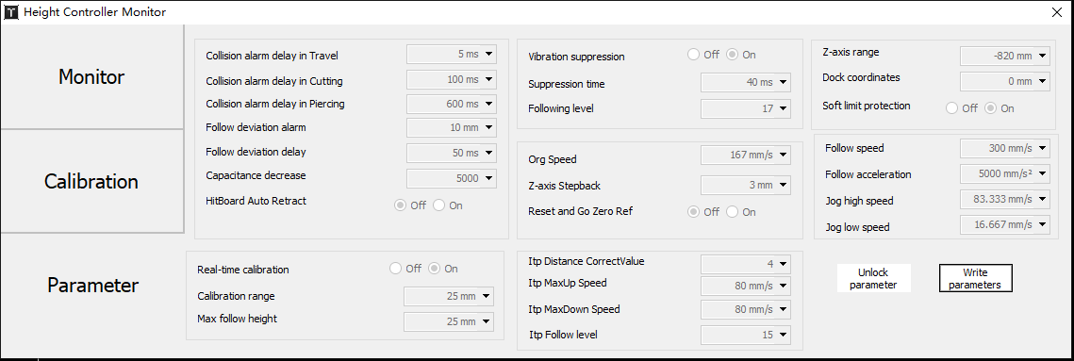

|  |  |
| --- | --- |
| **Parameter Name** | **Description** |
| Travel/Cut/Pierce hit-plate alarm delay | When the system is stopped or in the Travel/Cut/Pierce state, the Z-axis automatically lifts up and outputs an alarm signal if the hit-plate state lasts for this value. When this value is set to 0, the hit-plate alarm will no longer be triggered in the Stop or Travel/Cut/Pierce state. |
| Follow Deviation Alarm | Follower max deviation allowed. When the cutting head follows into position, the Follow Deviation Alarm alarm occurs when the Follow Error exceeds the set alarm value due to movement beyond the sheet boundary or due to the sheet shaking. |
| Follow Deviation Delay | Set the filter time to the follow error alarm. The bigger the value, the longer the tracking error is allowed and the greater the ability to filter out interference. |
| Capacitance diminished | When the capacitance of the main body decreases beyond the set value, a warning for decreased capacitance of the main body will be generated. |
| Vib suppress | This function reduces the vibration caused by cutting a sheet with a rigid structure that is disturbed by the flow of air, thus reducing the ripple of the cross-section. It can effectively suppress jitters caused by air blowing, etc. |
| Suppression filter | This parameter represents the strength of the vibration suppression function. The larger the value, the more pronounced the effect of vibration suppression, but it will decrease the responsiveness of the follower. The default value is 20ms, and the recommended range is 5~50ms. |
| Follow Level | The follow gain level is 1 to 30, and the default level is 17. The larger the level, the smaller the average tracking error, the faster the tracking action, and the stronger the ability to climb slopes. However, if the gain is too strong, the system generates a self-shock oscillation. This parameter is obtained by automatic adjustment. |
| Reset speed | Return speed |
| Z Stepback Dis. | Step back the Origin switch, and set that position as the origin for the Z-axis. |
| Reset and Go ZeroRef | After returning to the origin, return to a Zero Reference position. |
| Z axis stroke | Z axis stroke(downward means negative) |
| Zero ref | Zero reference of Z-axis |
| Enabled soft limit | Set the soft limit protection for the follower |
| Travel Speed | Travel speed of the follower |
| Travel Acceleration | Travel acceleration of the follower |
| Jog high speed | Set the high speed for jogging |
| Jog low speed | Set the low speed for jogging |

3.6.2 Motion Control Monitoring

Click on Tools - Monitor Tools - Motion Control Monitor above the software interface and the pop-up window will appear as shown in the following figure.

On the Motion Axis monitoring page, you can view the enable status, alarm status, hard limit status for each servo axis, soft limit state, origin switch state, pitch compensation state, command position of physical axis, feedback position, mechanical coordinates and speed of movement, and also send servo enable, close enable command, send pulse debugging, clear coordinates, and clear dual drive alarms.

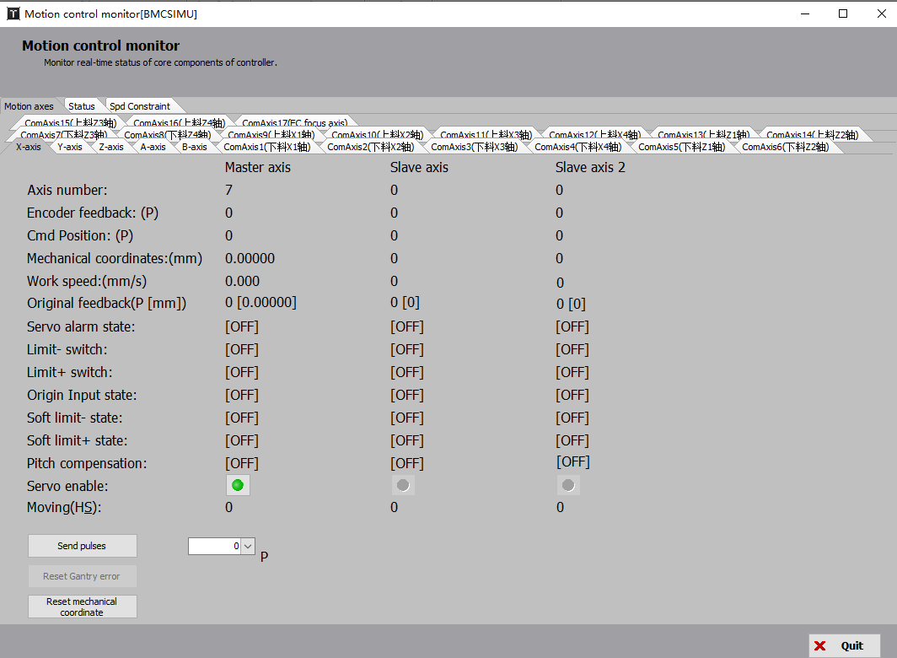

|  |  |
| --- | --- |
| **Parameter Name** | **Description** |
| Axis No. | Physical axis |
| Encoder feedback(P) | The encoder feedback value of the servo in pulses. |
| Command Position | Command position in pulses. |
| Machine Coordinates | Mechanical coordinates, the system command coordinate position, in mm or rad |
| Motion Speed | Real-time feedback speed of the current servo |
| Servo raw feedback | The encoder feedback position of the servo in pulses. |
| Servo alarm | Alarm state of the current servo |
| Pos/Neg limit switch | Current input state of +/- hard limit |
| Origin switch | Current input state of the origin |
| Pos/Neg soft limit | Current input state of +/- soft limit |
| Pitch compensation | Only for X, Y axis. It detects whether pitch compensation is on. |
| Servo enable | Servo enable status. Tap to turn Servo Enable on or off. |
| Send Pulses | In the system stop state, a specified pulse can be sent for testing. |
| Clear Dual-drive error | Clear the dual-drive error |
| Set Machine Coordinate to 0 | Current Z coordinates to 0 |

On the Kernel Status monitoring page, you can view some of the lower-level kernel status information, such as mechanical coordinates, program user coordinates, buffer quantities and G-code instruction information, etc. Due to the complexity of the concepts involved, a detailed explanation will not be provided here.

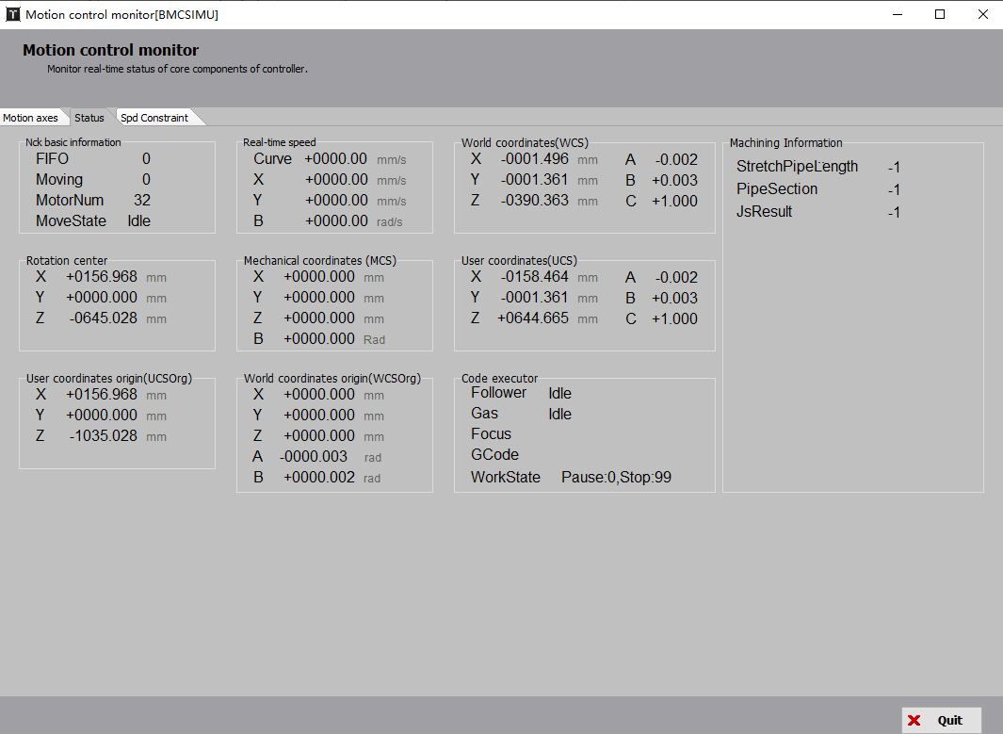

On the Constraint Status page, you can directly view the constraint configuration for each logical axis speed and acceleration.

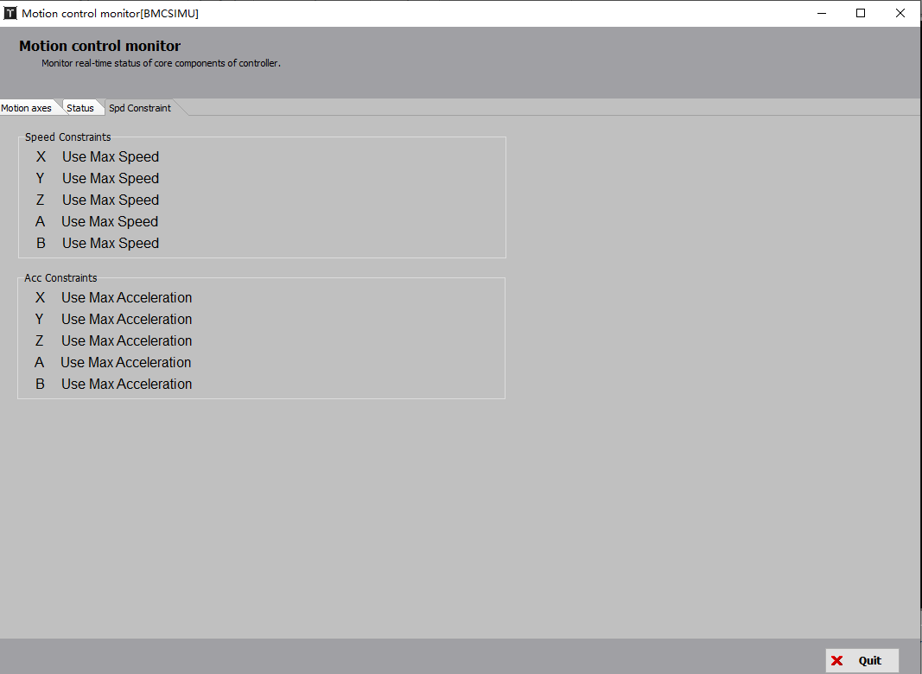

3.6.3 Extend Board Monitoring

Click Tools - Monitoring Tools - Extend Board Monitoring to display the extension board monitoring interface shown below.

Select the extension board serial number to test in the upper left corner to open/close the out ports, monitor the status of the inputs, and complete the simulated input port test. Perform debugging tests on PWM and DA to monitor AD sampling results.

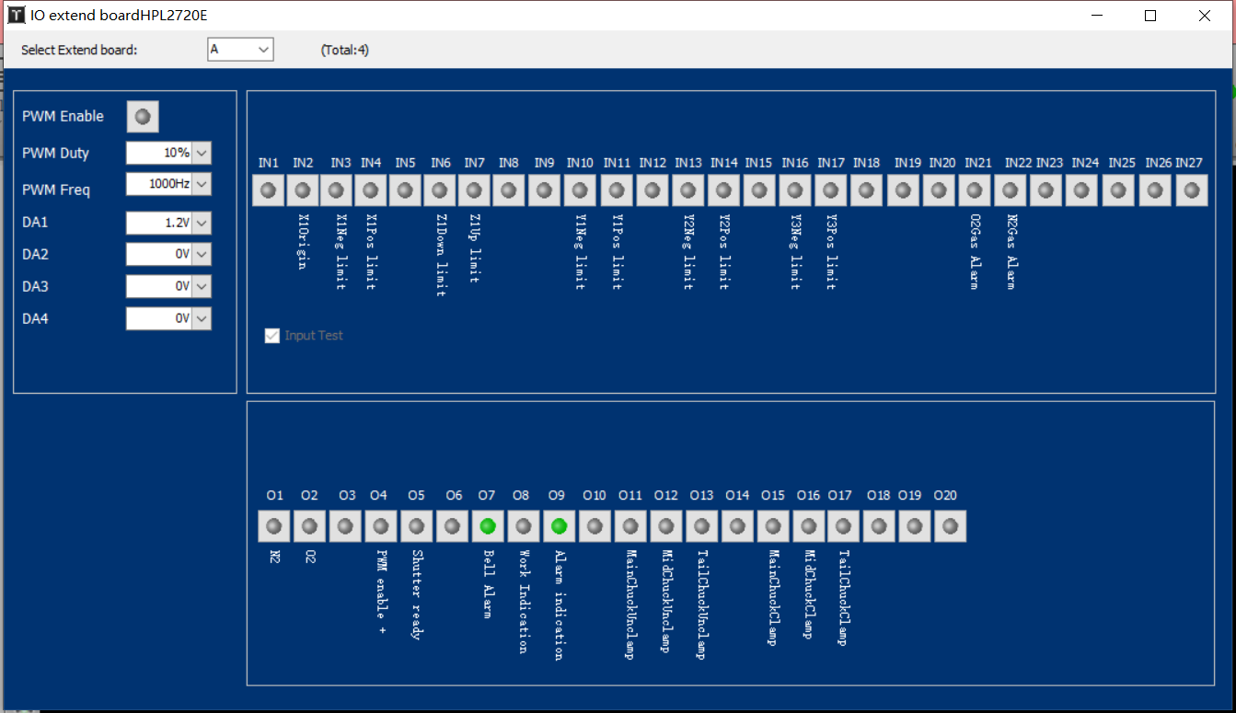

3.6.4 Real-time Curve Monitoring

Click Tools - Monitoring Tools - Real-time Curve Monitoring and the interface is shown below.

Real-time monitoring allows precise sampling of servo axis command position, command speed, feedback position, feedback speed per millisecond in real time. Feedback Torque, Command Deviation, Dual Drive Deviation, Buffer Quantity, Follower Height, etc. Four signals can be selected for monitoring at a time, including all logical and functional axes, and all four servo signals can be plotted at a time. Four signal curves are drawn by default, the signals to be monitored are selected by means of the signal tick option at the bottom, or the specified curves are scaled individually within a range.

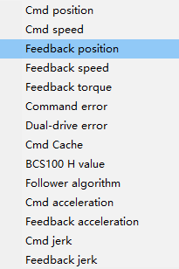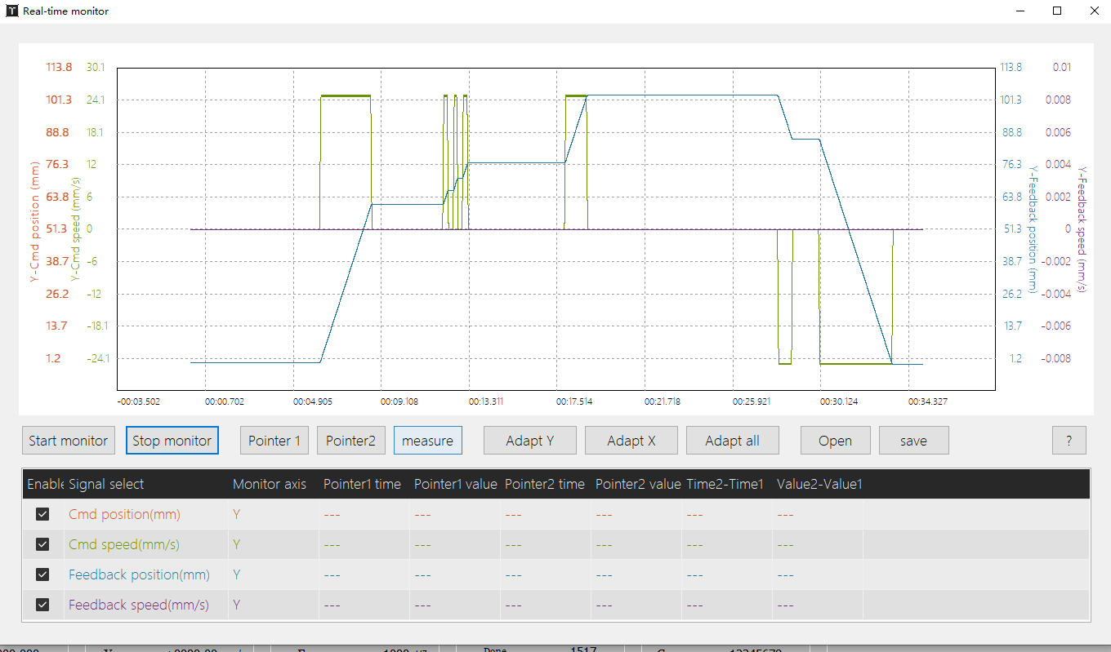

The vertical axis scaling of the curve can be adjusted using the mouse scroll wheel. Holding Ctrl and left-clicking the mouse allows vertical/horizontal movement of the monitoring curve. The options "Fit to Vertical Axis," "Fit to Horizontal Axis," and "Fit to All" can be used to adjust the monitoring range of the curve within the window.

Left-clicking the mouse can select a portion of the monitoring curve for zooming in and easier viewing. Within the curve, two cursor calipers (Pointer 1 and Pointer 2) can be set to capture precise values of the curve at a specific moment.

All monitored curves can be saved as .csv files for data storage. Previously saved .csv files can also be opened for browsing the monitoring curves.

3.6.5 WKB Function Hint

Click Tools - Monitoring Tools - WKB Monitoring and its interface is shown below. The interface displays the configured extended functions, the XY reversed effect.

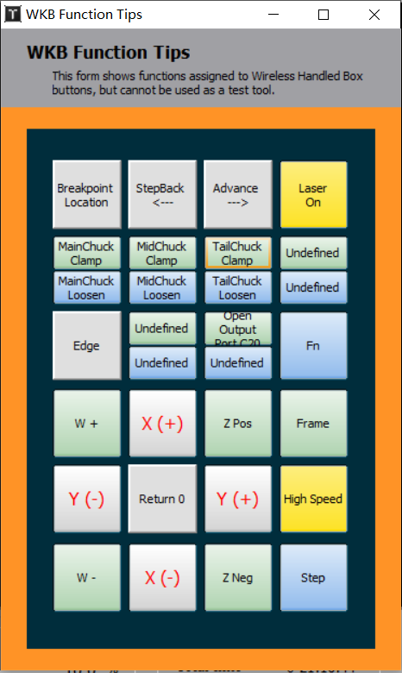

3.7 Assist Functions

3.7.1 Quick CutOff

Click Tools - Monitoring Tools - Quick CutOff and its interface is shown below.

TubePro offers quick cut-off function for common pipe types such as square/rectangular/round/triangular/obround/flat steel, and shape tubes, but not for grooved/angled/sectional non-closed or recessed special tubes.

Quick CutOff function cuts the tube clockwise or counterclockwise at the current position in the Y axis. If AutoCenter is checked, centering at the starting point is performed before cutting.

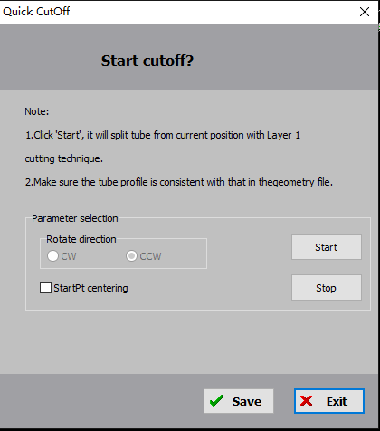

3.7.2 Quick Align Pipe

Click Tools - Monitoring Tools - Quick Align Pipe and its interface is shown below.

This function allows the software to locate the tube head automatically and eventually stop the cutting head at a distance from the tube head.

|  |  |
| --- | --- |
| **Parameter Name** | **Description** |
| Distance For CutHead to MidChuck | It is to avoid the situation where the pipe is not extended beneath the cutting head, causing the follower to miss the pipe. A certain distance of forward feeding is performed before executing the Quick Align Pipe. The parameter is 120mm by default, which can be adjusted according to the actual situation. |
| Y offset distance after alignment | After the cutting head locates the edge of the pipe during outward cutting, the Y-axis will move forward in the positive direction by an offset distance to prevent any jitter caused by the cutting head processing at the edge of the pipe. |
| Follow height | The following height of the cutting head when performing 'Quick Align Pipe'. |

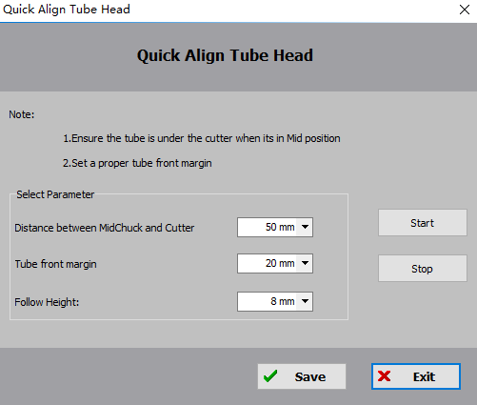

3.7.3 Display Multi-file Cutting

Click Tools - Assist Function - Multi-file Cutting and its interface is shown below. You can use a single input port to control the opening of the corresponding path file, or you can freely combine multiple input ports to open the corresponding path files.

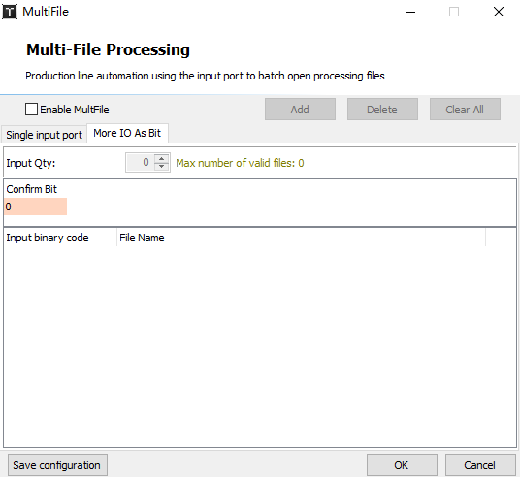

3.7.4 Time Estimates

Click Tools - Assist Function - Time Estimates and its interface is shown below.

By clicking on "Start", the system automatically estimates the time required for a complete processing and shows the total processing time, cutting time, travel time, pierce time, etc.

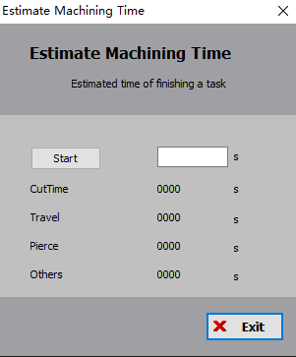

3.7.5 Tube Profile Offset

Click Tools - Assist Function - Pipe Profile Offset and its interface is shown below.

If the pipe to be cut is non-standard, you can apply correction parameters to square pipes, rectangular pipes, as well as angle steel, channel steel, and C-shaped steel by face. These parameters directly affect the modified contours of the pipe surface without affecting the cutoff line.

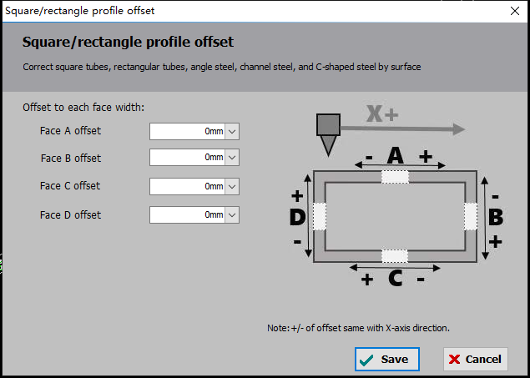

3.7.6 Gas DA Calibration

Click Tools - Assist Function - Gas DA Calibration and its interface is shown below.

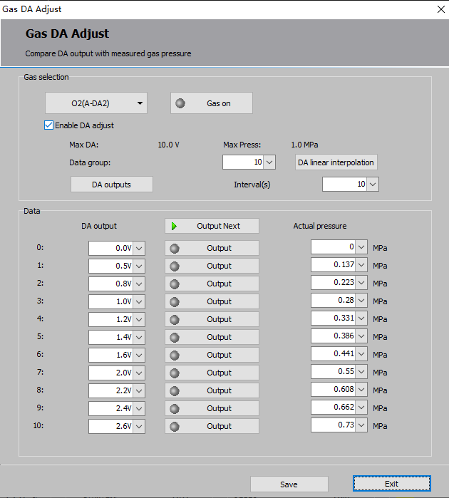

|  |  |
| --- | --- |
| **Parameter Name** | **Description** |
| Select Gas | Select the gas to be DA corrected |
| Data group | Sets the number of linear nodes of the data,the more groups the more accurate the fit. |
| DA auto write | Set the DA distribution value automatically equally spaced by the number of groups. |
| Sequential DA output | Output the DA values in the table in turn |
| Output next | Output the next DA manually |
| DA Output | Set the DA value for the actual air pressure to be acquired, either automatically or manually. |
| Actual pressure | Fill in the table with the actual air pressure corresponding to the DA. |

3.7.7 Quick Save Fault Info

Go to <File> → <Quick Save Fault Information> and you can save a compressed file on the desktop, making it easier to collect and send all information of a machine failure.

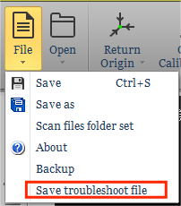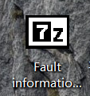

3.7.8 Loop Machining Settings

Click Tools - Assist Function - Loop Machining and its interface is shown below.

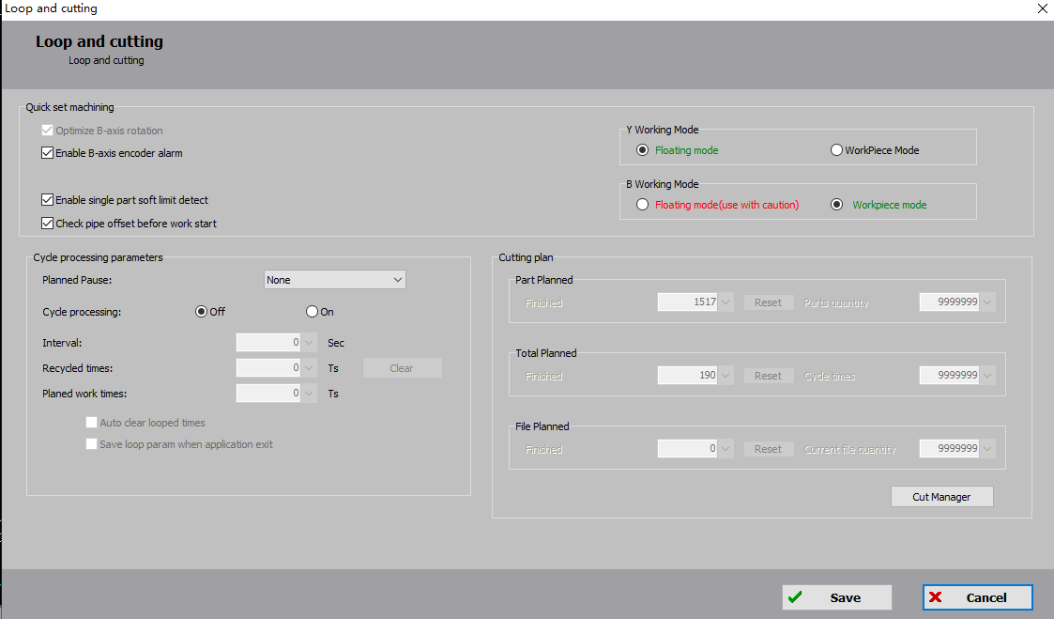

In the "Quick Set Function" module, the machining process can be set up. The corresponding meanings of the parameters are as follows.

|  |  |
| --- | --- |
| **Parameter Name** | **Description** |
| Optimize B-axis rotation | If the B-axis is equipped with an absolute encoder, there may be overflow issues. When this option is selected, the B-axis backlash will move in the opposite direction without affecting the machining process. |
| Enable B-axis encoder alarm | If the B-axis has an absolute encoder, this function is enabled by default. Its purpose is to provide advance warning of encoder overflow before machining, thus preventing alarms during the machining process. |
| Enable single part softlimit detection | If not selected, clicking "Start" will check the entire machining file to determine if any part will exceed the limits during machining. If any part exceeds the limits, the machining cannot be started. If selected, only the next machining part will be checked for potential limit violations. |
| Check pipe offset before machining | When checked and the centering deviation is greater than 5mm, the software goes into a paused state, and the log print, “Pipe centering offset is greater than 5mm. Continue?” |
| Y/B-axis Machining Mode | Floating mode starts machining from the current position, considering the current position as the starting point. Workpiece mode considers the starting position of the current file as the zero point and moves to the machining starting point of that trajectory before machining. It is recommended to use the floating mode for the Y-axis during machining and the workpiece mode for the B-axis during machining. |

In the "Loop Machining Parameters" module, you can set the relevant parameters for loop machining. Cycle demonstration machining can be used to showcase graphics in an exhibition by continuously machining them without activating the laser. It can also be used in conjunction with an automatic loading and unloading PLC system to demonstrate machining of entire pipes.

In this module, the "Planned Pause" dropdown menu allows you to set the pause time during the machining process by selecting options such as "None," "After Current Path," "After Current Part," or "After Current File (Loop)." You can enable or disable the "Loop Machining" mode, set the "Loop Interval Time," and specify the "Planned Loop Count." You can view the current number of cycles performed and reset the data to zero. By selecting the option below, you can automatically reset the loop count or save the set loop machining parameters when exiting the program.

In the "Work Plan" module, you can specify the calculation method for machining: based on the number of parts, based on the number of times the file is processed, or based on the number of times the current drawing is processed. The corresponding meanings of the parameters are as follows.

|  |  |
| --- | --- |
| **Parameter Name** | **Description** |
| Part planned | The number of parts cut can also be calculated by manually cleared, automatically stopping and printing the information after processing to a specified number of parts. 0 means off. Proofing mode also counts, while simulation and DryRun do not count. |
| Total Planned | According to the number of processing times of the file, the number of processing times is increased by one after each file, which can be manually cleared. |
| File Planned | The number of processing times is calculated according to the current drawing file, and the number of processing times is increased by one after each file, which can be manually cleared. |
| Cut/Password Manager | You can use the machining counter to set a password to prevent manual changes to the cut quantity. |

If you import a special drawing (the Nesting Task Package, which contains multiple machined sample files in the work plan), a new module will appear based on the original interface, as shown below.

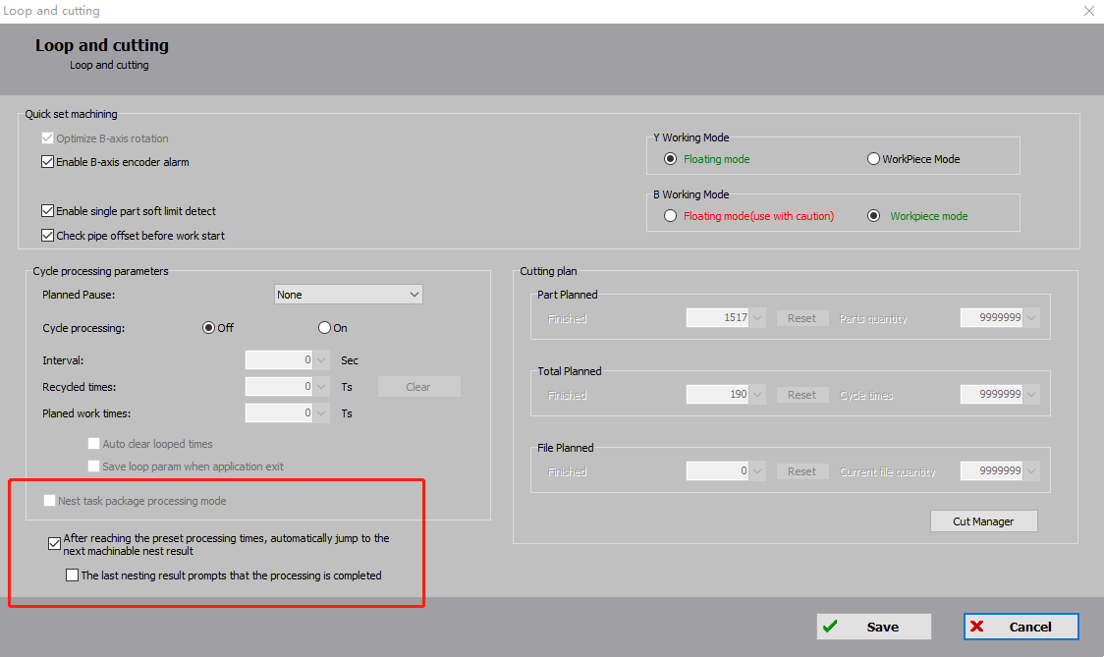

If "Nesting task package mode” is checked, the option "Auto switch to the next nesting result after reaching the preset machining count" will be automatically selected. Users can choose whether to select the option "Prompt processing completion after the last nesting result is done".

3.7.9 Set Current Position as Machine Origin

Set the current position of the cutting head as the origin and all X/Y/A/B coordinates to 0. Please modify it with caution.

**3.8 Centering/FindEdge/Leveling**

The centering can be determined when clamping the tube center is not coincident with the center of rotation (the center of the B-axis), so as to ensure the accuracy of the path during the machining process. Therefore, the tube should be centered before processing, and the software records the deviation between the center of the tube and the center of the B-axis.

TubePro has a set of centering types for different tube types.

|  |  |  |
| --- | --- | --- |
| **Centering Method** | **Tube Type** | **Tube Section** |
| 4-point Centering | For rectangular tube, round tube, and obround tube |  |
| 5-point Centering | For rectangular tube, obround tube |  |
| Ellipse Centering | For ellipse pipes |  |
| Multi-faced centering | For tubes with triangular and polygon sections, of which has more than 2 non-parallel straight edges. |  |
| L-shaped Centering | Standard angle steel with 90° angle |  |
| Angle Steel centering | Angle steel with an angle of 60° ~ 150° |  |
| I-beam Centering | I-beam |  |
| Symmetric arc centering | For symmetric arc |  |
| Single-face Leveling | For tubes with straight edges in cross-sections can be used, such as I-beam, D-shaped beam. |  |
| Manual Centering | For shape tubes that cannot automatically centered |  |
| Advanced Manual Centering |

When the file is imported, the software automatically recognizes the tube type and matches the appropriate auto-center method. If more than one auto-center method is available for a tube, you can select the auto-center method in the Debug Quick Setup (i.e., the key under Auto-Center); if the tube type does not have a matching auto-center method, select Manual Center or Advanced Manual Center mode, as appropriate.

Note: All pipe before the centering should first ensure that the pipe clamping and the drawing angle is consistent. If the angle deviation is large, you should first perform the"single-face leveling" or"set the current position to horizontal", so that the pipe clamping corresponds to that in the drawing angle.

3.8. 1 Single-face Leveling

Click Tools - Centering/FindEdge/Leveling - Single-face Leveling and its interface is shown below.

Single-side leveling can correct one flat surface of the pipe to a horizontal position and align it with the default upward-facing side of the drawing. After clamping the pipe, you can use single-face leveling to align the actual clamping position of the pipe with the corresponding position on the drawing.

If you import a sheet, TubePro automatically acquires the dimension width; if there is no sheet, you need to manually fill in the width of the flat faces to be leveled. Then, move the nozzle directly above the tube, click Start Single-face Leveling, and when the motion is finished, click Save to complete the single-sided leveling.

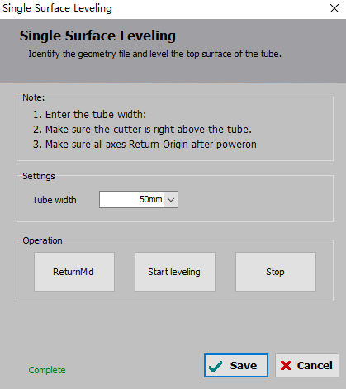

For example, a triangular tube is shown below. If the longest side of the tube is initially clamped at the lower side while the drawing has the longest side facing upward, and they do not match, then machining cannot be performed. In this situation, you need to manually adjust the longest side to be approximately horizontal before performing single-face leveling. This will ensure that the clamping of the tube aligns perfectly with the drawing.

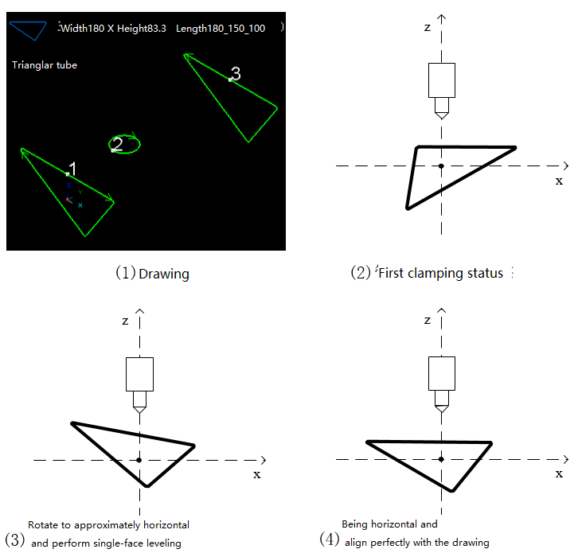

When using single-face leveling, please make sure that all axes have returned to the mechanical origin after powering on, the correct dimensions of the tube are entered, and the cutting head nozzle is positioned directly above the tube (you can use the "X-Axis ReturnMid" button to quickly adjust the position of the cutting head). When you are finished leveling, click Save.

3.8.2 4-point Centering

Click Tools - Centering/FindEdge/Leveling - 4-point Centering its and interface is shown below.

Four-point centering is suitable for rectangular tubes, round tubes, and obround tubes. During centering, the system will follow the four sides of the tube individually, determine the coordinates of the tube surface, and automatically calculate the deviation between the tube center and the mechanical center. This deviation is used for compensation during the cutting process.

To perform four-point centering, follow these steps:  
  
Confirm the dimensions of the tube to be cut.  
Ensure that all axes have returned to the mechanical origin after powering on.  
Verify that the system is centered and leveled.  
Click on "Start" to initiate the centering process.  
After centering is completed, the deviation values in the X and Z directions will be displayed on the interface.

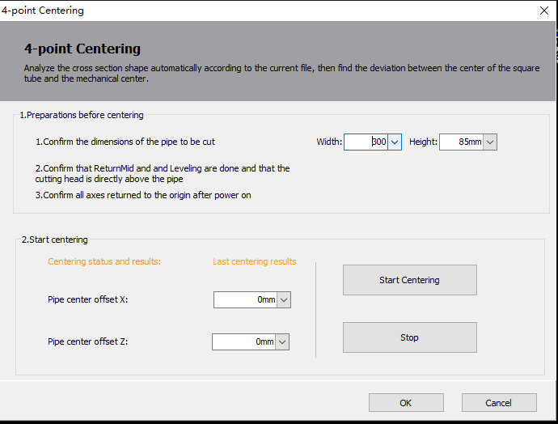

3.8.3 5-point Centering+Leveling

Click Tools - Centering/FindEdge/Leveling - 5-point Centering+Leveling and its interface is shown below.

5-point centering is suitable for rectangular tubes, obround tubes. Unlike "4-point centering", this feature automatically performs leveling, so you do not need to do single-face leveling.

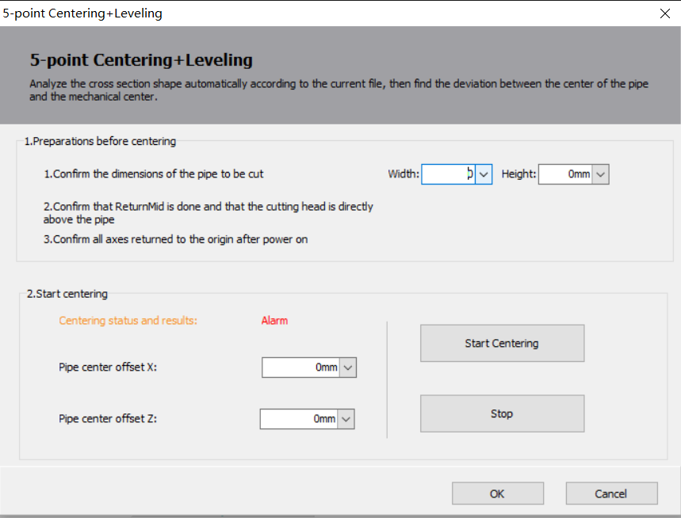

3.8.4 Multi-face Centering

Click Tools - Centering/FindEdge/Leveling - Multi-face Centering and its interface is shown below.

Multi-face centering is suitable for triangular tubes, tubes with polygonal cross-sections, and special-shaped tubes with at least two non-parallel sides. The center of a special-shaped tube is considered the center of its bounding box.

By clicking "Start," TubePro will follow all edges in the section that are equal to or greater than the "min detection width." Once the following process is completed, it returns to the first section and automatically calculates the deviation between the tube center and the mechanical center, displaying the deviation value in the "Centering Result" section. If there is interference with the cutting head during the following process, you need to select "Return Z-axis to ZeroRef during centering" to ensure clearance. Click Tools - Centering/FindEdge/Leveling - Multi-face Centering and its interface is shown below.

The cross section is a polygonal tube with at least two non-parallel sides in the cross section and the center of the tube of the heterotype is the center of the outer circumference.

By clicking "Start," TubePro will follow all edges in the section that are equal to or greater than the "min detection width." Once the following process is completed, it returns to the first section and automatically calculates the deviation between the tube center and the mechanical center, displaying the deviation value in the "Centering Result" section. If there is interference with the cutting head during the following process, you need to select "Return Z-axis to ZeroRef during centering" to ensure clearance.

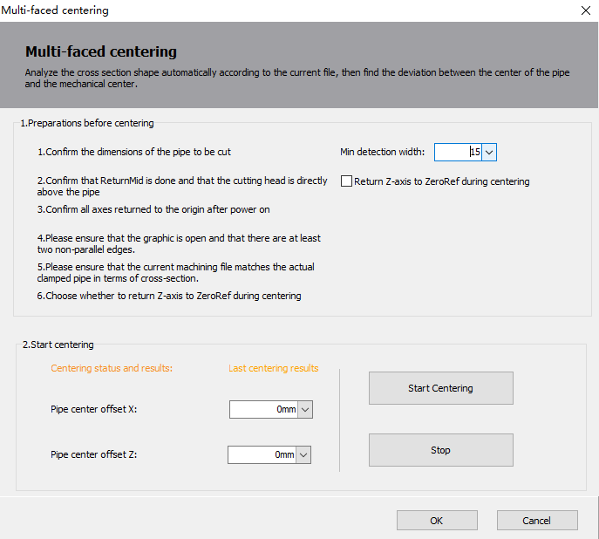

3.8.5 Ellipse Centering

Click Tools - Centering/FindEdge/Leveling - Ellipse Centering and its interface is shown below.

Ellipse centering is suitable for elliptical tubes. Before using ellipse centering, it is necessary to manually adjust the elliptical tube to a state where the major axis is approximately horizontal. Afterward, perform a single-face leveling to align one flat surface of the elliptical tube. Always make sure that all axes return to the mechanical origin after power-up, the dimensions of the tube are filled correctly, and the cutting head nozzle is directly above the tube.

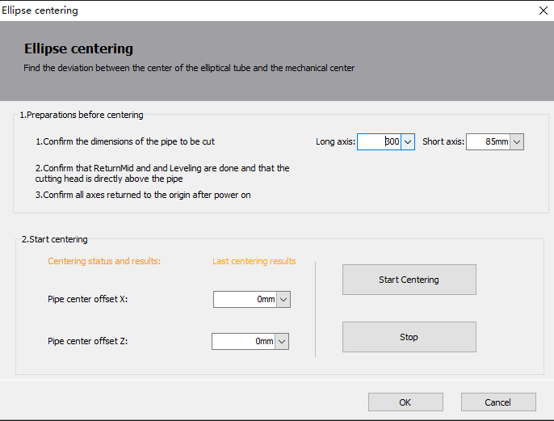

3.8.6 Angle Steel Centering

Click Tools - Centering/FindEdge/Leveling - Angle Steel Centering and its interface is shown below.

Angle steel deviation centering is suitable for angle steel with angles from 60° to 150°.

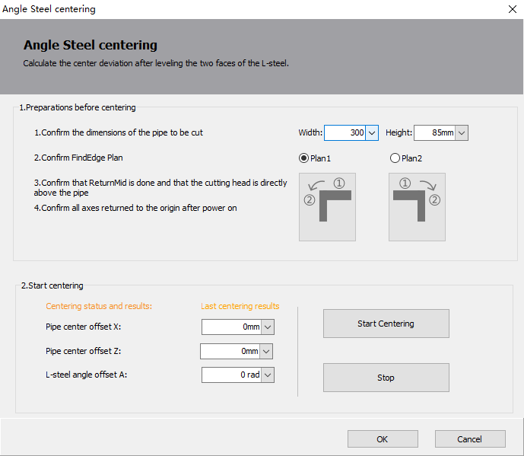

Unlike other centering methods, the centering results in angle steel centering also include "L-steel angle offset A", which can provide a deviation value of 90° from the standard angle between the two faces of angle steel to be cut (Note: The value is a radians value in rad, 1° = 0.01745 rad).

3.8.7 FindEdge Centering

Click Tools - Centering/FindEdge/Leveling - FindEdge Centering and its interface is shown below.

Find Edge Centering is suitable for tubes with two adjacent right-angled edges, i.e. rectangular tubes, square tubes, L/C steel (angle steel, channel steel, C-shaped steel), special pipes(according to the actual pipe shape, choose the appropriate centering method).

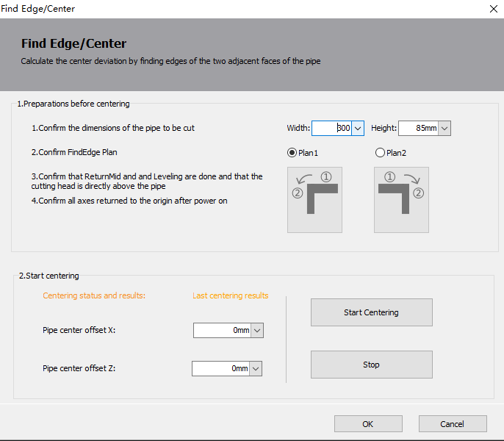

3.8.8 Symmetric Arc Centering

Click Tools - Centering/FindEdge/Leveling - Symmetric Arc Centering and its interface is shown below.

Symmetric arc centering is suitable for tubes with fully curved, non-planar faces and symmetrical about the YOZ plane. During centering, it is necessary to position the widest face upwards. You can manually adjust the tube to a position where the widest face is approximately horizontal. Then, select "Leveling" to perform a leveling action before centering to ensure the horizontal alignment of the widest face. If you are using a fixed fixture that maintains a specific angle between the widest face and the horizontal plane during clamping, you can input the "CW rotation" to rotate the tube to a basic horizontal position before leveling (if selected) and centering take place.

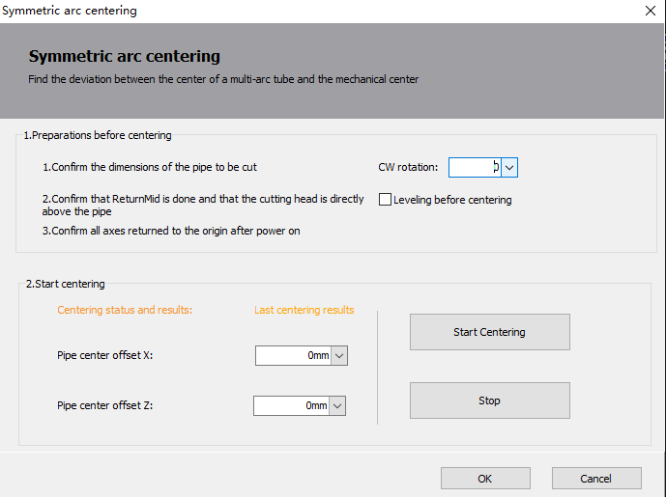

3.8.9 I-beam Centering

Click Tools - Centering/FindEdge/Leveling - I-beam Centering and its interface is shown below.

This method is for I-beam. Make sure the laser head is in ReturnMid position and tube surface is leveled

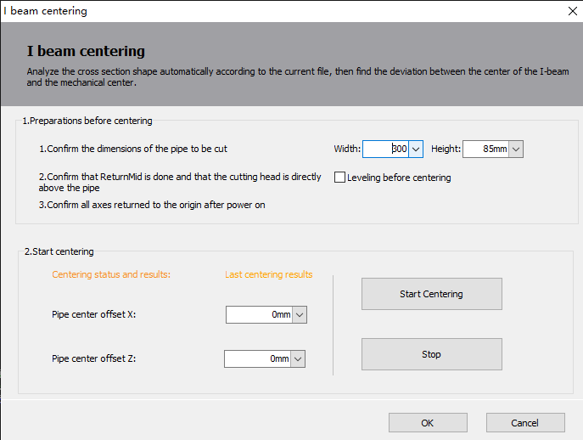

3.8.10 Advanced Centering

Click Tools - Centering/FindEdge/Leveling - Advanced Centering and its interface is shown below.

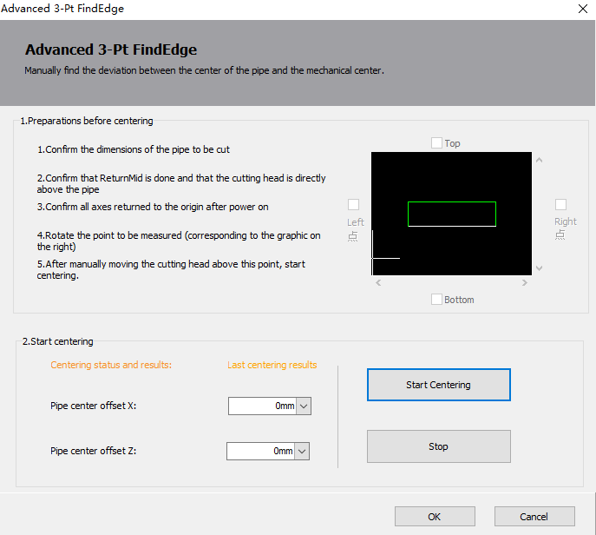

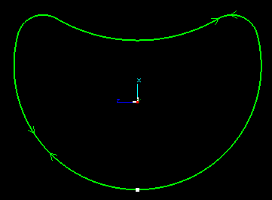Advanced Centering is for shape tubes that cannot automatically centered. In the case of a shaped tube, shown on the right, TubePro finds the highest point on the top, bottom, left and right faces, and selects one of them as the reference point.

For example, if you select Right Point as the reference point, the tube will be rotated until the right-side face is horizontally oriented upward. Jog the cutting head directly above the right point, click Start Centering, and when you are finished, click Save to exit.

3.8.11 Calibrate B-axis and Square Centering

When the mechanical structure is fixed, the B-axis has a fixed center of rotation, and "Calibrate B-axis" determines the coordinates (X, Z) of the center of rotation in the XZ plane. To calibrate the B-axis, you will need to use a standard rectangular tube without fillets. Before calibration, ensure that the system's X, Z, A, and B axes have returned to their respective mechanical origins. Then, position the cutting head directly above the rectangular tube and input the width and height of the tube. Click "Start Centering" to begin the calibration process. Upon completion of the calibration, the coordinates of the B-axis center and the deviation value from the center of the rectangular tube will be displayed in the "Centering Result" section.

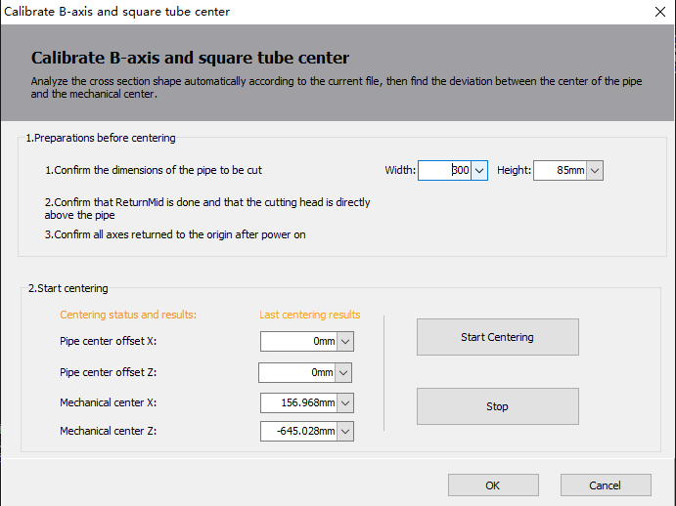

3.8.12 Manual Centering

Some shaped tube cannot be auto-centered and require manual leveling and input of deviations in the X and Z directions. 

Start with single-face leveling so that the tube is clamped in line with the drawing. Some tubes cannot be leveled on one side, then jog the tubes in line with the drawing, then click <Manual Centering> → <Set current position as horizontal>.

Next, move the cutting head to the center of the tube in the X-direction and note down the current X-axis mechanical coordinate. Refer to the measurement results obtained from "<Calibrate B-axis Center>" to calculate the center deviation in the X-direction. Finally, input this deviation into the manual centering results. Center Offset X = Pipe Center X - Mechanical Center X

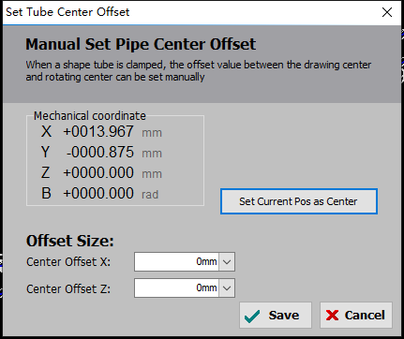

3.8. 13 Centering During Machining

Longer tubes can experience distortion, eccentricity, and deformation due to factors like gravity. As a result, the center of the tube may change after processing a certain distance, affecting the machining accuracy. To address this issue, you can set a centering point on the machining graphic. When reaching that point during the machining process, perform an automatic centering before continuing with the machining.

By setting the centering point and implementing an automatic centering procedure at that stage, you can maintain accuracy and ensure consistent machining results despite any potential changes in the tube's center caused by factors such as distortion or deformation.

If you select a graphic and click on<Centering>btnSeekCenter, the starting point of the graphic will be designated as the centering point. However, if you select multiple graphics and click on the centering option, you can automatically set the centering points by specifying the minimum distance between them within the part. This function allows you to efficiently set centering points for multiple graphics at once, ensuring accurate centering and alignment within the selected parts.

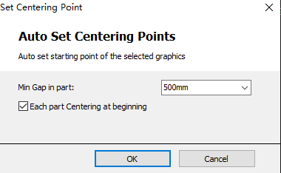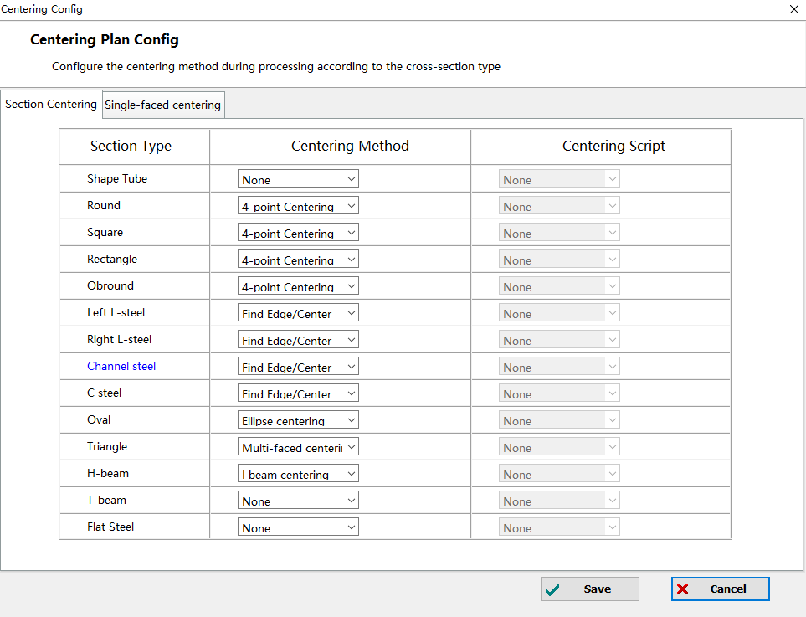

The automatic centering method during machining is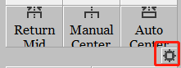selected here.

The "5-point leveling + Quick Centering" method in automatic centering includes an additional leveling step compared to the 4-point centering method. This is to address the potential issue of angular deviation caused by the distortion of long tube surfaces after processing a certain distance. By incorporating the leveling step, the alignment of the tube is corrected, ensuring consistent angles throughout the machining process.

It's worth noting that the calibration of the B-axis and centering results are only supported for rectangular tubes. This allows for simultaneous calibration of the B-axis center and obtaining centering results for the tube, which is beneficial when dealing with machines that have significant mechanical errors. However, if your machine has good precision, it is not necessary to use this method and the standard centering procedures should suffice.

3.8.14 Single-face Centering

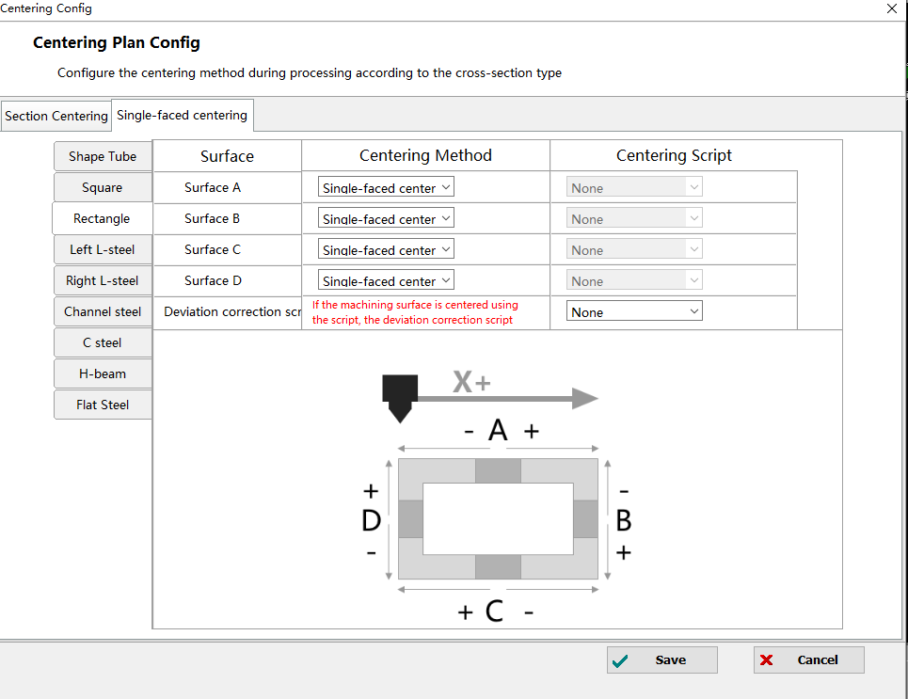

1. Based on the single-faced centering, the centering method can be expanded in the file parameters to include options for centering on each of the faces A, B, C, and D.
2. By default, there are seven single-face centering methods available: single-face centering, left FindEdge, right FindEdge, leveling + single-face centering, leveling + left FindEdge, leveling + right FindEdge, and script centering.
3. For script centering you can write your own centering actions or use external sensors such as probes.
4. By default, for the shaped tubes(non-standard tubes), only the A-face centering method is available.
5. Tubes with a steady error in left/right FindEdge can be compensated with the offset correction script.

**3.9 Cutter**

3.9.1 BLT Cutter Debug

Click Tools - BLT Cutter and its interface is shown below.

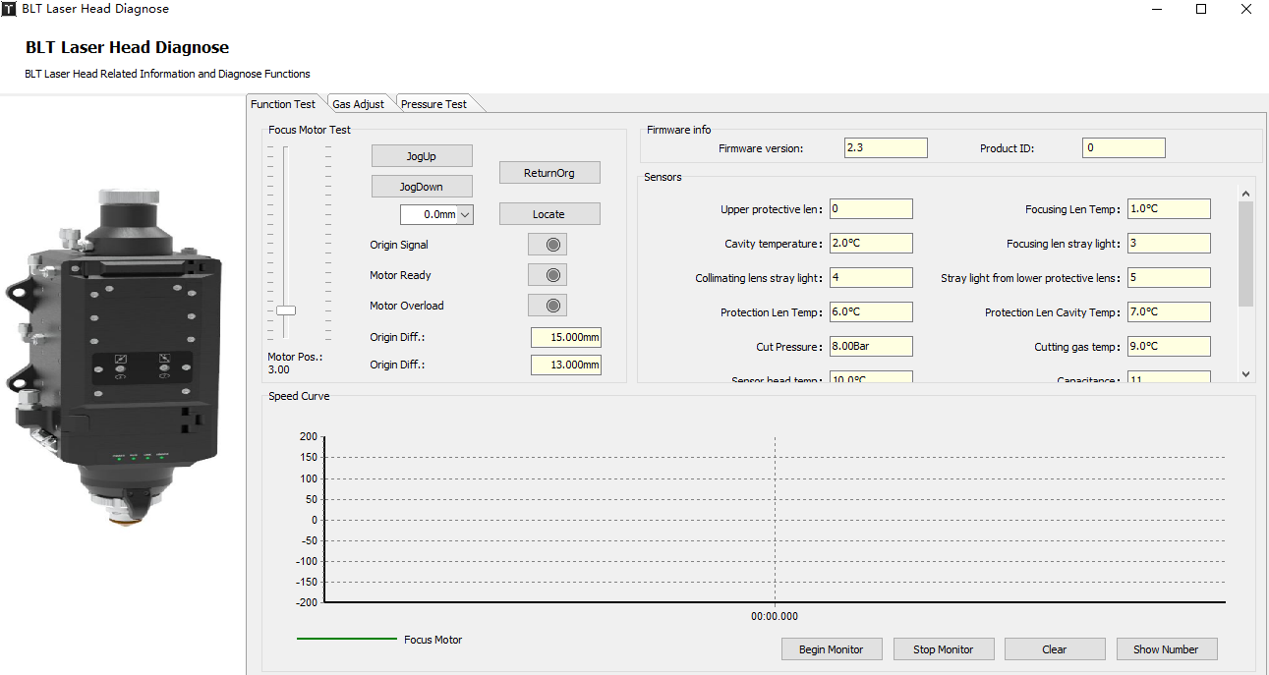

1.The parameters in the functional test are defined in the following table.

Focus Motor Test

|  |  |
| --- | --- |
| **Parameter Name** | **Description** |
| Origin signal | When the cutting head guard plate reaches the sensing position, the limit switch is triggered, and the origin signal light is on during the ReturnOrigin process. |
| Ready signal | The Ready light turns on when the motor has no servo alarm after power up and the phase search is successful. |
| Current Overload | The signal is on when the motor current exceeds a set value when the motor is blocked or seized. |
| Z-phase offset | At the end of the return origin, the Z-phase deviation of the return origin is displayed. |
| Initial Z-phase offset | The Z-phase deviation displayed after the completion of the installation back to the origin. |
| Locate | To locate the coordinates of the focus motor. |

Sensor

|  |  |
| --- | --- |
| **Parameter Name** | **Description** |
| Protective Lens Temp | By monitoring the temperature rise of the protective window to determine the lens cleanliness, effectively avoid the lens contamination caused by unstable cutting conditions.  When the sensor fails, the temperature is high, or the temperature rise is high, a warning will be issued. When the temperature is excessively high or the temperature rise is excessively high, an alarm will be triggered. |
| Protection Lens Cavity Temp |
| Cut Pressure | Display the current gas pressure and temperature in the cutting head and warns if the sensor fails and monitoring is not enabled. The cutting air pressure monitoring threshold can be configured in the machine configuration tool(CypConfig). |
| Cutting gas temp |
| Capacitance | Display the capacitance value between the current cutting head and the material. When the capacitance changes to 0 or the cutting head hits the material, an alarm is issued. |
| Sensor head temp | Display the current sensor head temperature and turn the laser off early when the sensor head is disconnected. When the temperature of the capacitive sensor head is too high or when it is disconnected, an alarm will be triggered. |
| Focusing Lens Temp | Monitor the contamination of the focusing lens.  When the sensor fails, the temperature is high, or the temperature rise is high, a warning will be issued. When the temperature is excessively high or the temperature rise is excessively high, an alarm will be triggered. |
| Cavity temperature |
| Protective lens drawer pressure | Display the current protective window cartridge air pressure and issues a warning when it leaks air. |
| Stray light from upper protective window | Contaminants on the lens can cause diffuse reflections of the laser, i.e. stray light.  The contamination level of the upper protective lens can be determined by displayed value, preventing the lens from cracking. An alarm prompt of "Contamination on upper protective window" will be triggered when it exceeds the configured alarm threshold. |
| Stray light from lower protective window | Contaminants on the lens can cause diffuse reflections of the laser, i.e. stray light.  The contamination level of the lower protective lens can be determined by displayed value, preventing the lens from cracking. An alarm prompt of "Contamination on lower protective window" will be triggered when it exceeds the configured alarm threshold. |
| Focusing lens stray light | Contaminants on the lens can cause diffuse reflections of the laser, i.e. stray light.  The contamination level of the focusing lens can be determined by displayed value. |

Gas Correction

Gas correction can adjust the relationship between DA proportional valve voltage and air pressure, so that the output of the air pressure during machining is more accurate.

Quick Gas Correction



3.9.2 Focus Autotest

Click Tools - Assist Function - Focus Autotest its interface is shown below.

The focus autotest can be used to find out the actual focus value for the zero focus of the cutting head.

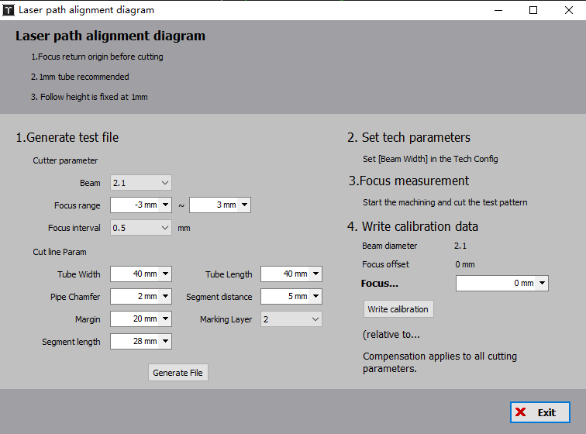

HowTo

1. Select the focus to be tested, modify the focus range range and focus interval, set the cut line parameters, click "Generate File", The test drawing can be generated according to the parameters;

2. Click on "Layer" above the color block of the layer on the right side of window to set the "Beam Width" to the spot value to be tested;

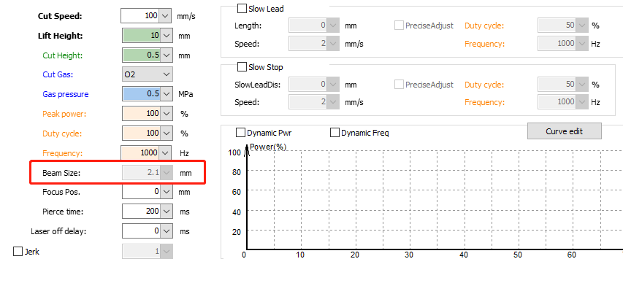

3. Perform machining operations and cut test graphics;

4. Analyze the cutting effect of different focal spot, find the slightest cut gap, fill the corresponding focal spot value in the "Focus Calibration", and click "Write Calibration" to perform focus compensation.

**3.10 Debugging Tool**

3.10.1 Auto Gas Correction

Please refer to 3.9.1 for instructions.

3.10.2 Photo Paper Test

Click Tools - Debugging Tools - Photo Paper Test and the window shown below will pop out.

Photo paper test can be used to check the optical path for lens contamination, using the following methods:

1. Place the photo paper in a suitable position under the cutting head;

2. Adjust the laser parameters and the LaserOn time;

3. Click on "LaserOn";

4. After the LaserOn, check the photo paper spot to determine if the lens is contaminated. If any contamination, additional testing is required to determine the source of the contamination.

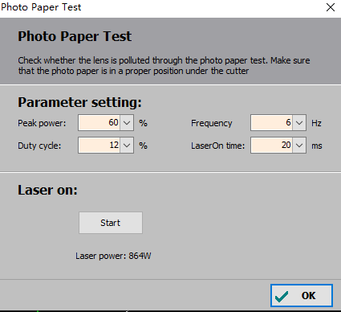

3.10.3 Z-phase Signal Initialization

Click Tools - Debugging Tools - Z-phase Signal Initialization and the window shown below will pop out.

Initialize the Z-phase signal initialization after it is shipped from the factory and readjusting the origin or mechanical switch.

Note: You need to check "Use Z-phase signal" in the Return Origin parameter of the Machine Config Tool - "Axis Config".

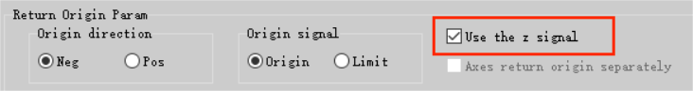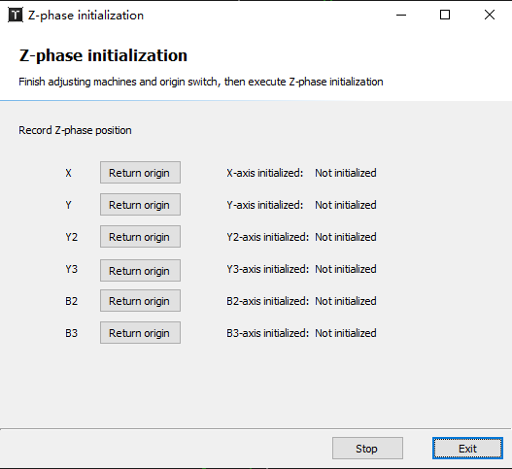

**3.11 Installation Tools**

3.11.1 Burn-in Test

Click Tools - Assist Function - Burn-in Test and its interface is shown below.

This function is to set the parameters of the burn-in test. You can enter the “Planned loops” and the interval time between loops. You can also choose to reset the displayed number of finished loops on the interface after the testing starts. Additionally, you have the option to select the burn-in PLC process and the number of repetitions.

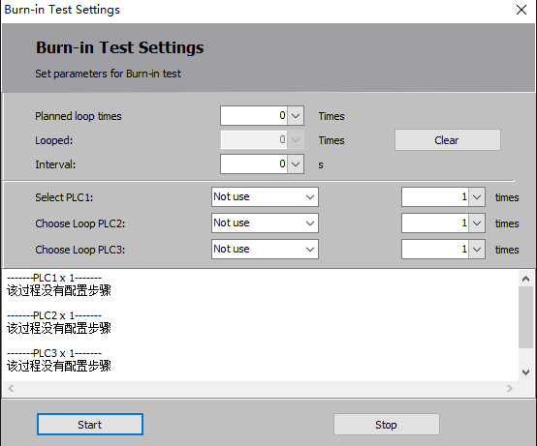

3.11.2 Interferometer Program

Click Tools - Assist Function - Interferometer Program and its interface is shown below.

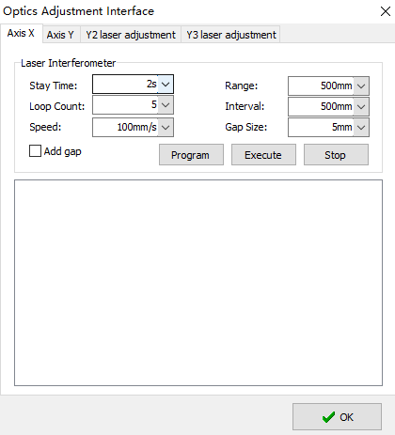

This function is to adjust the laser path of the axis. Click "Program", the program will be generated in the window. Once the verification is complete and the following conditions are met, simply click "Execute" to start the measurement.

1. The measured axis has been correctly returned to the origin, starting from the origin of the measurement;

2. The interferometer is ready and the parameters match the parameters set in the software.

|  |  |
| --- | --- |
| **Parameter Name** | **Requirement** |
| Stay Time | Set the stay time slightly larger than the interferometer's "minimum stop period" to ensure that the interferometer recognizes each point that needs to be measured. |
| Range | This value is automatic read and it needs to be set to the same value as the set value in the interferometer. (Note: Enter a negative value to return to the origin in the positive direction and input positive values for reverse. If there is an input error, the system will prompt during saving.)) |
| Loop Count | The number of loops is the same as the number of measurements set in the interferometer. Since the software only reads the measurements back and forth once, data from multiple measurements will only be read the first time when imported into the software. |
| Interval | The interval value needs to be set to the same as in the interferometer, otherwise the data may not be detected. |
| Gap Size | Gap size is to eliminate the mechanical backlash by continuing the set distance in the original direction and then returning to the set distance in reverse motion. The value should not be greater than the spacing value minus the tolerance window. Otherwise, the interferometer may mistakenly identify it as a point that needs to be measured. |

**3.12 Advanced Tools**

3.12.1 New Motor Tuning

Click Tools - Advanced Tools - New Motor Debug Tool and its window is pop pit as shown below.

Single Axis Tuning

The single-axis tuning is primarily used to check for correct ratio of inertia for single-axis servo and for normal static torque.

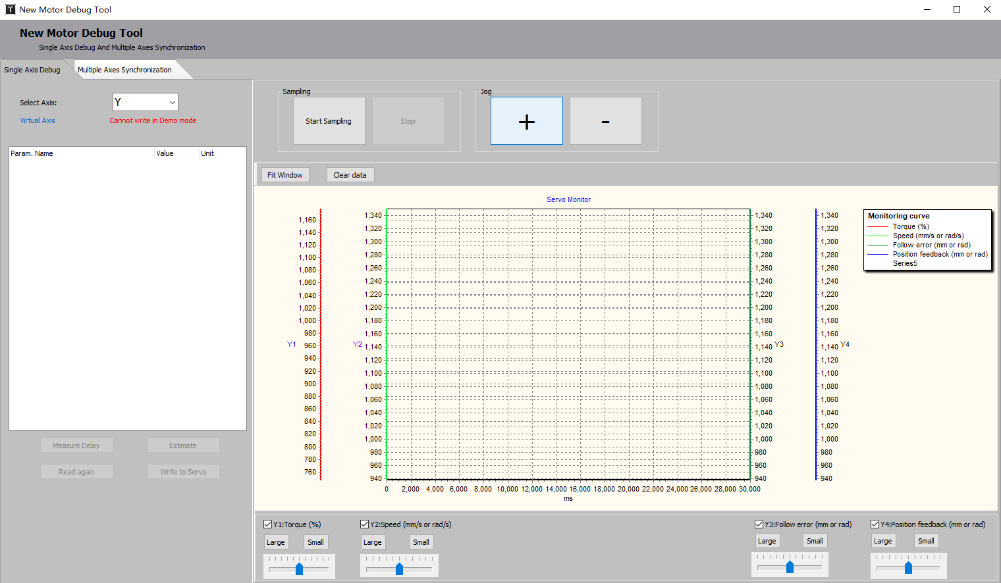

Multiple Axes Synchronization

It is for roundness testing(Circle Test), rectangle testing (Rectangular Test), round tube-wrapped roundness testing(Wrapped Circle Test), miter-cut testing(Bevel Cut Test), custom trajectory testing(Custom Path Test), etc. It can test the error values of relevant graphic instructions and feedback positions.

Fill in the parameters in the 'Testing Path' and click 'Generate Path' to generate the test graphics, and click 'Start Test.' The blue trajectory displayed on the interface represents the actual feedback trajectory, and the corresponding error values will be displayed in the 'Test Result'."

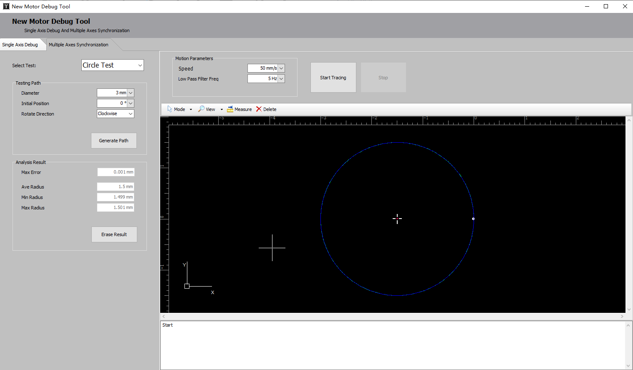

3.12.2 FindEdge Repeatability Analysis

Click Tools - Advanced Tools - FindEdge Repeatability Analysis and its interface is shown below.

This function is used to test the edge finding performance of the height adjuster and check if the performance is within the acceptable range. For a normal 2D nozzle, the maximum error in edge finding should be within 8 si, while for a 3D nozzle, it should be within 12 si..

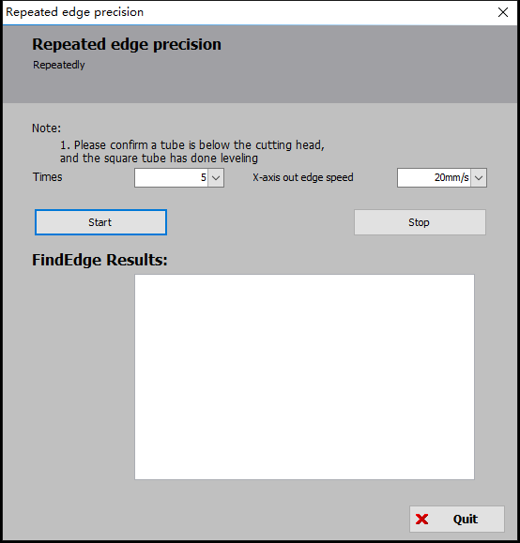

3.12.3 Square Profile Precision Analysis

Click Tools - Advanced Tools - Square Profile Precision Analysis and its interface is shown below.

The cross-section analysis allows you to see the appearance of the rectangular tube and test the deviation between the current tube and the ideal rectangular tube.

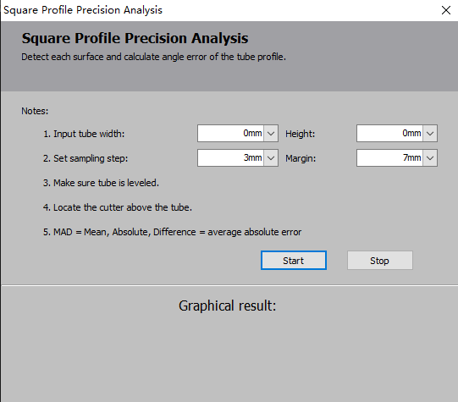

3.12.4 Coordinates Viewer

Click Tools - Advanced Tools - Coordinates Viewer to view the mechanical coordinates of the current position or to manually switch the axis controlled by the jog action bar.

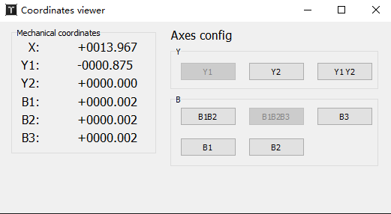

3.12.5 Create CAD Test File

Click Tools - Advanced Tools - Square Profile Precision Analysis and its interface is shown below.

To facilitate trial cutting, TubePro offers a feature to create test files, allowing for the quick creation of perforation patterns on rectangular tubes for simple testing purposes.

For the tube surface holes, you can choose between rectangular or circular holes. Additionally, you can specify the distance of the hole center from the near-end surface of the tube. TubePro also allows for the application of a DXF wrap on the tube surface. You can import the corresponding DXF file and input the desired wrapping starting position, as well as the distances from the left and right sides of the section.

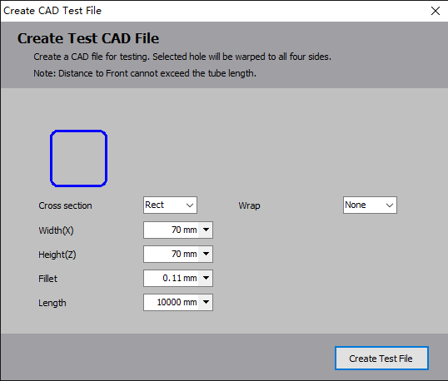

3.12.6 Advanced Debugging Tools

Click Tools - Advanced Tools - Advanced Debugging Tools, and you can select Set Current as Mechanical Origin to set the current position of the cutting head to the origin and change the X/Y/A/B coordinates to 0. Please use it with caution.

3.13 Global Parameter

The global parameters contain settings for machining settings, motion parameters, algorithm parameters, and general units.

3.13.1 Machining Settings

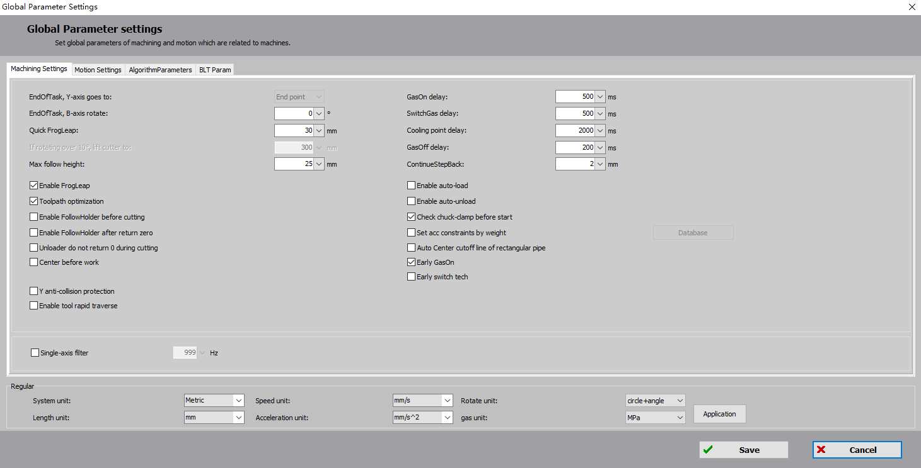

|  |  |
| --- | --- |
| **Parameter Name** | **Description** |
| EndOfTask, Y-axis goes to | You can select zero point/near-end/far-end/end point. |
| EndOfTask, B-axis rotates | For special machine models, the B-axis turns at an angle after processing to facilitate loading. |
| Quick FrogLeap | When this option is checked, a travel below this setting will perform a fast FrogLeap (i.e., leap without a up-down delay), a travel above this setting will leap with a up-down delay; if unchecked, no leap will be performed. |
| If rotating over 10°, lift cutter to | The height of the Z-axis raised when cutting in a different face without using travel optimization. This parameter does not take effect if travel optimization is turned on |
| Max follow height | The capacitive sensing range for the tip nozzle is limited and a maximum follow height can be set here. |
| GasOn delay | This is to make sure that the air pressure at the cutting head stabilizes after the air circuit. |
| SwitchGas delay | When changing the gas, there should be a delay from completely purging the original gas to the new gas reaching a stable pressure at the cutting head. Additionally, during the initial start of the process, the first blowing of gas will have an additional changeover delay on top of the initial gas on delay, known as the first point gas on delay. |
| CoolingPoint delay | The time for blowing air to cool down at the cooling point. |
| GasOff delay | After completion of the cutting process, it is advisable to introduce a delay before shutting off the gas. By implementing this delay, the number of gas opening actions for short-distance cuts can be minimized. |
| Resume stepback |  |
| FrogLeap lift | FrogLeap lift during travel |
| Toolpath optimization | The Z-axis is lifted up appropriately according to the tube size in the drawing. |
| Auto loading | Click Start Processing, the Loading PLC is executed before the File Begins PLC. |
| Auto unloading | After the process is finished and the"Unloading" PLC is executed after the "File Ends" PLC action |
| Enable follow-up holder before cutting | If the follow-up holder is configured, check this option and the holder is automatically set to coupled follow-up before processing. |
| Check chuck-clamp before start | Check the condition of the chuck before starting processing and pop-up indicates if it is not clamped. |
| Enable follow-up holder axis after return zero | If this option is checked, the holder will be follow-up coupled state after return zero. |
| Velocity Parameter | You can set different Y-axis, B-axis travel speed, travel acceleration, processing acceleration based on the weight of the pipe. Up to six sets of data can be configured. |
| Unloader no return zero during cutting | If this option is checked, the follow-up holder does not return to the docking position throughout processing. |
| Auto center cutoff line for rect tube | If this option is checked, it enables real-time deviation calculation for rectangular tubes. Only available for bus systems. Auto collect Z-value information while processing the cutoff line of rectangular tubes to calculate the deviation of the tube center and update it in the configuration file. |
| Centering before machining | The first toolpath of the file is forced to do centering, not valid for shape tubes. |
| Quick FrogLeap no lift | To maximize efficiency, when this option is selected, the Z-axis remains in a full follow mode throughout the travel. Whether to select this option or not should be based on the actual machining scenario and requirements. |
| Early GasOn | This option is checked by default. Early gas opening can be achieved during the travel. This improves the processing efficiency and reduces the gas opening delay for each path. |
| Early switch technique | This option is checked by default. The process enables parallel execution of technique settings such as time, focus, spot size, laser power, etc., during the travel. This enhances machining efficiency. |

3.13.2 Motion Parameters

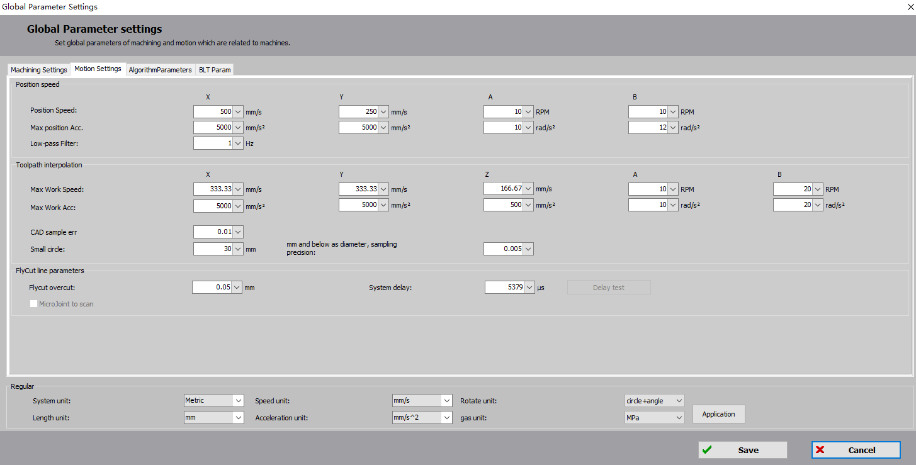

|  |  |
| --- | --- |
| **Parameter Name** | **Description** |
| X/Y/A/B travel speed | Max travel speed for X/Y/A/B axis |
| X/Y/A/B travel acc | Max acceleration for X/Y/A/B axis |
| Travel LPF | Set the low pass filter frequency for travel. This parameter is dependent on mechanical properties and is set to 5Hz by default.  If the cutting error is large, you can try to reduce this parameter. |
| X/Y/Z/A/B Max cut speed | Limit the speed of single-axis machining |
| X/Y/Z/A/B cut acc | Limit the acceleration of single-axis machining |
| CAD sampling precision | By setting the sampling precision for machining curves, it is possible to improve accuracy and achieve smoother processing curves. This means that the curves will be represented with more data points, resulting in a higher level of detail and smoother transitions. |
| Small circle/CAD sampling precision | For small circles, the CAD precision that can be saved can be set separately;  The wrap and punch circles created in TubesT are not taking effect.  IGS and SAT parts are OK.  Path type: Only valid for round holes; ellipses, rectangular tubes, unenclosed graphics not valid;  Not valid for cutoff lines, replace with lines, replace with points. |
| FlyCut overcut | Set the overcut distance for the fly cut pattern to ensure that the hole is cut completely.  Only the bus system can do FlyCut, and the system delay can be automatically calculated and compensated by EtherCAT bus. This ensures multi-axis synchronization at the same time while compensating for this lag, thus ensuring the accuracy of the hole positions during cutting. |
| System delay/Delay test |
| FlyCut at MicroJoint | For drawings with MicroJoints, check this option to cut MicroJoint in continuous FlyCut ways; drawings without MicroJoints are grayed out. |

3.13.3 Algorithm Parameter

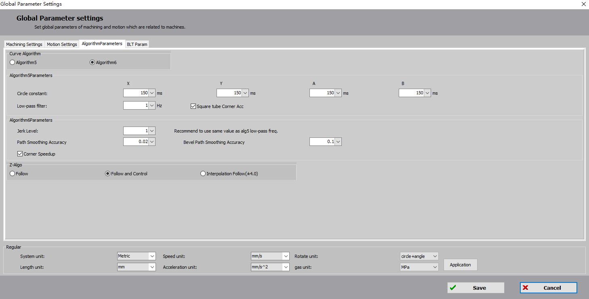

|  |  |
| --- | --- |
| **Parameter Name** | **Description** |
| Algorithm5 Parameter | |
| Small circle time constant | The minimum time parameter used for processing small circles. Increasing this parameter ensures higher precision for processing small circles. The larger the value set, the higher the accuracy achieved when processing small circles. |
| Low-pass filtering freq | The default low-pass filtering frequency for machining is 5Hz. The better the performance of the machine, the higher the set acceleration and low pass filtering. |
| Square tube corner acc | If this option is not checked, the corners of square tubes are limited by the B-axis small circle time constant, resulting in speed restrictions at the corners.  When checked, the square tube has no speed limit on the corner and the machining is faster. |
| Algorithm6 Param | |
| Jerk level | It is recommended to use the same value as the algorithm 5 for processing the low-pass filtering frequency |
| Z-axis algorithm | |
| Z-axis algorithm | There are three different Z-axis control algorithms to choose from based on different scenarios. |

3.13.4 Speed Unit



Speed Unit mm/s, m/s, m/min, mm/min, in/min, in/s

Rotate unit: rad, angles/RPM, revolutions + angles

Gas unit BAR、PSI、MPa

3.14 Layer Parameters

If the graphic contains more than one layer, each layer can be set individually and the user can set it as desired.

3.14.1 Cut Technique

The cutting technique contains parameters such as speed, air pressure, power, delay, etc. for the processing of the corresponding layer.

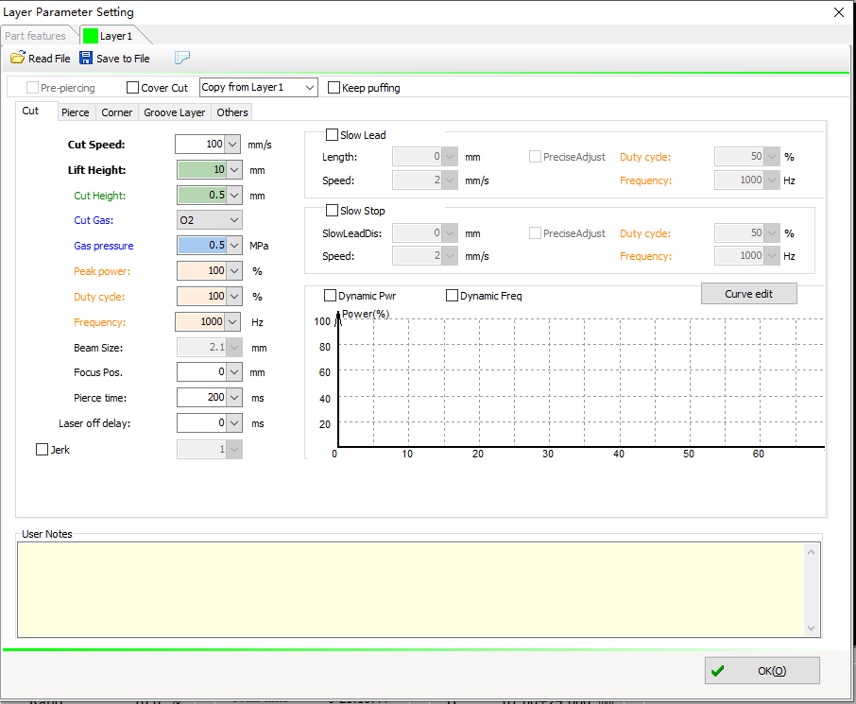

|  |  |
| --- | --- |
| **Parameter Name** | **Description** |
| Lift height | The height at which the Z-axis is raised during the travel movement between two consecutive toolpaths in a normal machining process. |
| Spot/Focus | If an electrically focused cutting head is used, the spot/focus parameters can be configured |
| Stay Time | The delay between the start of cutting and the travel along the trajectory to ensure the laser can penetrate the tube material. |
| Delay before LaserOff | The delay from the end of the trajectory until the laser beam is turned off. |
| LaserOn Technique | Set the distance, speed, laser frequency, duty cycle at the beginning of each path. |
| LaserOff Technique | Set the distance, speed, laser frequency, duty cycle at the end of each path. |
| LPF Freq | If enabled, this layer can be set to a separate low pass filter; if not enabled, the layer uses the process low pass filter in the global parameters |
| Real-time adjust power/freq | Set the relation between the power/frequency of the path machining laser and the cutting speed. |
| Edit Curve | Edit the power/frequency curve for speed |
| Defilm cutting | You can remove the pipe surface oxide film or protective paint in advance with a small laser power. After checking the option, you have to configure the parameters for removing the film. |
| GasOn | After checking the option, the gas will not be turned off throughout the machining process. |

3.14.2 Pierce Technique

You can access the Layer Parameter Setting window by clicking "Layer" above the color block of the TubePro interface.

Select the "Layer" for the corresponding layer and click "Pierce" to select the piercing method and configure the parameters.

Users can select No Pierce, 1-stage/2-stage/3-stage piercing according to the requirements, and adjust the parameters of each stage. Pierce method include segmented perforation, lightning perforation, and progressive nozzle. If the selected pierce mode is a 2 piercing, the second stage piercing is performed first and then the first stage piercing is performed. The concepts are as follows.

|  |  |
| --- | --- |
| **Pierce method** | **Description** |
| Segment Piercing | Piercing is performed at set times using the corresponding power, frequency, duty cycle, etc. at different perforations heights. |
| Flash Piercing | Pierce by a fast frequency conversion to power, fast penetration is achieved for thick plates. |
| Nozzle stepping | After the stay time has elapsed for the piercing at the current stage, the laser continues to glow at a certain speed (speed = difference in height / pierce time) to the next stage. |

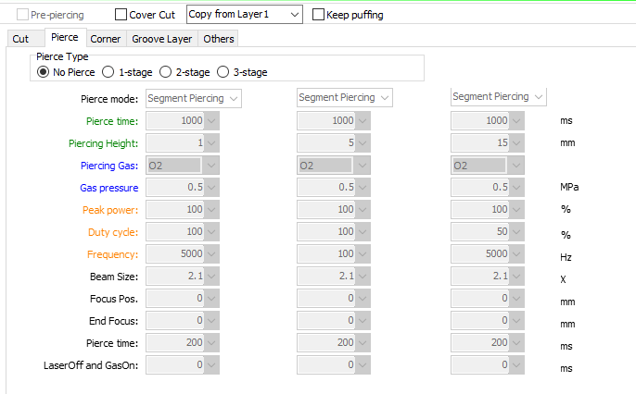

|  |  |
| --- | --- |
| **Parameter Name** | **Description** |
| Step Time | The time the cutting head moves one level down from the current height. |
| Nozzle Height | Nozzle height during the piercing process. |
| Gas Type | The gas type for the piercing process. |
| Pressure | The air pressure during the piercing process. |
| Peak Power | The peak power of the laser during the piercing process. |
| Duty Cycle | The duty cycle of the laser during piercing . |
| Laser Frequency | Set the laser frequency for the piercing process |
| Beam Size | If the focus axis is configured, the spot diameter during piercing can be set here. |
| Focus Position | If the focus axis is configured, the focus position during piercing can be set here. |
| Stay Time | The time the cutting head stays at the current height to pierce. |
| LaserOff and GasOn | The time to stop the laser and blow air after the piercing is completed. |
| Pre-piercing | All of the points in a workpiece that need to be pierced are pierced before cutting. |
| Smooth Pierce | This option is to improve the piercing efficiency. |

3.14.3 Corner Technique

Enable the corner process to make pipe corners cut better. You can set parameters such as Follow and Control, corner air pressure, peak power, duty cycle, and pulse frequency. It is also possible to limit the speed and acceleration of the B-axis.

|  |  |
| --- | --- |
| **Parameter Name** | **Description** |
| Follow and Control | FSCUT5000A and 5000B can enable integrated Follow and Control, allowing the Z-axis to lift more promptly at corners and reducing the possibility of collision with the workpiece. |
| Follow height offset | Actual follow height at corner = cut follow height + follow height offset |
| Peak power | If the machine uses a laser that controls peak power via DA, the cutting peak power at the corner can be configured separately. |
| Duty cycle | The duty cycle can be reduced at corners to avoid burns to parts. |
| Define Corner | If the B-axis needs to rotate by a set angle for every 1mm of processing in the X-direction, it is considered to have entered the cornering segment. The default value of 1.146°/mm is recommended. |
| Limit B-axis speed | When cutting pipes of different sizes, the speed and acceleration of the B-axis often affect the cutting quality of the entire cross-section. By using a separate cornering B-axis speed, it is possible to improve cutting quality without compromising overall processing efficiency. |

3.14.4 File Parameter

File parameters are those set for different tube or machining files.

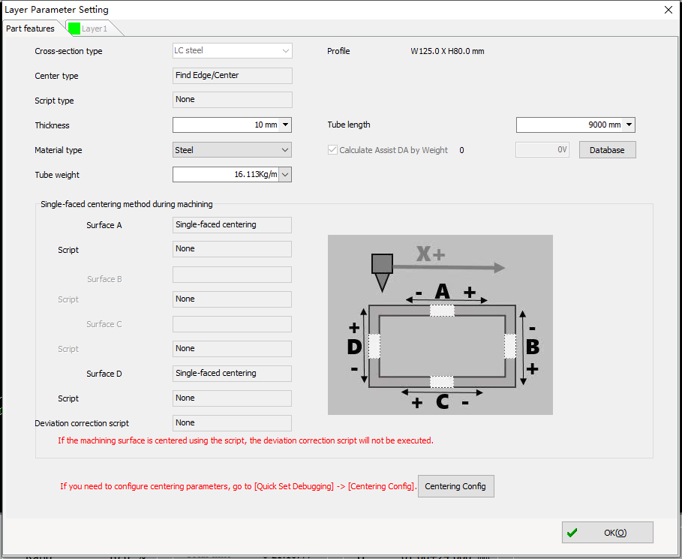

|  |  |
| --- | --- |
| **Parameter Name** | **Description** |
| Section Type | TubePro automatically identifies the type and size of the section based on the machining file. |
| Centering method | Based on the different pipe types, select an appropriate method for finding the center during processing. When processing a graphic with a centering point, the machine will first perform an automatic center-finding using this method before proceeding with the cutting process. |

3.15 Custom PLC

Click on "PLC" - "Custom PLC" to configure the PLC in the displayed page.

3.15.1 Function Layout

|  |  |
| --- | --- |
| **Module** | **Description** |
| View | Save/clear/stop/change PLC sequence can be performed on the current program. |
| Current Program | Display the currently edited PLC process program. |
| PLC Library | Drag the PLC in "PLC Library" to the "Current Program" on the left and release it to add the PLC. |
| Edit variable table | 1. Add/delete/select variable tables;  2. In each variable table, variables of basic types (integer/floating point/Boolean/string) can be added/delete;  3. The default variable "V1" in the default variable table VarT1 cannot be deleted;  4. For the current program, if a certain variable table is selected, the variables in the variable table can participate in some logic PLC of the program, such as if/while conditional judgment, etc. |
| Edit Param/Condition | 1. Edit Param: For a selected PLC, if the parameter is included, the parameter value can be edited here;  2. Edit Condition: For a condition of the if/while statement, you can edit/add/remove the condition here. |

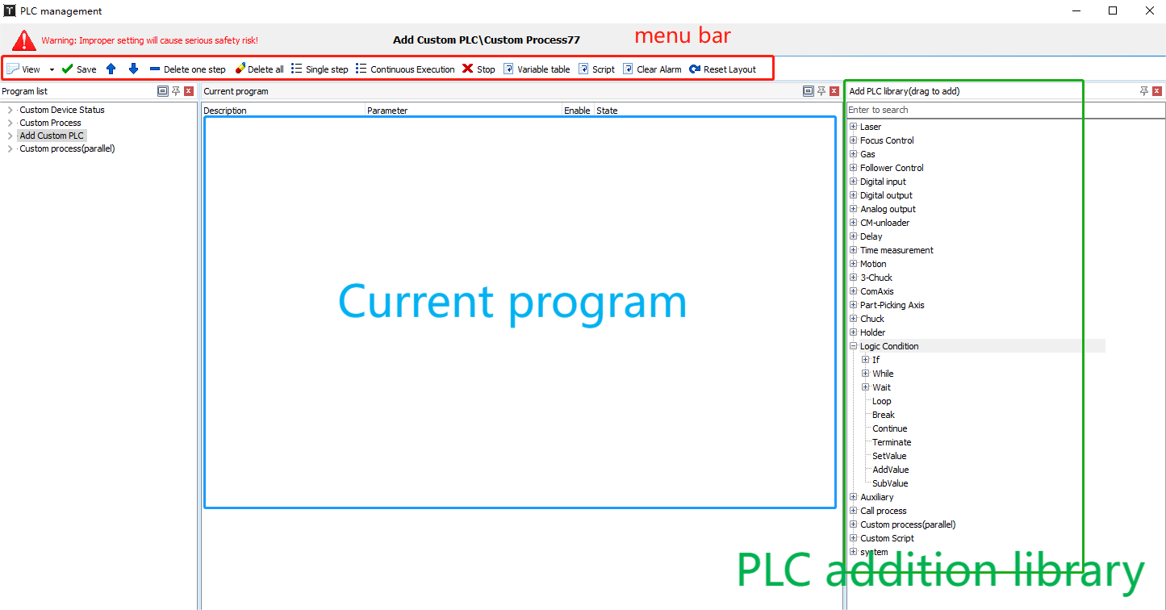

(1)Add PLC/SubProcess

Add PLC: Select a PLC in the PLC Library and drag to the left "Current Program". If you drag and drop a PLC onto a specific node in the "Current Program," it will be added after that PLC. If you drop it in a blank area, it will be added to the end of the "Current Program" by default.

Add SubProcess: For an "if" statement, you can add a sub-process under the "Condition Met" or "Condition Not Met" nodes. Similarly, for a "while" or "loop" statement, you can also add a sub-process.

How to add: Select a PLC from the PLC library, drag it to the desired parent node, and release it. This will add the PLC as the last element in the sub-process of that parent node.

In summary, when you select a PLC from the PLC library, drag it to the "Current Program," and release it while pointing to a specific node, the behavior depends on whether the node can have sub-processes. If the node can have sub-processes, the PLC will be added to the end of the sub-process. If the node cannot have sub-processes, the PLC will be added after the node as a parallel PLC.

(2) Change the PLC order

In the Current Program, select a PLC, drag to the desired node position, and release to complete.

(3) Copy/Cut/Paste PLC

In the Current Program, select a PLC, Ctrl+C (or right-click to select) to copy, Ctrl+X (or right-click to select) to cut, Ctrl+V (or right-click to select) to paste after the currently selected node.

3.15.2 Logical Conditions

* If/while

(1) Types of conditions that can be added: Variable comparison form; valid input port; invalid input port.

As shown in the following figure, the if statement is added by selecting the Variable Comparison Form and dragging to the left to the Current Program. The condition in this case defaults to the first variable in the current variable table equal to the form of its initial value (note that the default if variable comparison form results in true).

(2) Modify the condition

Conditions for this statement can be modified/added/removed in the Edit Param/Condition module.

Execute

When the PLC is executed, it is executed in the PLC order from top to bottom in the Current Program, one by one. For a PLC that is judged by a condition, either True or False is returned based on its condition and the corresponding sub-procedure is performed.

* Loop

The Loop statement causes the sub procedure to cycle a set number of times.

When dragging a loop statement from the PLC library to the current program, the default number of loops is 1, which can be modified in the Edit Param/Condition module on the right. If you change the number of loops to 5, then when you execute the Loop statement, it executes its subprocess 5 times (from top to bottom).

* Break

Use the Break statement to jump out of the current loop. Note: The use of if statements must be accompanied by while/loop loops. Please use them with caution.

Both while and loop cycle through their subprocesses. While will continue to execute until the while condition is no longer satisfied, indicating the completion of the while statement. Loop will execute a predetermined number of times before considering the loop statement as completed. During the execution of the sub-process, if certain conditions of if statements are met/not met, you can use the "break" statement to exit the current loop, indicating that the while/loop statement has completed its execution.

* Continue

The "continue" statement means to skip the remaining steps within the current iteration of the loop and move on to the next iteration. Note: The use of if statements must be accompanied by while/loop loops. Please use them with caution.

Similar to the "break" statement, the "continue" statement is used within while/loop loops with if statements. When certain conditions are met/not met, the current iteration of the loop is skipped. The difference from the "break" statement is that after the "break" statement exits the loop, the current while/loop statement is considered completed, and the program proceeds to the next line of code. On the other hand, after the "continue" statement skips the remaining steps in the current iteration, it returns to the condition check of the while/loop. If the while condition is still satisfied or the number of loop executions has not reached the specified count, the program will continue with the next iteration and execute the sub-process sequentially. In other words, the "continue" statement only skips the remaining steps within the current iteration of the loop, and whether to enter the loop again depends on the condition evaluation.

* Set Value

During program execution, you can assign values to logical variables, which can then be used in other conditional statements.

* Wait

The Wait statement is similar to the previous Wait Input Valid/Invalid. The PLC statement has three variables: Condition function, condition parameter, and timeout.

Condition Function: "Input Port Valid/Invalid" can be selected.

Condition Parameter: Select the input port.

Timeout: Set the maximum waiting time, T.

During the execution process, if the selected condition is met, the statement is considered complete. Otherwise, after waiting for the duration of T, it is considered complete, and the next statement is executed.

3.15. 3 Single-step Execution

Click Single Step and the program will be executed step by step in order.

During single step execution, only the following options can be clicked: "View," "Single Step," and "Stop." Clicking on "View" in the dropdown will show the corresponding module in the interface. This allows you to view the specific module being executed. "Single Step" allows you to proceed to the next step after the current PLC step is completed. It ensures a step-by-step execution of the program. Clicking on "Stop" will transition from the single step execution state to the stop state, halting the execution of all PLCs.

During single step execution, the status of each executed PLC will be displayed. The statuses include "Executing," "Execution Completed," and "Executed." If it is a conditional statement, it will indicate whether the condition is satisfied or not. If it is a loop, it will display the current loop iteration number out of the total number of iterations.

"Executing" indicates that the current PLC is executing, click "Stop" to terminate execution.

3.15.4 JavaScript

Go to the Machine Config Tool - Advanced, and tick Enable JavaScript, and save the settings.

Once the software is opened, you can access the CNC Script Editor by clicking on the "CNC Script Editor" option in the "PLC Process" dropdown. This allows you to write and edit scripts.

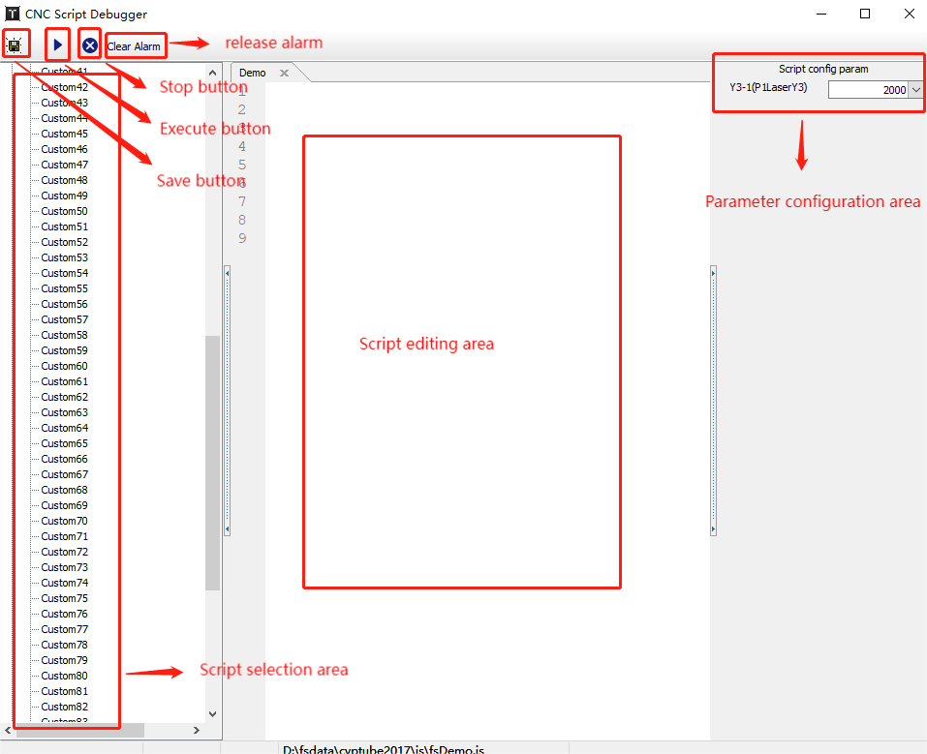

When executing a script, you can perform different action process based on the external cmd value. After you configure the Wait for Script Execution End time, the software alerts you if the timeout is exceeded. If the value is set to 0, the script execution will be completed, or parallel script if this time value is not configured. The script can only be stopped by an external call, not by pressing the Stop button.

4. Machine Function

**4.1 Auto Dodge**

Dodge function includes cutting head dodge and chuck dodge. By employing special movements of the chuck or cutter, the cutter can be moved from the front to the back of the chuck (between the main chuck and the middle chuck).

Go to Machine Config Tool to enable the automatic dodge.

### 4.1.1 Cutter Dodge

If you enable Cutter Dodge and not [Enable Y1 dodge positive stroke], the following should be met: Y1 limit coordinate - current position of main chuck > remaining drawing length, or Y1 positive stroke - current position of main chuck + cutter dodge relative distance > remaining drawing length. So it will not cut beyond the software stroke.

To cut the last part, it should be: remaining drawing length <Y1 limit coordinate - current position of main chuck + distance from dodge coordinate to cutting head position after dodge.

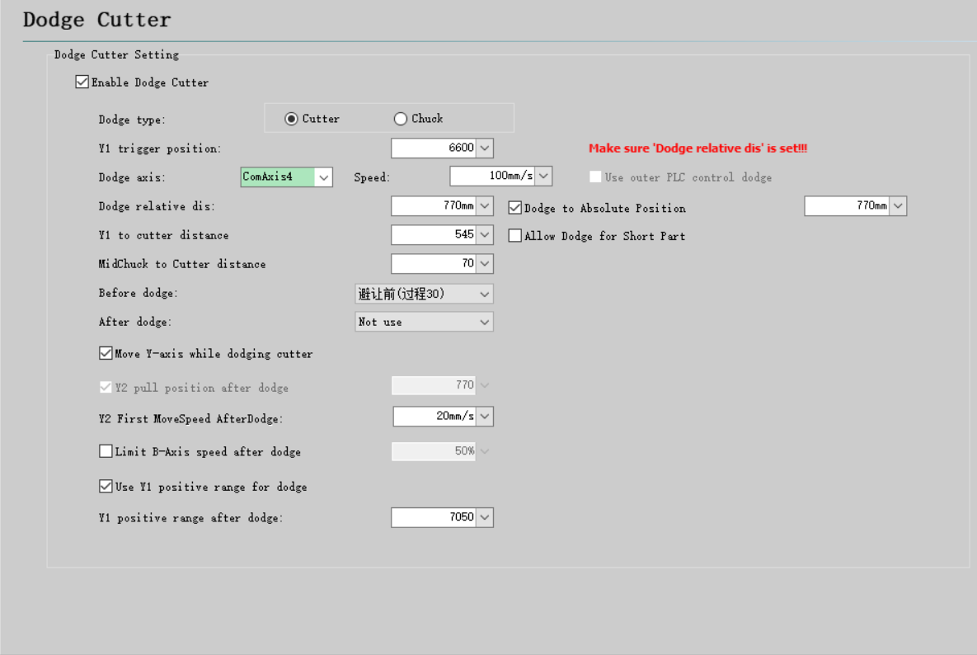

|  |  |  |
| --- | --- | --- |
| **Parameter Name** | **Description:** | **Note** |
| Y1 limit coordinate | Y1 coordinate that triggers the dodge action. | It determines if the Y1 limit coordinates will appear on the next trajectory (cutoff line also counts)and triggers the dodge. |
| Dodge relative distance | The distance of relative motion(move by) during cutter dodge |  |
| Y1 DodgePos To Cutter | The distance from the Y1 limit coordinate to the cutting head | This value needs to be filled based on the actual machine tool configuration. |
| MidChuck to Cutter | It is used to determine whether a part will be pulled out of the the middle chuck. | This value needs to be filled based on the actual machine tool configuration. |
| Dodge axis and its speed | Dodge axis | The axis used for dodge can be configured with a common axis. If the configuration for a CommAxis is not available, you can also incorporate the logic for the dodge axis within the "BeforeDodge PLC" configuration. |
| Dodge to Absolute Position | The cutting head moves to a specific, predetermined position(move to). | When using relative dodge, there is a risk of unexpected alarms or stops during the dodge process, which may interrupt the dodge. In such cases, when re-executing the dodge action, the dodge axis may still move a relative distance, which might lead to in a collision with the main chuck. Using absolute positions eliminates this risk. If the option for absolute position is configured, the system will operate using absolute positions. If the option is not selected, relative positions will continue to be used. When the option for absolute position is selected, and both relative and absolute motions are configured, the dodge axis will move based on absolute motions(move to), while the dodge judgment will still be based on relative parameters(move by). The main chuck will also use relative parameters for motion if the option (when "Move Y-axis while dodging" is selected.) |
| Allow Dodge for Short Part | Switch to the short part dodge mode | Once the short workpiece avoidance mode is enabled, TubePro will no longer check whether the pipe is pulled out of the middle chuck due to dodging.. |
| BeforeDodge action | PLC actions executed before dodge. | Move the cutting head to a position where it will not interfere with the chuck when dodging.  If you do not configure Dodge Axis, you need to configure all dodge actions of the cutting head and the main chuck. |
| AfterDodge action | PLC actions executed after dodge. | You can configure some operations after dodging, such as [Enable special B-axis center]. |
| Move Y-axis while dodging | When dodging is triggered, the Y1 axis and the dodge axis synchronize their movements. | There is no need to configure any of the motion logic of the Y1 axis in the BeforeDodge action, and the synchronous dodge speed takes a smaller value between the Global Parameter - Y Travel Speed and Axis Dodge Speed. If [Move Y-axis while dodging] is not enabled, Y1 will also move, but not start moving with the cutting head at the same time It will wait until the cutting head movement is finished and then it moves to the relative position in the negative direction. If the dodge axis is not configured, but [Move Y-axis while dodging] is enabled, Y1 will not move when the dodge is triggered. |
| Y2 Preparing Speed After Dodge | The speed of the Y2 axis moving in the negative direction after dodging. | It ensures that the unloading device can descend into position smoothly when B3 retracts. This is necessary to prevent any interference. |
| Limit B-axis Travel Speed After Dodge | To restrict the travel speed of the B-axis after dodging, you can apply a speed limitation specifically for this scenario. | When dealing with short part that require single-chuck clamping after dodging, it is important to limit the rotational speed of the B-axis while the B-axis speed before avoidance is retained. |
| Enable Y1 dodge positive stroke | When the dodge is complete, the new Y1 axis positive stroke after dodging is enabled. | As for the cutter dodge, it is a bit useless. However, it is practical for the chuck dodge and can increase the cutting capacity. This function is similar to the [Y-axis extra stroke] of the chuck. |
| Y1 positive stroke after dodge |
| Enable external PLC control for dodge axis | For non-bus systems, it is not possible to configure the dodge axis.In this case, the dodge actions for the cutting head can be configured within the BeforeDodge actions. | If [Y1 axis and avoidance axis synchronization participate in avoidance] is not enabled, the actions are: Before/AfterDodge action - MainChuck moves to [Y1 coordinate - Dodge relative distance] coordinates - MainChuck moves to the front of the next path to start cutting;  Enable [Y1 Axis and Avoidance Axis Simultaneous Participation Avoidance],then the actions are: BeforeDodge action - MainChuck moves to [Y1 Coordinate - Dodge Relative Distance] Coordinates - AfterDodge action - MainChuck moves to the front of the next path to start cutting. |

### 4.1.2 Chuck Dodge

The trigger is the Y1 dodge coordinate.

The Y1 limit coordinate is triggered when the chuck dodge is switched on and the Y axis moves to the set limit coordinate during processing, which starts the chuck dodge (the conditions for the chuck dodge need to be met).

The Y1 limit coordinate position is generally set near the positive and negative direction of the stroke. Currently, the software does not limit the Y1 limit coordinate. The chuck dodge cannot be triggered when the Y1 limit coordinate is set greater than the Y1 positive travel (the Y1 positive limit is triggered before the limit coordinate is triggered).

Chuck Dodge Condition: Distance from Right end of next path to Right end of tube + Distance from MidChuck to Cutter > Chuck dodge relative distance (to prevent tubes form being pulled out of the middle chuck).

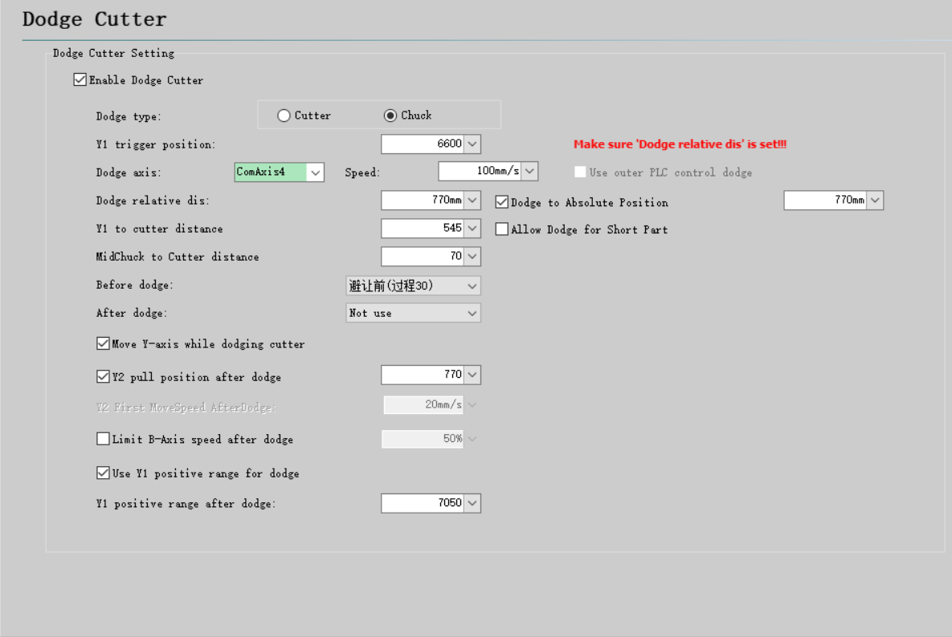

|  |  |  |
| --- | --- | --- |
| **Parameter Name** | **Description** | **Note** |
| Y1 limit coordinate | Y1 coordinate that triggers the dodge action. | It determines if the Y1 limit coordinates will appear on the next path and triggers the dodge. |
| Dodge relative distance | The distance of relative motion(move by) during chuck dodge |  |
| Y1 DodgePos To Cutter | The distance from the Y1 limit coordinate to the cutting head | This value needs to be filled based on the actual machine tool configuration. |
| MidChuck to Cutter | It is used to determine whether a part will be pulled out of the the middle chuck. | This value needs to be filled based on the actual machine tool configuration. |
| Dodge axis and speed | For the dodge axis | You can configure a common axis for dodge.  If not configured, the doge axis logic can also be configured in the "BeforeDodge PLC" module. |
| Dodge to Absolute Position | The chuck moves to a specific, predetermined position(move to). | When using relative avoidance, if an unexpected alarm or stop occurs during the avoidance process, causing the dodge to be interrupted, and then the avoidance motion is re-executed. This means the dodge axis will still move a relative distance, which may lead to chuck being pulled out of the chuck. Using a absolute position can prevent this from happening.  If absolute positioning is configured, it will use the absolute position. If not, it will use a relative distance.  If this option is checked and both relative and absolute motions are configured, the dodge axis will do absolute motions, but the dodge judgment uses relative parameters. The main chuck also moves using relative parameters (if [Move Y-axis while dodging] is checked). |
| Allow dodge for short part | Switch to the short part dodge mode | Once the short workpiece avoidance mode is enabled, TubePro will no longer check whether the pipe is pulled out of the middle chuck due to dodging.. |
| BeforeDodge action | PLC actions executed before dodge. | Move the cutting head to a position where it will not interfere with the chuck when dodging. |
| AfterDodge action | PLC actions executed after dodging. | You can configure some operations after dodging, such as [Enable special B-axis center]. |
| Move Y-axis while dodging | When the dodge is triggered, the Y1 axis synchronizes its motion with the dodge axis. | After doing the chuck dodge, the middle chuck clamps nothing, so it is necessary for Y1 to synchronize and move forward a certain distance.  If the function is enabled for 2-chuck machine, Y1 will move forward synchronously until the next path is under the cutting head.  If 【Move Y-axis while dodging】 is not moved, Y1 will not move.  The synchronized dodge speed is determined by selecting the smaller value between the "Global Parameter - Y Travel Speed" and the "Axis Dodge Speed". |
| Y2 Preparing Speed After Dodge | The speed of the Y2 axis moving in the negative direction after dodging. | It ensures that the unloading device can descend into position smoothly when B3 retracts. This is necessary to prevent any interference. |
| Limit B-axis Speed After Dodge | Limit the B-axis travel speed after dodging. | When dealing with short part that require single-chuck clamping after dodging, it is important to limit the rotational speed of the B-axis while the B-axis speed before avoidance is retained. |
| Enable Y1 dodge positive stroke | When the dodge is complete, the new Y1 axis positive stroke after dodging is enabled. | It is useful for the chuck dodge and can increase the cutting capacity. This function is similar to the [Y-axis extra stroke] of the chuck. |
| Y1 positive stroke after dodge |
| Enable external PLC control for the dodge axis. | For non-bus systems, it is not possible to configure the dodge axis. The chuck dodge action needs to be configured separately within the BeforeDodge action. | Motion: Before/AfterDodge Motion – The main card moves to the starting point of the next part. |

**4.2 Bevel Cutting**

The bevel cutting function needs to be selected in the Machine Config Tool - Advance - "Enable bevel cutting", the axis configuration will have an A-axis added. Configure the parameters, then open the software. Note the positive and negative stroke set to ±46°.

### 4.2.1 Preparation Before Debugging

1. A-axis return origin is set to the vertical position of the cutting head. Confirm the Return Origin works OK.

2. Prepare a standard tube, measure is dimension an accuracy of 0.1 mm.

3. Perform capacitance calibration and B-axis center calibration.

4. Verify that the A-axis motion angle is correct.

5. Select the interpolation follow algorithm in the Global Parameter for the height controller(follower).

6. Set the interpolation correction value to 0 in the parameter.

7. Generate a test file that conforms to the standard tube size. Set different marking processes for Layer 1 and Layer 2. Set a higher nozzle height (>2mm) and select normal vector follow in the bevel technique. The marking trace should be as fine as possible.The finer the marks, the better.

### 4.2.2 Adjust Servo Rigidity

Adjust the rigidity of the servo drives for each axis, as well as the velocity feedforward and feedforward velocity ratio. Different drives may have varying adjustable parameters.

The actual displayed values should be considered as the reference. If the displayed gain value or any other parameter shows "-1," it indicates that the drive does not support parameter reading.

After adjustments, perform a delay test and ensure that the delay test results for each axis are close in value. Increasing rigidity and velocity feedforward, as well as the feedforward velocity ratio, will reduce system delay.

Conversely, decreasing these parameters will increase system delay.

Once the delay values for each axis are close, proceed with roundness testing. Do not clamp the pipe. Set the roundness test diameter to approximately 25-40, and the angle to 45°. The maximum allowable error for the test results is generally below 0.1mm.

### 4.2.3 Swing Axis Calibration Parameter

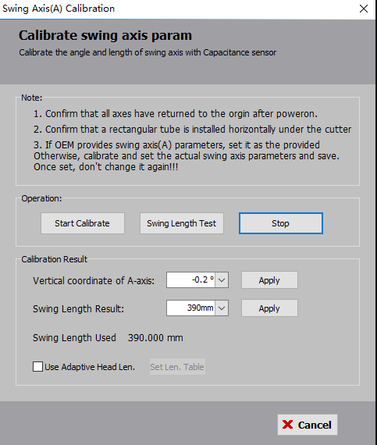

Click Start Calibration, the axis will move to different angles to calibrate, and click Apply when calibration is complete. If the manufacturer has provided a swing length, enter that value into the coarse swing length and click Apply to save.

### 4.2.4 Verticality Correction/Test

1. Click on the Correct Verticality, the cutting head will swing to different positions to follow and automatically correct the vertical position.

2. Click on the Test Verticality, the cutting head will also swing to the different positions to follow and test the verticality deviation. Typically, after performing verticality correction, a value below 0.05 is considered normal. If the measured value is too large, it could indicate non-standard pipe or poor accuracy in the installation of the cutting head.

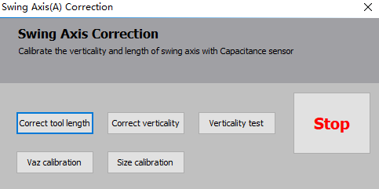

### 4.2.5 Vaz Calibration

Click on the Calibrate Vaz, the A-axis is rotated to different angles, and marking is performed in the Y direction as shown in the diagram below:



Based on the marking results, adjust the "Vertical error around Z" to make the three lines coincide.

Increase this value: Left side gets lower, and the right side gets higher.

Decrease this value: Left side gets higher and the right side gets lower.

It is recommended to adjust no more than 0.04° at a time and multiple times until the three lines coincide.

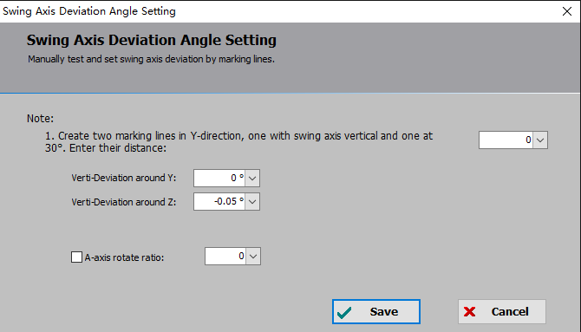

### 4.2.6 Swing(A) Axis Calibration

Click on the Correct Length, the A-axis is rotated to different angles, and marking is performed in the X direction as shown in the diagram below:

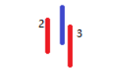

Now adjust the "A-axis vertical coordinate" so that the three lines are as coincident as possible, treat the blue line as if it were not moving, increase the value, and shift the red lines to the left. Decrease the value and shift the red lines to the right. It is recommended to adjust no more than 0.04° at a time and multiple times until the three lines have equal spacing. Adjust the swing size again so that the three lines coincide.

If 2 is on the left and 3 on the right, decrease the swing length, and vice versa.

**4.3 7-axis Pulling**

7-axis pulling can machine long parts to achieve zero-tailings cut. Open the Machine Config Tool, tick "Enable 7-axis pulling" in the "Advance" and configure the Y2, B3 axes in the axis configuration. Open the software to configure the seven-axis pulling parameters.

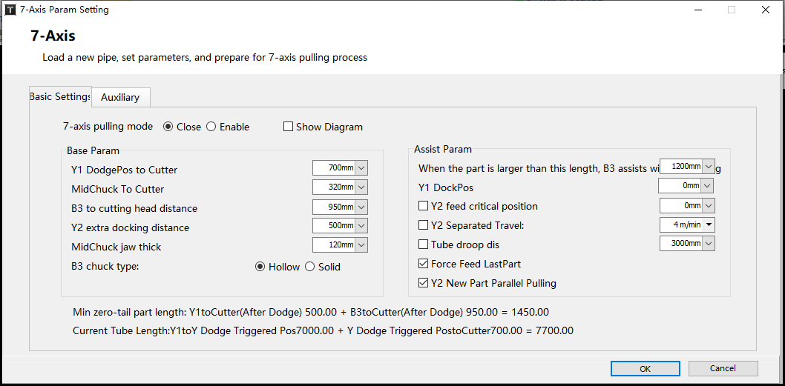

| Parameter | Description | Note |
| --- | --- | --- |
| Basic Function | | |
| Y1 DodgePos to Cutter | Y1 moves to【Y1 limit coordinate】. The distance of the end position of the pipe clamped by B1 to the center of the cutting head nozzle. | Dual Y machine require the cutting head to be moved to the positive limit of the small Y. |
| MidChuck to Cutter distance | Distance from the outer edge of the middle chuck to the center of the cutting head nozzle. | Dual Y machine require the cutting head to be moved to the positive limit of the small Y. |
| B3 to Cutter distance | Y2 is at the negative limit to the center of the cutting head nozzle. The distance from the position of the pipe that can be stably clamped by B3. | Dual Y machine require the cutting head to be moved to the negative limit of the small Y. |
| Y2 Extra Dock distance | When B3 is not involved in machining, [actual position of Y2 docking] =Y2 negative limit + Y2 extra docking distance. | If this position interferes with the tube head, B3 will adaptively dock at a safe location. Stop at this position, which is equal to [Part Length + Y2 Extra Dock - B3 to Cutter] |
| MidChuck jaw thick | The width of the middle chuck |  |
| B3 chuck type | Select the chuck type according to the actual chuck used. |  |
| Pulling Function | | |
| B3 assists machining when the part is larger than | Minimum part length required for pulling with B3. |  |
| Y1 DockPos | Position to move to after releasing B1 when doing zero-tail cutting. |  |
| Y2 feeding critical position | If B3 is a hollow chuck, Y2 pulling stroke is the negative stroke to this critical position.  If B3 is not a hollow chuck, please set it to the positive stroke coordinate of Y2. |  |
| Y2 Separate Travel | Set the separate travel speed for Y2. It is effective during single-axis positioning. | Y2 returns to the docking position or moves from the docking position to the pulling position. |
| Tube Drop distance | It is estimated that a pipe extension will not sagging in the length, to improve the pulling efficiency, can not strictly pull the material at the Y2 negative limit every time, to avoid the redundant action of Y1 must hold the tube head back to the Y2 negative limit when processing long holes or slopes. |  |
| Force Feed LastPart | When ticked, even if the last part is smaller than the set value for "B3 assists maching when the part is larger than", B3 will still involve in pulling. |  |
| Y2 New Part Parallel Pull | When ticked, it will automatically detect if the part requires B3 auxiliary clamping before it starts processing and allow B3 to adapt to a safe position before unclamping. | Currently, only hollow chuck is supported. To enable the option, please select "Hollow" as the "B3 chuck type." |
| Auxiliary Function | | |
| Execute PLC before B3 clamp | Perform a custom process before pulling or repeatedly pulling on the B3 chuck. |  |
| Y2 Limit IO Holder, Up-Down distance is: | When unchecked, the feed support is determined by the extension length of the part when it rises;  When checked, the unloading holder is raised or lowered entirely by the Y2 coordinate regardless of the part extension.  The Y2 coordinate value that controls the lowering of the holder is still configured in the PickPart page in the Machine Config Tool, and the Y2 coordinate value that controls the raising is uniformly determined by adding the specified distance to the descent coordinate. |  |
| Y2 Limit Follow-up Holder, Up-Down distance is: | When using servo axes as unloading follow-up holder and selecting this option, there is no need to calculate the automatic descent position. Instead, manually set a distance. Thus, the "Unloading follow-up holder StartDownPosition" = "Y2 Limit Position" + "distance." |  |
| B3 independently clamp for cutting tube tail | To enable this option, "Force Feed LastPart" must also be selected. Once selected, B2 and B3 can switch to a separate B3 cutting state, allowing the material to be pulled out from the middle chuck. First, all servo-controlled(follow-up) unloading axes will perform coupling actions, followed by switching B2B3 to B3. |  |
| B1 keeps coupled | B1 is coupled synchronously throughout the processing and rotates with the tube. |  |
| B2 coupled in Y2B3 cutting mode | It can only be used when switched to the Y2B3 mode. In Y2B3 mode, it performs reverse cutting, and B2 rotates in synchronized coupling. | Enabling the "7-axis pulling” mode will gray out this function.  This function is used for cutting long parts and requires B2 assistance in clamping. |
| Assist cutting for round tube tails | When cutting the last part, allow the short part to be pulled out of the chuck, exceeding the value set by [Assist cutting for round tube tails], which triggers the auxiliary cutting PLC. The logic that can be used to configure the auxiliary support. | This function only supports round tubes. |
| AssistCut PLC |

**4.4 3-Chuck**

Go to Machine Config Tool - Advance and tick "Enable 3-Chuck/2-Chuck special cutting", then TubePro enters 3-chuck mode, allowing automatic dodge actions of Y2Y3 axis;

When "Enable 2-Chuck mode" is checked, TubePro enters two-chuck mode, allowing cylinder dodge MidChuck and does not support zero-tail cutting.

|  |  |
| --- | --- |
| **Parameter Name** | **Description** |
| Y-axis Position Change Speed | "Y1/Y2/Y3 speed" is the Y-axis movement speed when the 3-chuck machine dodge. "Y1 feed speed" is the speed of the first feed of Y1 before the dodge action. |
| Y-axis Pre-cut Position Detection | If a valid input is detected, the current Y axis motion is stopped and a subsequent PLC motion is performed. |
| Dodge Action | Enable X-axis motion to safe position  If unchecked, the dodge can be performed before the dodge action is performed, after the height controller is moved to the docking position;  If checked, the X-axis moves to the specified position while the height controller is docked before the dodge action is performed. After dodging, move along the X-axis to the machining starting position. |

Parameter Options:

|  |  |
| --- | --- |
| **Parameter Name** | **Description** |
| Unloader down when program starts | When enabled, after the software starts, the auto unloading axis will descend. This is mainly used for resetting the motion of the unloading axis. It is not recommended to enable it during the debugging process. When not enabled, no operation will be performed on the unloading axis. If the unloading axis is not in the lowered or docked position, a warning will be displayed. |
| Detect axis position status when program starts | When enabled, after the software starts, it will automatically match the current position status based on the coordinates of the axis. The specific configuration of the status is several position states on the three-chuck debugging page. When not enabled, the status will not be automatically matched, and a warning will be displayed after the software starts indicating an unknown status. Before machining, the position status must be manually specified in order to start the cutting process. |
| Matching detection of pipe size and chuck type | When enabled, it will check whether the current state of the drawing matches the set chuck state based on the chuck size information. If it doesn't match, a dialog box will pop up, prompting the customer to replace the chuck and set a new chuck type. When not enabled, no chuck type detection will be performed. |
| Semi-auto loading PLC(External PLC) | First version of Tcp communication protocol, suitable for older versions of mechanical loading; |
| Semi-auto loading PLC(ExtendIO) | Suitable for loading motion via parallel PLC+ loading function axis + IO port. |
| Semi-auto loading PLC(PLC_Modbus) | It is suitable for controlling the external PLC through Modbus protocol, to achieve loading motion and status monitoring; "Need StepBack Cmd" means to allow the PLC editor to have an additional stepback command; for CCD image loading does not need to perform the PLC; for mechanical loading need to perform stepback motion. |
| Get PipeLength form loading PLC | Suitable for reading tube length via external PLC and directly affecting the results of the "Y1 move to clamp position" execution. |

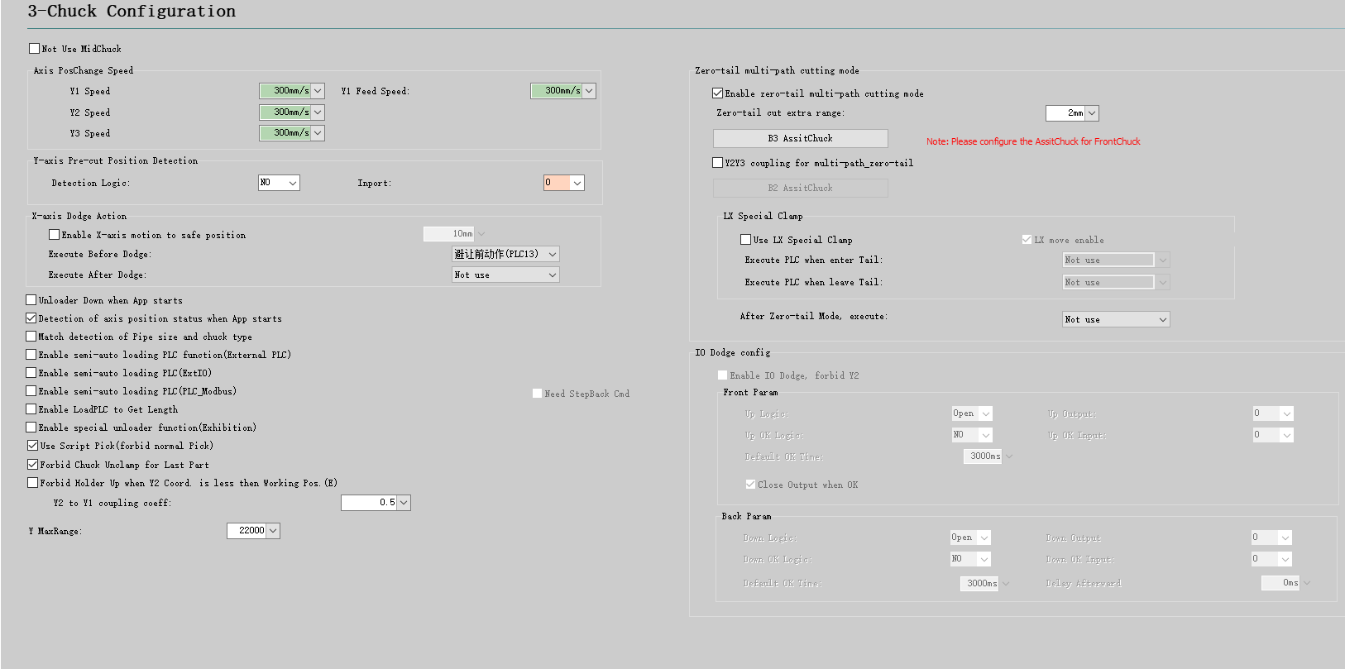

### 4.4.1 3-chuck Position Parameters

Basic Position Parameter

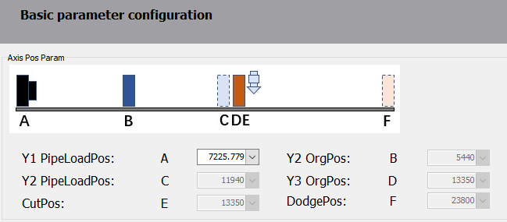

1. Parameters B and D are used to map the Y2Y3 coordinates to the Y1 coordinate system (setting parameters B and D based on the rightmost position of the chuck).

2. The position parameters on the parameter configuration interface are all Y1 coordinates.

Position Change Parameters

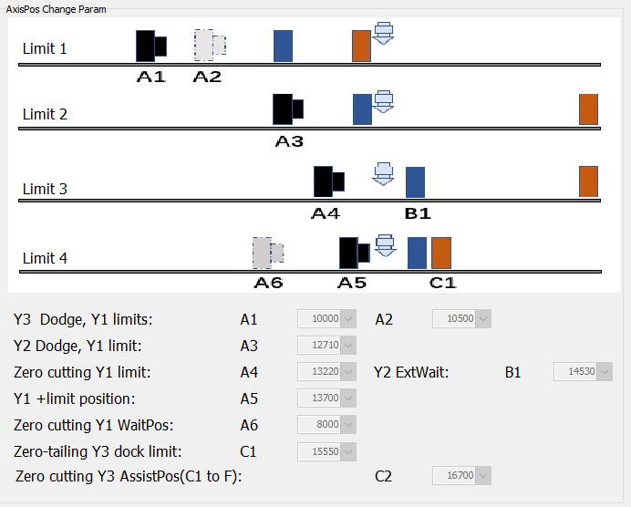

1. The positions are shown in the diagram, and the relationships between the parameters are as follows:

A1 < A2 < A3 < A4 ≤ A5 < position of the cutter

A4 represents the maximum coordinate where Y1 can clamp and process (Y1 cannot interfere with the cutting head at position A4).

A5 represents the maximum coordinate where Y1 can clamp (Y1 can interfere with the cutting head at position A5, which is the coordinate from the left side of the B1 chuck jaw to the cutting head).

2. Zero-tail mode

B1 chuck feeds the tube until reaching position A5, then the B3 chuck clamps the tube at position C2, and the B2 chuck assists in cutting the final straight cutoff line (B3 chuck has roller jaws and can only clamp with rotation, without Y-axis movement).

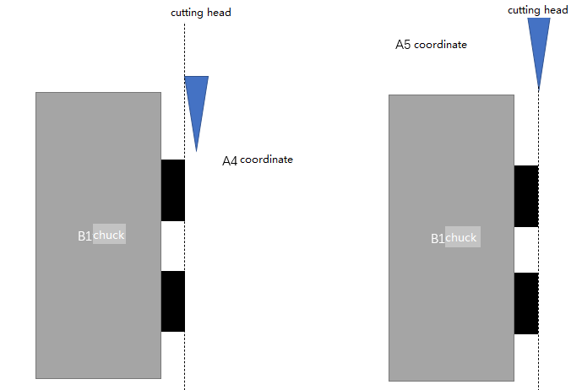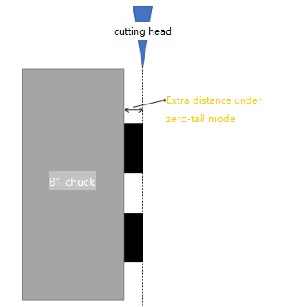

3. Mode for multi-path& zero-tail

Before transferring from the B1 chuck to the A5 position, the B3 chuck is clamped at the C2 position, and the B2 chuck holds

the final cutting trajectory. (Entering zero-tail mode, PLC can be executed to replace the B3 chuck's roller and jaw

with the B1 jaw to pull and cut the final trajectory of the tube).

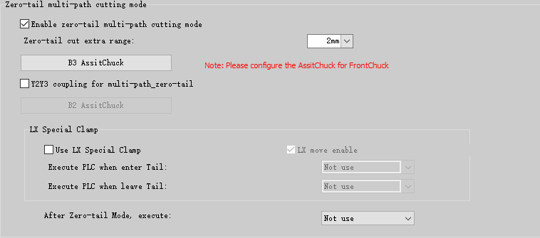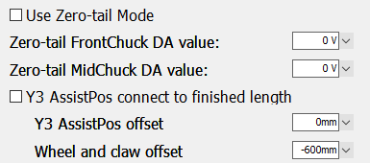

In zero-tail mode, the front/mid chuck DA value: When it is greater than 0, the chuck clamp uses the current DA value.

Adjust Y3 position based on CutLength: In zero-tail mode, the Y3 position is no longer fixed at C2 but is automatically calculated based on the length of the cut parts. Additionally, to prevent insufficient gripping of the tube by the jaw, a Y3 position compensation can be applied.

### 4.4.2 3-chuck Position

**1. Loading: RearChuck and MidChuck at LoadPosition, FrontChuck at CutPosition**



Y1 to LoadPos. A, Y2 to LoadPos. C, Y3 to CutPos. E.

**2. Processing in progress**

2.1 Initial processing state: MidChuck at clamp position, FrontChuck at cut position.



Y2 to ClampPos, Y3 CutPos(E)

Y2 CutPos. = (Y1 coordinate + Y3 coordinate) /2

(When Y2 = 0, and the Y1 coordinate corresponding to it is greater than the auxiliary clamp position, Y2 moves to the position Y2 = 200, and moves forward with Y1 to approach the auxiliary clamp position. Once Y2 meets the auxiliary clamp position, it remains coupled and moves to the auxiliary clamp position.)

In this state, Y1 and Y2 move forward together, with Y2 moving at half the speed of Y1.

2.2 Processing in progress: MidChuck at cut position, FrontChuck at dodge position.

When Y1 moves within the range of A1 to A2, the front card starts avoiding and moves to position F.



At this point, the state switches to the middle chuck at cutting position E and the front chuck at dodge position F.



After the state switch, the rear card continues moving forward for processing while the middle and front cards remain stationary.

2.3 Processing in progress: MidChuck at dodge position, FrontChuck at dodge position.

When Y1 reaches position A3, the middle card moves to position B1.



Y1 clamps and feeds the tube for cutting. If the zero-tail mode is not enabled, Y1 can move up to position A4.



2.3* Optional Processing in Progress State: MidChuck at cut position, FrontChuck at assist position.

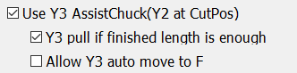

It is possible to dodge earlier based on the length of the part. If the part length exceeds the position of the assist position C2 for the front card, the front chuck dodges in advance and moves to position C2.

2.4 Zero-tails processing mode: MidChuck at dodge position, FrontChuck at assist position.

Zero-tail mode

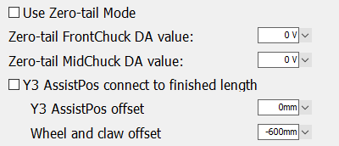

Processing conditions for zero-tail mode: The second-to-last path must be smaller than A4, and the last path should be between A4 and A5. Only straight cutting is possible because the tail chuck is a roller and cannot pull the material.



Y1 feeds up to A5, Y2 to loading position C2, Y3 to processing position E, then Y1 back to zero-tail dodge position A6, B2B rotates for zero-tail to be cut off.

Multi-path zero-tail mode

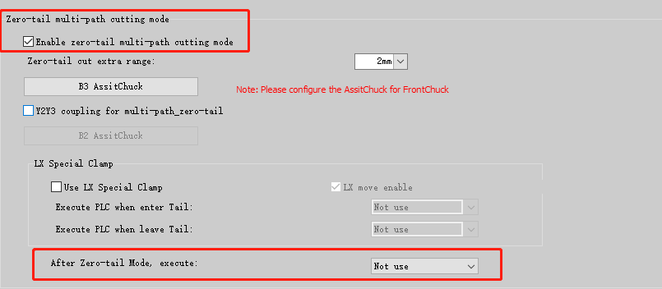

The extra stroke of the multi-path zero-tail is the extra length of the tube that is clamped by the rear jaws.

Conditions for multi-path zero-tail: The rear chuck can be changed from roller to jaw to pull the material for cutting.



Y1 feeds up to A5, Y2 to loading position C2, rear chuck performs zero-tail actions, Y3 moves to position C2, and Y1 returns to position A6. The rear card pulls the material for zero tail processing.

2.5 3-Chuck Safety Parameter

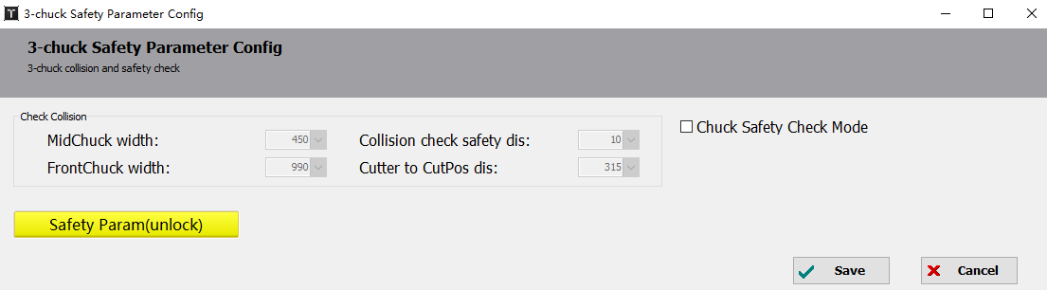

All three chuck are in the Y1 coordinate system,Y1-1 is the Y1coordinate, Y2-1is the Y2 coordinate in the Y1 coordinate system, and Y3-1 is the Y3 coordinate in the Y1 coordinate system.

The difference between Y1-1,Y 2-1, Y3-1is the distance between Y1 and Y2, Y2 and Y3;

Jog to the Y1 limit close to Y2, then Y2-1-Y1-1 is the width of the middle chuck;

Jog to the Y2 limit close to Y3, then Y3-1 -Y 2-1 is the width of the tail chuck;

Mechanical interference safety distance is set aside to prevent over-impact of the chuck;

Cutter to CutArea distance has an internal alarm. When there is a chuck below the cutting head, the cutting head is not allowed to descend.

If Cut Position - Current Position > Cutter to CutArea distance, an alarm is triggered when the cutting head descends.

If B1, B2, and B3 are not synchronized and B3 card holder is clamped, jogging B1 will be disabled and a warning will be displayed.

### 4.4.3 3-chuck Unloading Action

1. Basic unloading actions

The configuration includes 6 servo-controlled unloading axes and a configuration of tilting/leveling cylinders for the servo-controlled flipper. To prevent mechanical interference, the flipper will not be tilting or leveling after the middle chuck dodges.

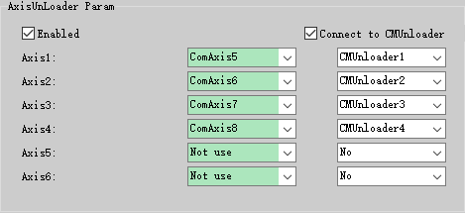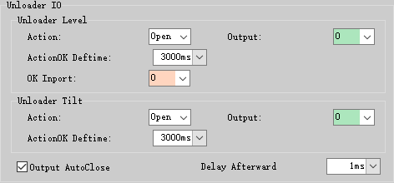

Conditions for material discharge servo control:

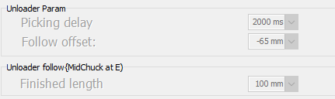

Follow-up deviation value = Unloading calibration value - Loading calibration value.

Based on the provided parameters, when the auxiliary unloading function is enabled, the flipper will tilt after the part is cut, and it will remain tilted for 2 seconds.

When the part length exceeds 1.5 meters, the unloading holder will rise to follow.

1. Common unloading actions

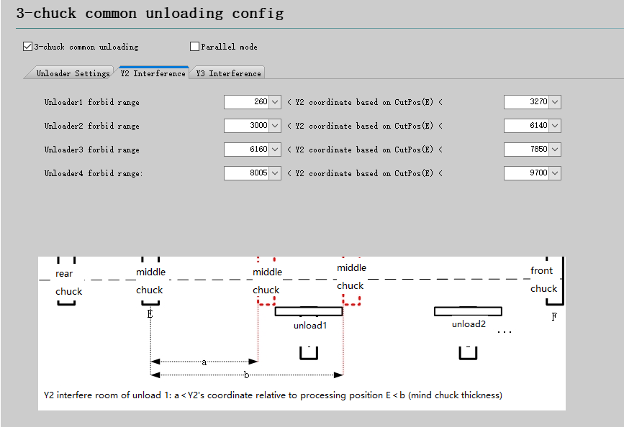

### 4.4.4 3-chuck Parameter Configuration

1. Front Chuck Pulling Assist

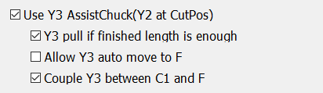

Enable Y3 AssistChuck(Y2 at CutPos)

When enabled, the middle chuck is at the dodge position and the part length exceeds C1, then the front chuck B3 moves to C1 for assist clamping;

When not enabled, the middle chuck is at the dodge position and the length of the part exceeds the F, then the front chuck directly clamps at the dodge position.

Y3 dodge if finished length exceeds AssistPos

Once enabled, when the front chuck is in the cutting position and the length of the finished parts exceeds the position of Y3 auxiliary clamp, Y3 will immediately start dodging.

Note: This is done to prevent issues caused by thin pipe material and long parts, which could result in swinging at the front end.

Allow Y3 auto move to F

Once enabled, when the front chuck is in the assist clamping position and the length of the finished part exceeds the F position, Y3 will move to the F position.

Note: When the front chuck is in the assist clamping position, Y3 moves to the F position before cutoff actions to avoid the risk of Y3 directly descending after the cutting operation and to facilitate unloading.)

Couple Y3 between C1 and F

Once enabled, when Y3 is in the auxiliary clamping position, it is possible to perform the cutting operation by synchronizing Y1's movement from the clamping position to the dodge position until reaching the dodge position F, and then decoupling.

Note: This is done to prevent excessive sagging of the front end of the pipe when the pipe is relatively long.Note: The tube is long to prevent too much sag in the front end of the tube.

2. Zero-tail Cutting

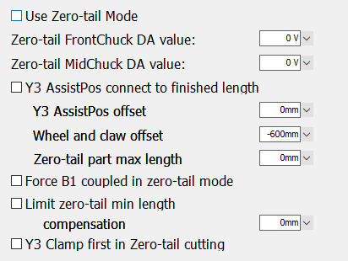

Enable zero-tail mode

Allows zero-tail cutting when enabled; allows the front and middle chucks to clamp; (If Zero-tail Multi-path cutting Mode is enabled in the Machine Config Tool, multiple paths of pipe cutting are allowed with the front chuck. Also change the front/middle chuck air pressure DA value and IO port at zero-tail cutting; if Zero-tail multi-path cutting mode is not enabled, the maximum cutting capacity is A5, and it only allows the front chuck to cut the last track and perform straight cutting.)

Zero-tail cutting action is not allowed when this option is not enabled; maximum cutting capacity is limited by A4 (maximum limit for rear clamp);

FrontChuck DA value

When enabled (value is greater than 0), the DA value of the set chuck clamping takes effect directly after entering the zero-tail cutting mode;

When not enabled (equal to 0), no DA value modification, and the DA value set on the debug interface will be used;

Adjust Y3 AssistPos on finished length

When enabled, the minimum assist clamping position for Y3 = zero-tail FrontChuck Dock Limit (C1) + the distance compensation between the rollers and the jaws.

When not enabled, the minimum assist clamping position for Y3 = zero-tail FrontChuck Pull Position (C2).

Note:

1. The zero-tail will automatically move to the C2 position, and the front-end of the part can be clamped using the front rollers.

2. The front jaw can be set according to the part front position for special zero-tail.

Y3 position offset

It directly adds to the clamping position of the front chuck, which means to move the clamping position backward.

Roller and Jaw Offset

When calculating the minimum auxiliary clamping position, it is superimposed directly on the calculation result to relax the restriction.

Note: For a chuck with both claws and rollers, the position of the Y3 chuck can be adjusted based on the position of the jaws to clamp the pipe.

Example: In a chuck configuration with the left jaw and right roller, where the front end of the pipe is clamped by the left jaw and not by the right roller, Y3 needs to move 50mm to the right from the original clamping position of the pipe. In this case, the value would be set to 50mm.

Max part length limit

When enabled (checked and the value is greater than 0), the error message 'Part-X length-X exceeds zero-tail length limit X” will be triggered.

Note: Due to Y3 stroke limitations, it is necessary to manually limit the maximum length of the zero-tail part.

Force B1 coupled in zero-tail mode

When activated, when zero tailings are cut, B1 is not decoupled and will also rotate.

Min part length limit

When enabled, the error 'Part-X length-X is smaller than zero-tail length limit X' is triggered.

Min part length compensation

When calculating the minimum part length limit, it is directly added to the calculated result to relax the restriction.

Note: In the zero-tail mode, the cutting range is A5 + extra stroke - A4, and the zero-tail path is also within this range.

The minimum path length for zero-tail cutting = C - E - Cutter compensation (distance from cutting head to chuck).

Zero-tail min part length = Min path + Jaw parameter

Jaw parameter = A5 + extra stroke - A4

3. ReturnZero Assit Settings

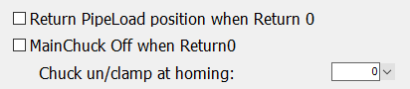

Y1Y2Y3 return LoadPosition when ReturnZero

When enabled, click "Return zero", and the rear chuck returns to the loading position, and the front and middle chuck return to the initial position before processing, the cut position or the dodge position;

When enabled, the PLC "3-chuck loading position" command is executed, the rear chuck returns to the loading position, and the front and middle chuck return to the initial position before processing.

When not enabled, click "Return Zero", then only the rear chuck moves;

The speed of Y1 during the ReturnZero process is the Position Change Speed set in the Machine Config Tool;

MainChuck Off when ReturnZero

When enabled, clicking the ReturnZero button will first release the chuck, then perform the homing action for XYB axes.

When not enabled, click "Return Zero", then no chuck moves;

Un/clamp times at ReturnZero

Multiple clamping and releasing actions are performed to ensure proper releasing.

4. Unloading Assist Settings

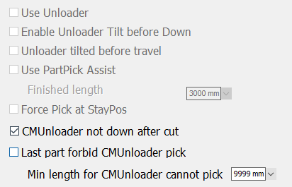

Enable unloading assist

When enabled, during the machining process, the unloading axis will either follow or maintain a fixed height, and the flipper will tilt and flatten. The debugging actions of the unloader on the 3-chuck debugging page will all respond.

When not enabled, the unloading axis will not perform any actions of the flipper.

Note: Please ensure that the unloading axis is in the Down state before unchecking this option.

1. The unloading will only follow if the length of the part exceeds the floating support length of the unloading.

2. If it does not exceed, the unloading will maintain a fixed height at the docking coordinate of the unloading axis.

Flipper flip before holder down

When enabled, an additional action of flattening and flipping the flipper is performed before executing the descent action of the unloader.

flipper tilt before travel

When enabled, during the picking process, it waits for the completion of the flipper action before performing the travel motion.

Note: Cut the next part after the picking action is completed. This is to prevent the next part from extending and knocking away the current part before it has fallen.

Unloading rack support

When enabled, if the length of the cut parts(finished length) exceeds a certain distance, the unloading rack will go up. (Upward/downward)

Note: Generally used with special unloading for the exhibition. When the last part length exceeds Length4, the exhibition unloading action is automatically performed after the cut-off; (clamping cylinder is released + flipper lowered + auxiliary pallet lowered (check this to make it work)

Finished length

Typically this length is where the tube extends beyond the unloading holder.

Force Pick at DockPos

When enabled, before performing the picking action, the unloading axis will move to the docking position and then tilt the flipper.

When not enabled, the unloading axis can flipper while in the follow-up state."

5. Other Parameters

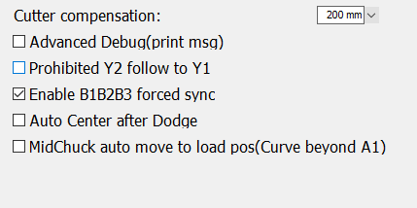

Cutter to Chuck CutPos(Cutter compensation)

The condition for determining if clamping is required in the dodge position is: (Finished Length + "Cutter Compensation") > (MidChuck DodgePos - CutPosition), where the finished length is calculated automatically according to the paths in the drawing;

The Cutter Compensation default value is 50. If the length of the tube is not enough for clamping, the compensation value can be reduced. EXAMPLE: For a cutoff line with beveled cuts, the compensation value can be reduced so that the cut distance is long enough before the clamping is performed.

Modifying the compensation value affects the clamping at the dodge position for the middle chuck, clamping at the dodge position for the front chuck, clamping at the assist position for the front chuck, and the cutting capability for zero-tail.

Advanced Debug

When enabled, debug information will be printed during cutting. Check this option when abnormal motion is detected.

If not enabled, no debugging information will be printed during the cutting.

Disable Y2 Y1 Sync

When checked, the middle chuck will remain in the loading position and wait while the holder does follow-up motion during machining;

If this option is not checked, when the middle chuck is in the loading position, it will move directly to the middle position of the front and rear chuck to assist clamping;

Force B1B2B3 sync

When enabled, all three chucks rotate at the same time, regardless of whether the front/middle chuck is clamped or not;

If not enabled, the front/middle chuck does not rotate at the dodge position, and it rotates when it is clamped.

Auto Center after Dodge

After the chuck dodging during machining, it will automatically seek the center position for the next path.

MidChuck move to LoadPos(path exceeds A1)

The front chuck will dodge, when the path exceeds the A1 position and the middle chuck will automatically go to the loading position.

Note: Prevent A1A2 from being small, causing the front card to directly avoid the tube from sagging